1 Which situation should be analyzed using bivariate data?
1) | Ms. Saleem keeps a list of the amount of time her daughter spends on her social studies homework.
2) | Mr. Benjamin tries to see if his students’ shoe sizes are directly related to their heights.
3) | Mr. DeStefan records his customers’ best video game scores during the summer.
4) | Mr. Chan keeps track of his daughter’s algebra grades for the quarter.

2 Which situation is an example of bivariate data?
1) | the number of pizzas Tanya eats during her years in high school
2) | the number of times Ezra puts air,in his bicycle tires during the summer
3) | the number of home runs Elias hits per game and the number of hours he practices baseball
4) | the number of hours Nellie studies for her mathematics tests during the first half of the school year

3 Which situation is represented by bivariate data?
1) | A student lists her algebra quiz grades for one month.
2) | A wrestler records his weight before each match.
3) | A musician writes down how many minutes she practices her instrument each day.
4) | An ice cream vendor tracks the daily high temperature and how many ice cream bars he sells each day.

4 Which situation is an example of bivariate data?
1) | shoe sizes of a tennis team
2) | goals scored in soccer games
3) | Calories consumed in one day
4) | hours studying compared to test scores

5 Which table shows bivariate data?
1) | 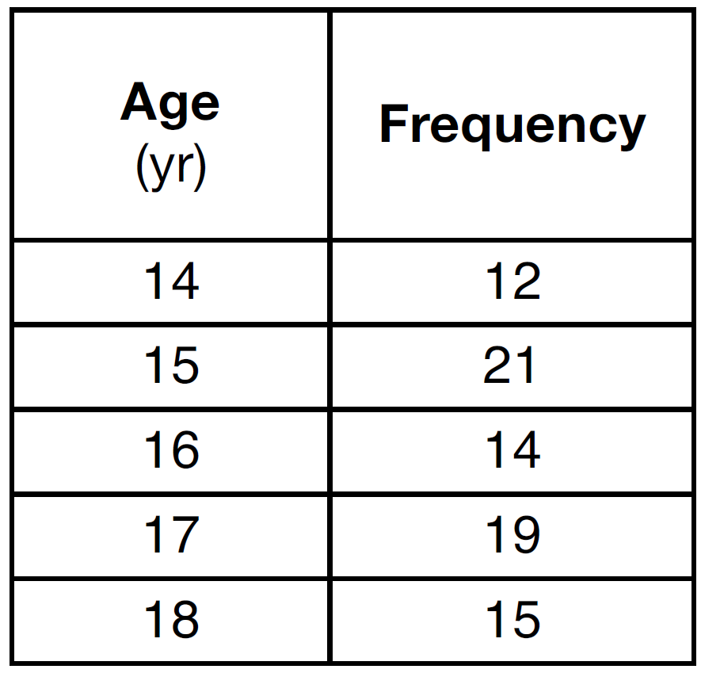
2) | 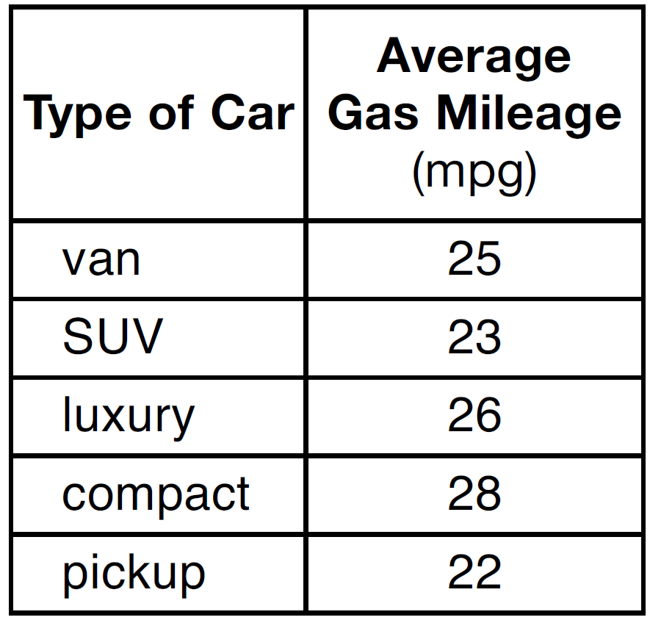
3) | 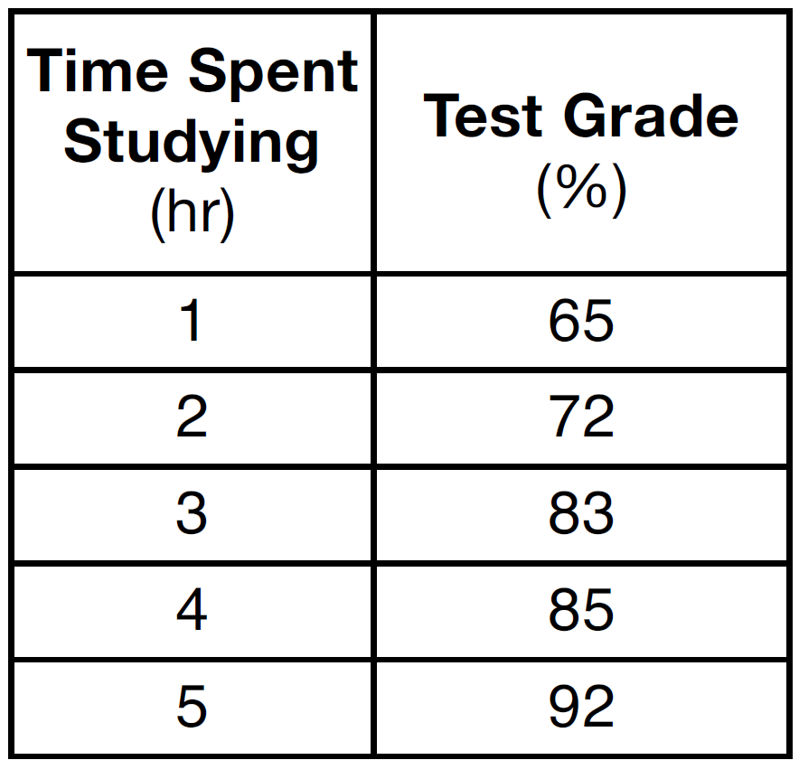
4) | 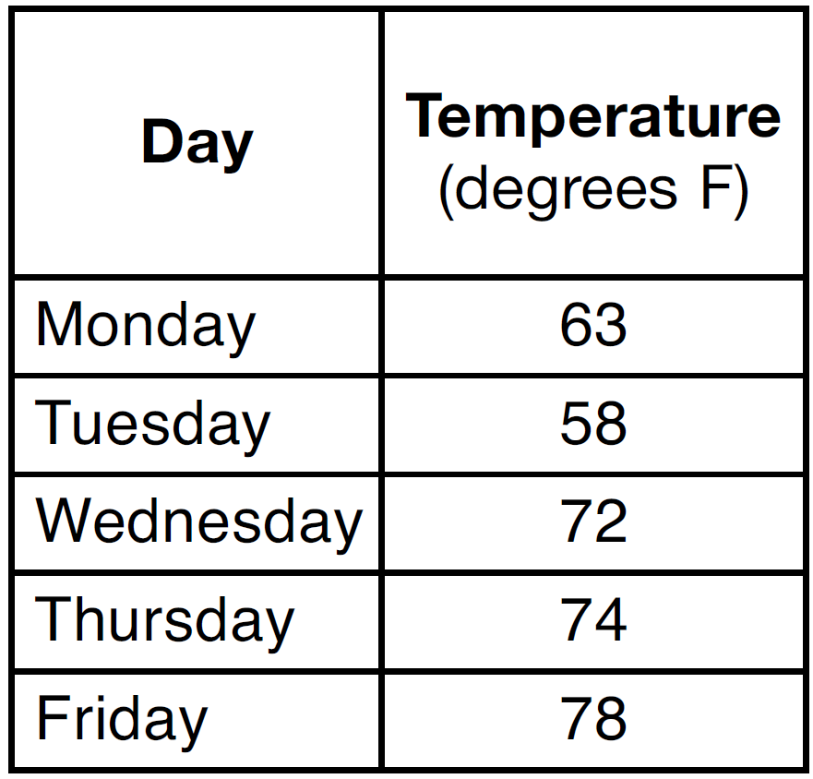

6 Which table does not show bivariate data?
1) | 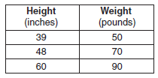
2) | 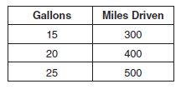
3) | 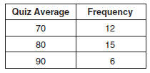
4) | 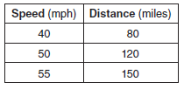

7 Which data table represents univariate data?
1) | 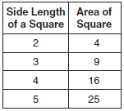
2) | 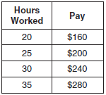
3) | 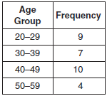
4) | 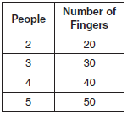

1 ANS: 2
The two values are shoe size and height.

REF: fall0714ia

2 ANS: 3 REF: 061206ia

3 ANS: 4 REF: 011504ia

4 ANS: 4 REF: 061510ia

5 ANS: 3
Due to lack of specificity in the wording, this 13th question was removed from the June, 2013 Regents Exam.

REF: 061313ia

6 ANS: 3 REF: 061011ia

7 ANS: 3
Frequency is not a variable.

REF: 011014ia

