1 Which relationship can best be described as causal?
1) | height and intelligence
2) | shoe size and running speed
3) | number of correct answers on a test and test score
4) | number of students in a class and number of students with brown hair

2 Which situation does not describe a causal relationship?
1) | The higher the volume on a radio, the louder the sound will be.
2) | The faster a student types a research paper, the more pages the paper will have.
3) | The shorter the distance driven, the less gasoline that will be used.
4) | The slower the pace of a runner, the longer it will take the runner to finish the race.

3 Which relationship can best be described as causal?
1) | The alarm goes off and the sun rises.
2) | The car is moving slowly and the driver is singing.
3) | The snow is falling and the stores run out of snow shovels.
4) | The birds are chirping and the rain is coming down.

4 Which correlation shows a causal relationship?
1) | The more minutes an athlete is on the playing field, the more goals he scores.
2) | The more gasoline that you purchase at the pump, the more you pay.
3) | The longer a shopper stays at the mall, the more purchases she makes.
4) | As the price of a gift increases, the size of the gift box increases.

5 Which phrase best describes the relationship between the number of miles driven and the amount of gasoline used?
1) | causal, but not correlated
2) | correlated, but not causal
3) | both correlated and causal
4) | neither correlated nor causal

6 A study showed that a decrease in the cost of carrots led to an increase in the number of carrots sold. Which statement best describes this relationship?
1) | positive correlation and a causal relationship
2) | negative correlation and a causal relationship
3) | positive correlation and not a causal relationship
4) | negative correlation and not a causal relationship

7 What type of relationship exists between the number of pages printed on a printer and the amount of ink used by that printer?
1) | positive correlation, but not causal
2) | positive correlation, and causal
3) | negative correlation, but not causal
4) | negative correlation, and causal

8 The data obtained from a random sample of track athletes showed that as the foot size of the athlete decreased, the average running speed decreased. Which statement is best supported by the data?
1) | Smaller foot sizes cause track athletes to run slower.
2) | The sample of track athletes shows a causal relationship between foot size and running speed.
3) | The sample of track athletes shows a correlation between foot size and running speed.
4) | There is no correlation between foot size and running speed in track athletes.

9 Which situation describes a correlation that is not a causal relationship?
1) | The rooster crows, and the Sun rises.
2) | The more miles driven, the more gasoline needed
3) | The more powerful the microwave, the faster the food cooks.
4) | The faster the pace of a runner, the quicker the runner finishes.

10 Which situation describes a correlation that is not a causal relationship?
1) | the number of miles walked and the total Calories burned
2) | the population of a country and the census taken every ten years
3) | the number of hours a TV is on and the amount of electricity used
4) | the speed of a car and the number of hours it takes to travel a given distance

11 Which situation describes a correlation that is not a causal relationship?
1) | the length of the edge of a cube and the volume of the cube
2) | the distance traveled and the time spent driving
3) | the age of a child and the number of siblings the child has
4) | the number of classes taught in a school and the number of teachers employed

12 Beverly did a study this past spring using data she collected from a cafeteria. She recorded data weekly for ice cream sales and soda sales. Beverly found the line of best fit and the correlation coefficient, as shown in the diagram below.

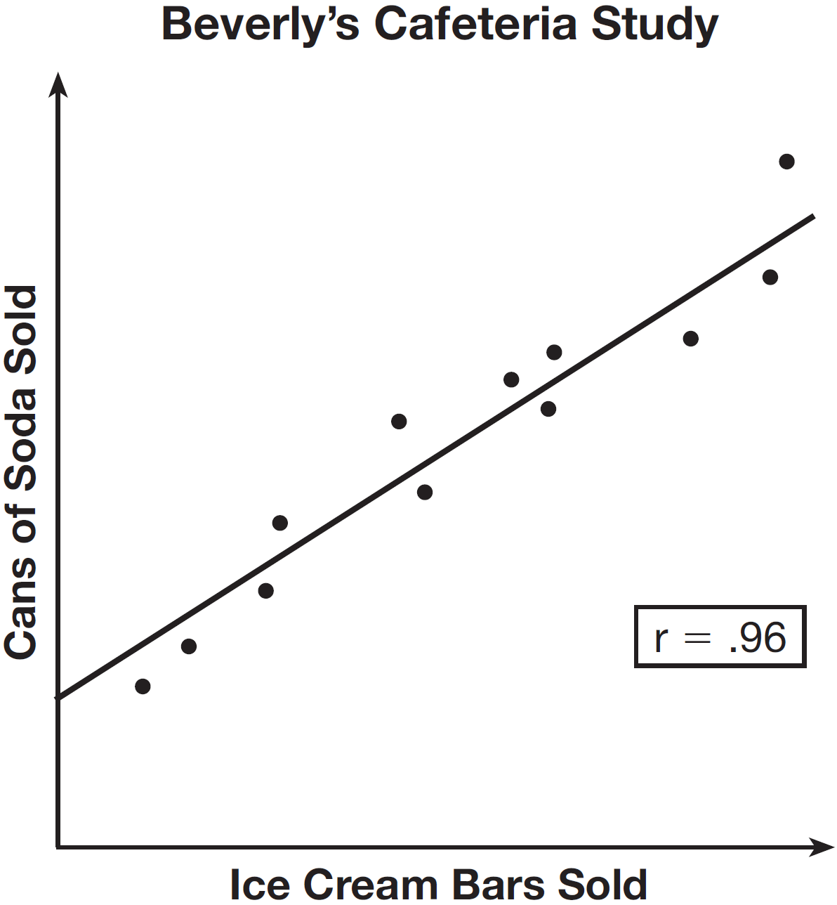

Given this information, which statement(s) can correctly be concluded?
I. Eating more ice cream causes a person to become thirsty.
II. Drinking more soda causes a person to become hungry.
III. There is a strong correlation between ice cream sales and soda sales.
1) | I, only
2) | III, only
3) | I and III
4) | II and III

1 ANS: 3
The number of correct answers on a test causes the test score.

REF: 080908ia

2 ANS: 2 REF: 081708ai

3 ANS: 3 REF: 081406ia

4 ANS: 2 REF: 062201ai

5 ANS: 3 REF: 081017ia

6 ANS: 2 REF: 061122ia

7 ANS: 2 REF: 011713ai

8 ANS: 3 REF: 081821ai

9 ANS: 1
A rooster crows before sunrise, not because of the sun.

REF: fall0707ia

10 ANS: 2 REF: 061427ia

11 ANS: 3
The age of a child does not cause the number of siblings he has, or vice versa.

REF: 011030ia

12 ANS: 2 REF: 061516ai

