1 Bella recorded data and used her graphing calculator to find the equation for the line of best fit. She then used the correlation coefficient to determine the strength of the linear fit. Which correlation coefficient represents the strongest linear relationship?
1) | 0.9 | 3) | -0.3
2) | 0.5 | 4) | -0.8

2 Analysis of data from a statistical study shows a linear relationship in the data with a correlation coefficient of -0.524. Which statement best summarizes this result?
1) | There is a strong positive correlation between the variables. | 3) | There is a moderate positive correlation between the variables.
2) | There is a strong negative correlation between the variables. | 4) | There is a moderate negative correlation between the variables.

3 The results of a linear regression are shown below.
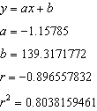
Which phrase best describes the relationship between x and y?
1) | strong negative correlation | 3) | weak negative correlation
2) | strong positive correlation | 4) | weak positive correlation

4 What is the correlation coefficient of the linear fit of the data shown below, to the nearest hundredth?

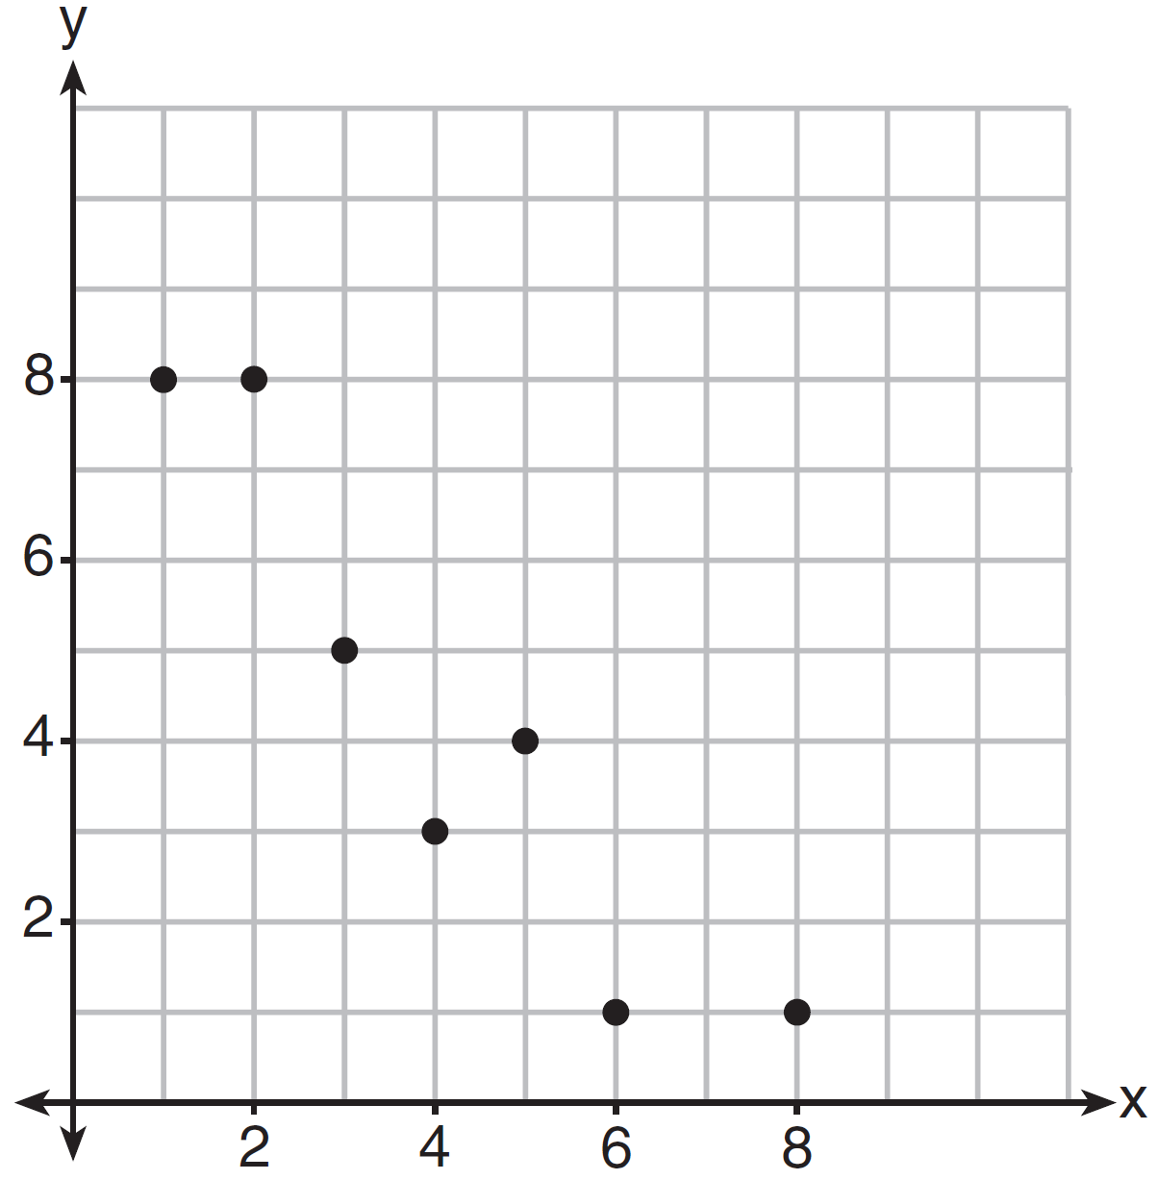
1) | 1.00 | 3)
2) | 0.93 | 4)

5 The scatterplot below compares the number of bags of popcorn and the number of sodas sold at each performance of the circus over one week.

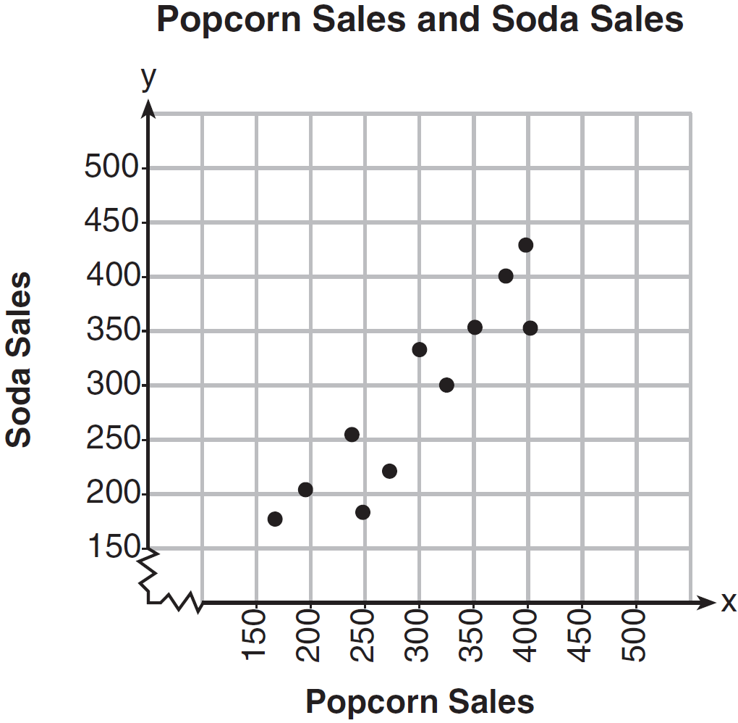

Which conclusion can be drawn from the scatterplot?
1) | There is a negative correlation between popcorn sales and soda sales. | 3) | There is no correlation between popcorn sales and soda sales.
2) | There is a positive correlation between popcorn sales and soda sales. | 4) | Buying popcorn causes people to buy soda.

6 The table below shows the time, in hours, spent by students on electronic devices and their math test scores. The data collected model a linear regression.

Time Spent on an  Electronic Device (hours) | Math Test Score
3 | 85
1 | 99
4 | 81
0 | 98
3 | 90
7 | 65
5 | 78
2 | 90

What is the correlation coefficient, to the nearest hundredth, for these data?
1) |  | 3) | 0.98
2) |  | 4) | 0.95

7 The table below shows 6 students' overall averages and their averages in their math class.

Overall Student Average | 92 | 98 | 84 | 80 | 75 | 82
Math Class  Average | 91 | 95 | 85 | 85 | 75 | 78

If a linear model is applied to these data, which statement best describes the correlation coefficient?
1) | It is close to . | 3) | It is close to 0.
2) | It is close to 1. | 4) | It is close to 0.5.

8 At Mountain Lakes High School, the mathematics and physics scores of nine students were compared as shown in the table below.

Mathematics | 55 | 93 | 89 | 60 | 90 | 45 | 64 | 76 | 89
Physics | 66 | 89 | 94 | 52 | 84 | 56 | 66 | 73 | 92

State the correlation coefficient, to the nearest hundredth, for the line of best fit for these data. Explain what the correlation coefficient means with regard to the context of this situation.

9 A nutritionist collected information about different brands of beef hot dogs. She made a table showing the number of Calories and the amount of sodium in each hot dog.

Calories per  Beef Hot Dog | Milligrams of Sodium  per Beef Hot Dog
186 | 495
181 | 477
176 | 425
149 | 322
184 | 482
190 | 587
158 | 370
139 | 322

a) Write the correlation coefficient for the line of best fit. Round your answer to the nearest hundredth.
b) Explain what the correlation coefficient suggests in the context of this problem.
1 ANS: 1 REF: 061714ai

2 ANS: 4 REF: 011703ai

3 ANS: 1 REF: 081722ai

4 ANS: 3 REF: 061411ai

5 ANS: 2 REF: 061604ai

6 ANS: 1

REF: 082223ai

7 ANS: 2

REF: 081606ai

8 ANS:
. The correlation coefficient suggests a strong positive correlation between a student’s mathematics and physics scores.

REF: 011831ai

9 ANS:
. The correlation coefficient suggests that as calories increase, so does sodium.

REF: 011535ai

