1 In a linear equation, the independent variable increases at a constant rate while the dependent variable decreases at a constant rate. The slope of this line is
1) | zero
2) | negative
3) | positive
4) | undefined

2 In a given linear equation, the value of the independent variable decreases at a constant rate while the value of the dependent variable increases at a constant rate. The slope of this line is
1) | positive
2) | negative
3) | zero
4) | undefined

3 If the value of dependent variable y increases as the value of independent variable x increases, the graph of this relationship could be a
1) | horizontal line
2) | vertical line
3) | line with a negative slope
4) | line with a positive slope

4 The data in the table below are graphed, and the slope is examined.

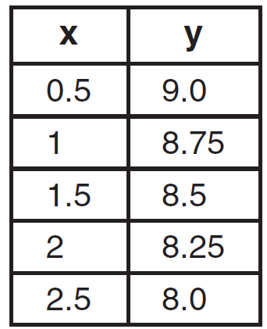

The rate of change represented in this table can be described as
1) | negative
2) | positive
3) | undefined
4) | zero

1 ANS: 2 REF: 080823ia

2 ANS: 2 REF: 081223ia

3 ANS: 4 REF: 080417a

4 ANS: 1 REF: 081115ia

