1 The accompanying figure shows the graph of the equation .

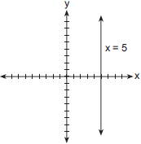

What is the slope of the line ?
1) 5 2) 3) 0 4) undefined

2 What is the slope of a line represented by the equation ?
1) 1 2) 3) 4)

3 What is the slope of the line whose equation is ?
1) 5 2) 2 3) 4)

4 What is the slope of the line represented by the equation ?
1) 2) 3) 4)

5 What is the slope of the line represented by the equation ?
1) 2) 3) 4)

6 What is the slope of the line whose equation is ?
1) 2) 3) 4)

7 What is the slope of the line whose equation is ?
1) 2) 3) 3 4)

8 What is the slope of the linear equation ?
1) 10 2) 2 3) 4)

9 The line represented by the equation has a slope of
1) 2) 2 3) 3 4)

10 What is the slope of the line whose equation is ?
1) 2) 3) 4)

11 Which linear equation represents a line that has a slope of ?
1) 2) 3) 4)

12 The line has
1) a slope of and a y-intercept of 2) a slope of and a y-intercept of 6
3) a slope of 3 and a y-intercept of 4) a slope of and a y-intercept of
1 ANS: 4 REF: 060012a

2 ANS: 2
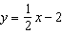
REF: 011409ia

3 ANS: 3
To solve for y, divide the equation by 2. 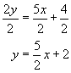
REF: 010203a

4 ANS: 4
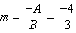
REF: 011516ia

5 ANS: 4
REF: 061319ia

6 ANS: 2
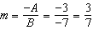
REF: 011122ia

7 ANS: 1
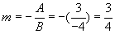
REF: 089919a

8 ANS: 2
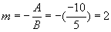
REF: 060205a

9 ANS: 4
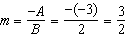
REF: 061212ia

10 ANS: 1 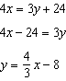
REF: 061615ia

11 ANS: 4 REF: 061509ia

12 ANS: 1 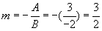. 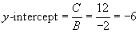.
REF: 060428a

