1 If a line is horizontal, its slope is
1) 1 2) 0 3) undefined 4) negative

2 What is the slope of the line containing the points and ?
1) 2) 2 3) 4)

3 What is the slope of the line that passes through the points and ?
1) 2) 2 3) 4)

4 What is the slope of the line that passes through the points and ?
1) 2) 3) 4)

5 What is the slope of the line passing through the points and ?
1) 2) 3) 4)

6 What is the slope of the line that passes through the points and ?
1) 2) 3) 4) 5

7 What is the slope of the line that passes through the points and ?
1) 2) 3) 4)

8 What is the slope of the line that passes through the points and ?
1) 2) 0 3) 4) undefined

9 What is the slope of the line that passes through the points and ?
1) 2) 3) 4)

10 What is the slope of a line that passes through the points and ?
1) 2) 3) 4)

11 What is the slope of a line passing through points and ?
1) 2) 3) 4)

12 A line with a slope of passes through the point . Which point also lies on this line?
1) 2) 3) 4)

13 Line segment AB has a slope of . If the coordinates of point A are , the coordinates of point B could be
1) 2) 3) 4)

14 What is the slope of the line passing through the points A and B, as shown on the graph below?

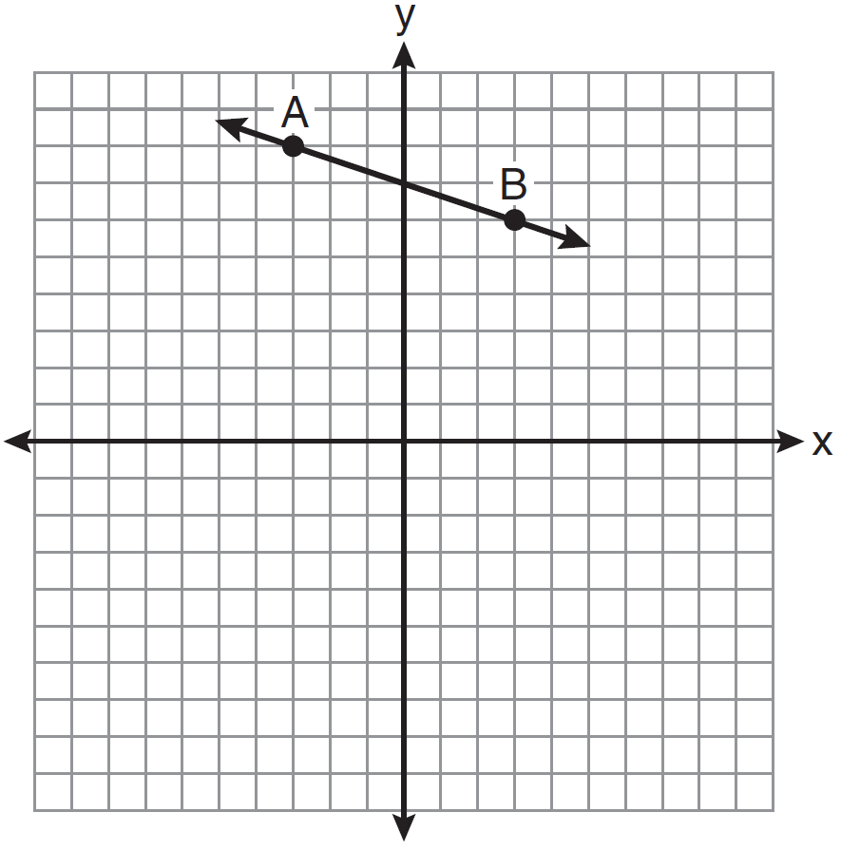
1) 2) 3) 3 4)

15 What is the slope of line shown in the accompanying diagram?

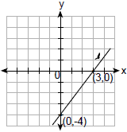
1) 2) 3) 4)

16 What is the slope of line in the accompanying diagram?

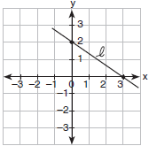
1) 2) 3) 4)

17 In the diagram below, what is the slope of the line passing through points A and B?

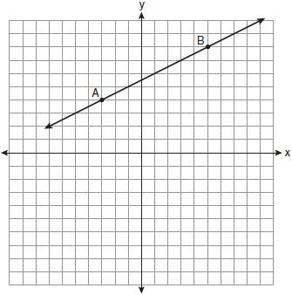
1) 2) 2 3) 4)

18 A straight line with slope 5 contains the points and . Find the value of K. [The use of the accompanying grid is optional.]

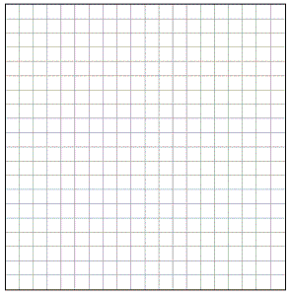
1 ANS: 2 REF: 060618a

2 ANS: 3
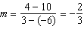

REF: fall0716ia

3 ANS: 3
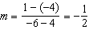

REF: 060820ia

4 ANS: 2
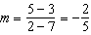

REF: 010913ia

5 ANS: 3
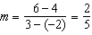

REF: 061110ia

6 ANS: 2
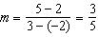

REF: 061004ia

7 ANS: 4
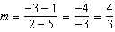

REF: 011215ia

8 ANS: 1
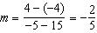

REF: 080915ia

9 ANS: 2
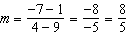

REF: 081310ia

10 ANS: 2
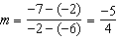

REF: 061410ia

11 ANS: 2
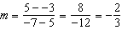

REF: 081411ia

12 ANS: 4
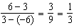

REF: 080828a

13 ANS: 1
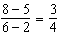

REF: 080728a

14 ANS: 2
and . 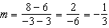

REF: 081005ia

15 ANS: 1
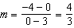

REF: 069918a

16 ANS: 2
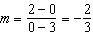

REF: 010115a

17 ANS: 4
and . 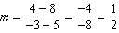

REF: 011007ia

18 ANS:
12. 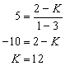. 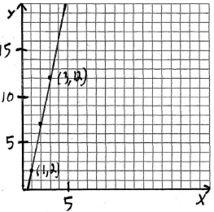
REF: 010024a

