1 The scatter plot below shows the profit, by month, for a new company for the first year of operation. Kate drew a line of best fit, as shown in the diagram.

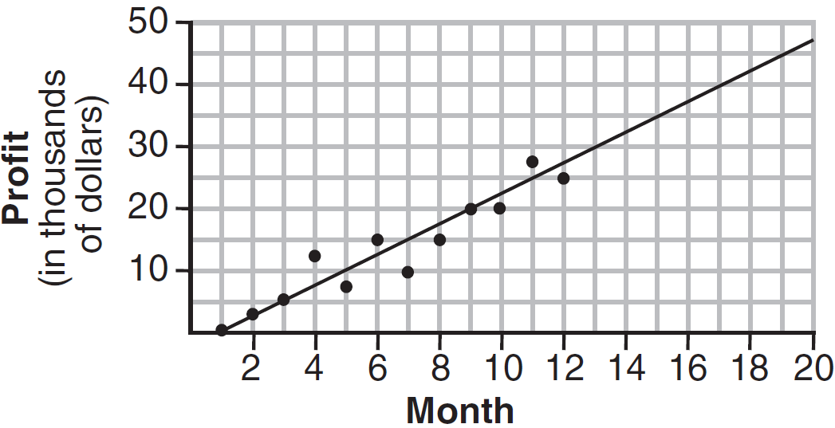

Using this line, what is the best estimate for profit in the 18th month?
1) | $35,000
2) | $37,750
3) | $42,500
4) | $45,000

2 Based on the line of best fit drawn below, which value could be expected for the data in June 2015?

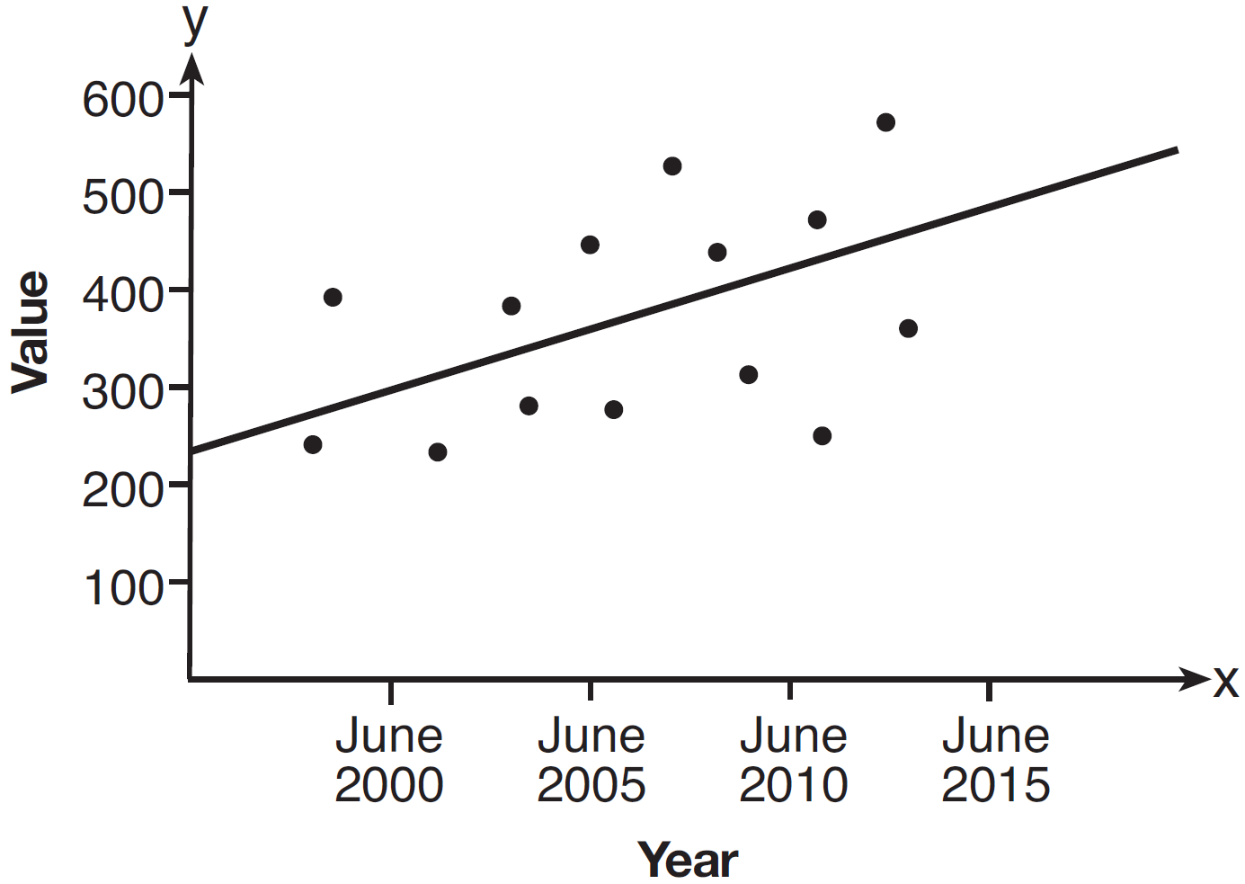
1) | 230
2) | 310
3) | 480
4) | 540

3 The number of hours spent on math homework each week and the final exam grades for twelve students in Mr. Dylan's algebra class are plotted below.
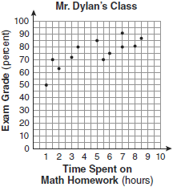

Based on a line of best fit, which exam grade is the best prediction for a student who spends about 4 hours on math homework each week?
1) | 62
2) | 72
3) | 82
4) | 92

4 The scatter plot below shows the relationship between the number of members in a family and the amount of the family's weekly grocery bill.
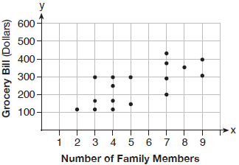

The most appropriate prediction of the grocery bill for a family that consists of six members is
1) | $100
2) | $300
3) | $400
4) | $500

5 The graph below illustrates the number of acres used for farming in Smalltown, New York, over several years.

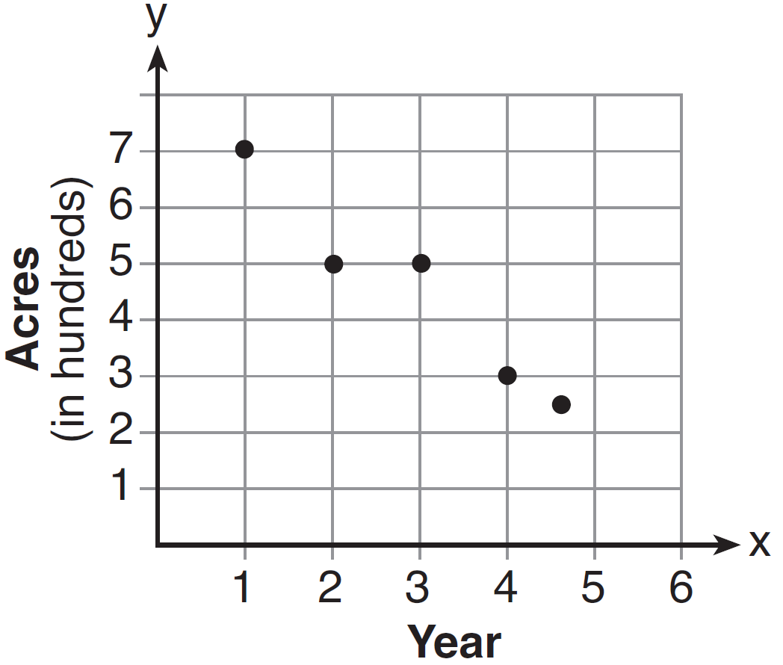

Using a line of best fit, approximately how many acres will be used for farming in the 5th year?
1) | 0
2) | 200
3) | 300
4) | 400

6 A scatter plot was constructed on the graph below and a line of best fit was drawn.

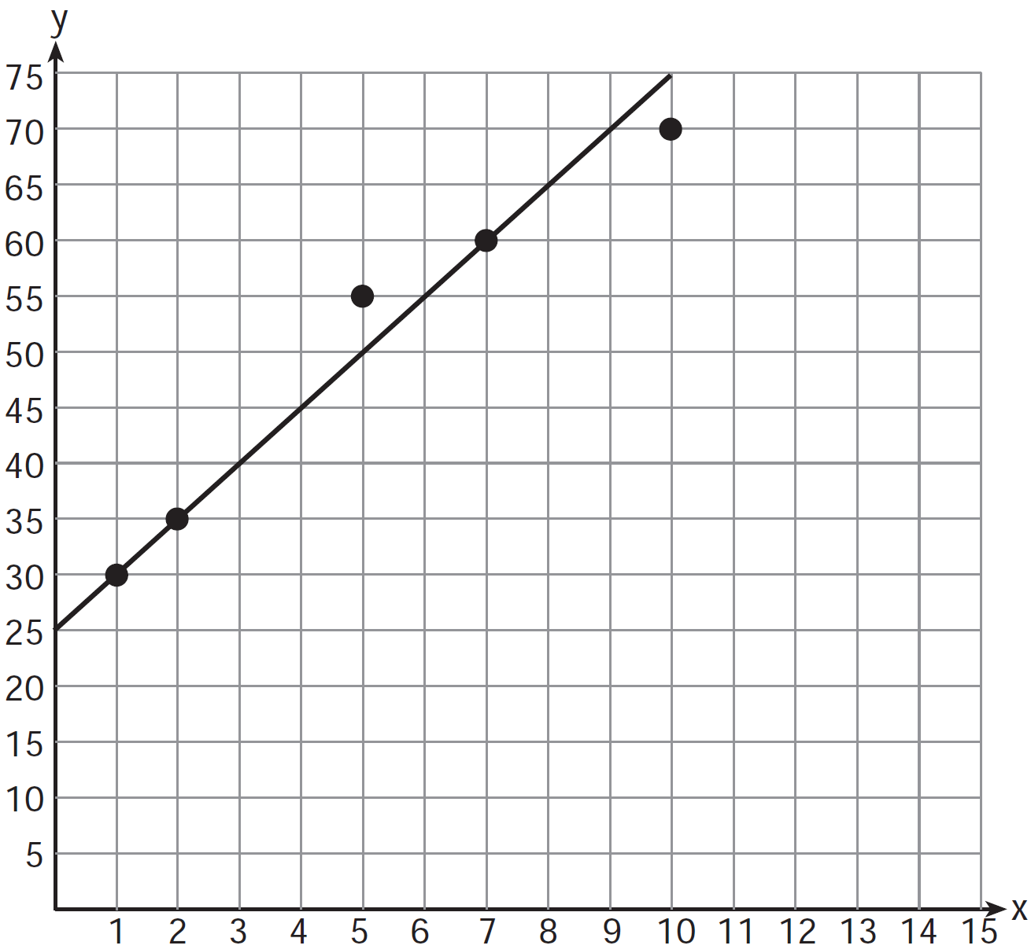

What is the equation of this line of best fit?
1)
2)
3)
4)

7 Which equation most closely represents the line of best fit for the scatter plot below?

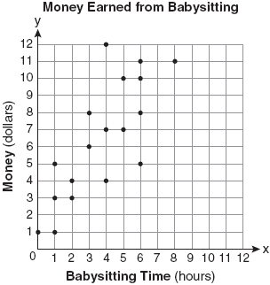
1)
2) | 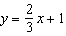
3) | 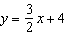
4) | 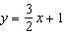

8 The table below shows the number of prom tickets sold over a ten-day period.

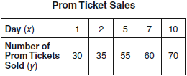

Plot these data points on the coordinate grid below. Use a consistent and appropriate scale. Draw a reasonable line of best fit and write its equation.

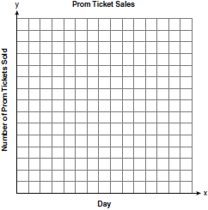

9 Megan and Bryce opened a new store called the Donut Pit. Their goal is to reach a profit of $20,000 in their 18th month of business. The table and scatter plot below represent the profit, P, in thousands of dollars, that they made during the first 12 months.

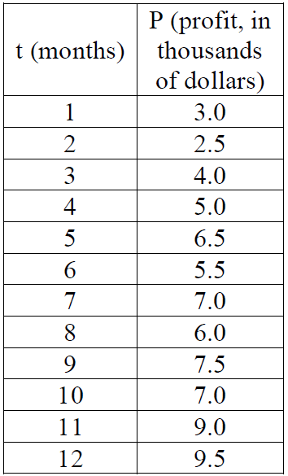

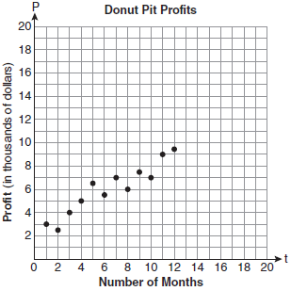

Draw a reasonable line of best fit. Using the line of best fit, predict whether Megan and Bryce will reach their goal in the 18th month of their business. Justify your answer.
1 ANS: 3 REF: 081208ia

2 ANS: 3 REF: 061303ia

3 ANS: 2 REF: 080930ia

4 ANS: 2 REF: 011901ai

5 ANS: 2 REF: 011411ia

6 ANS: 4 REF: 011229ia

7 ANS: 4
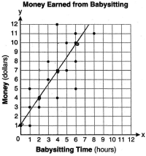

REF: 080822ia

8 ANS:
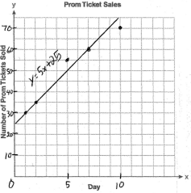

REF: 060936ia

9 ANS:
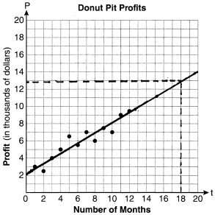 They will not reach their goal in 18 months.

REF: 061036ia

