1 There is a negative correlation between the number of hours a student watches television and his or her social studies test score. Which scatter plot below displays this correlation?
1) | 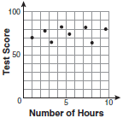
2) | 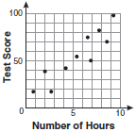
3) | 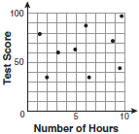
4) | 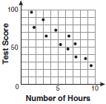

2 Which scatter plot shows the relationship between x and y if x represents a student score on a test and y represents the number of incorrect answers a student received on the same test?
1) | 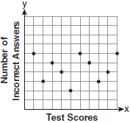
2) | 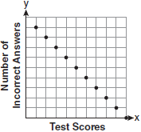
3) | 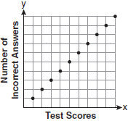
4) | 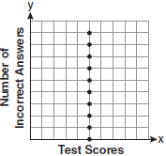

3 A line of best fit has been drawn on the scatter plot below.

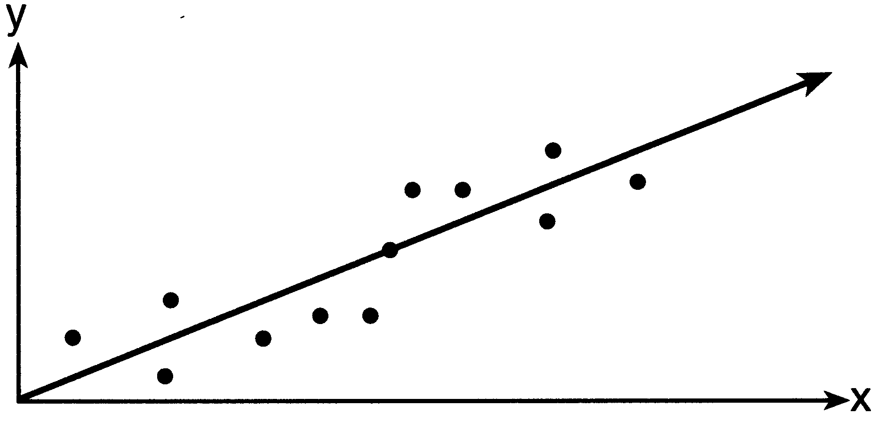

The relationship between these variables can be described as having
1) | a negative correlation
2) | no correlation
3) | a positive correlation
4) | zero correlation

4 What is the relationship between the independent and dependent variables in the scatter plot shown below?

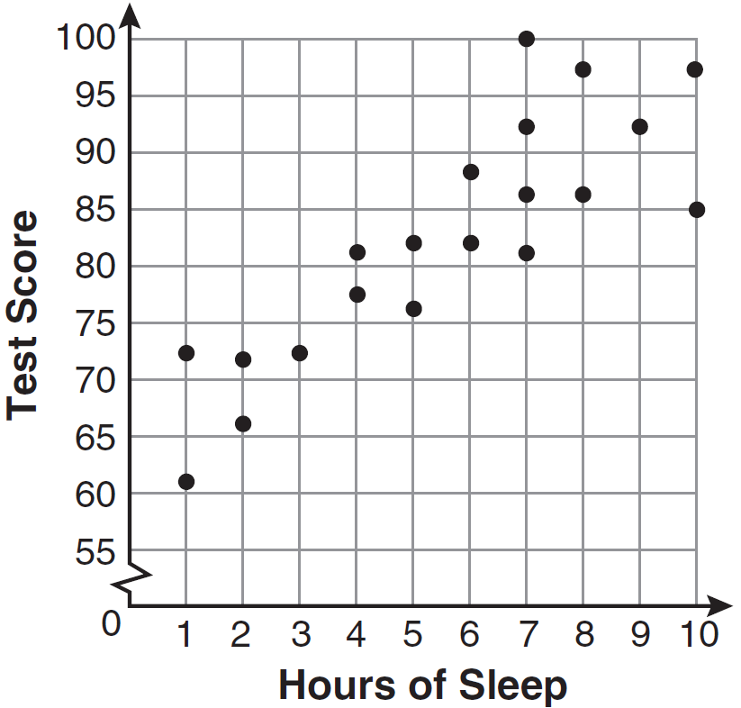
1) | undefined correlation
2) | negative correlation
3) | positive correlation
4) | no correlation

5 The scatter plot below represents the relationship between the number of peanuts a student eats and the student's bowling score.
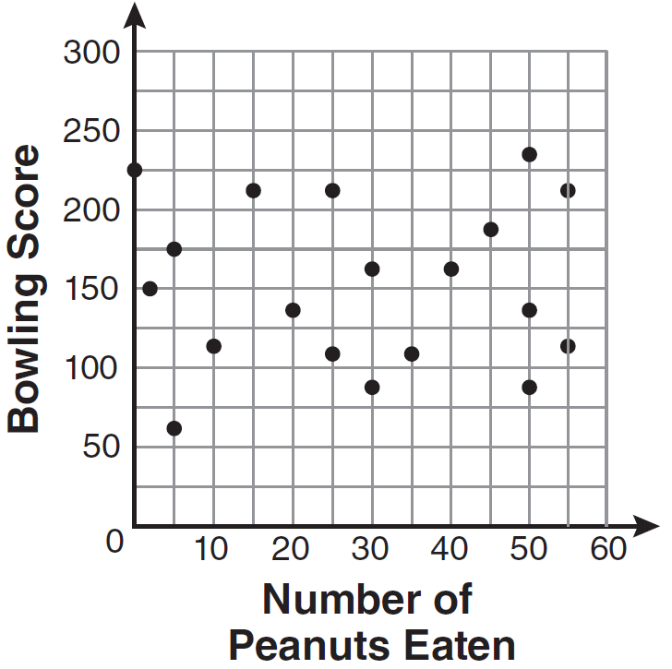
Which conclusion about the scatter plot is valid?
1) | There is almost no relationship between eating peanuts and bowling score.
2) | Students who eat more peanuts have higher bowling scores.
3) | Students who eat more peanuts have lower bowling scores.
4) | No bowlers eat peanuts.

6 A set of data is graphed on the scatter plot below.
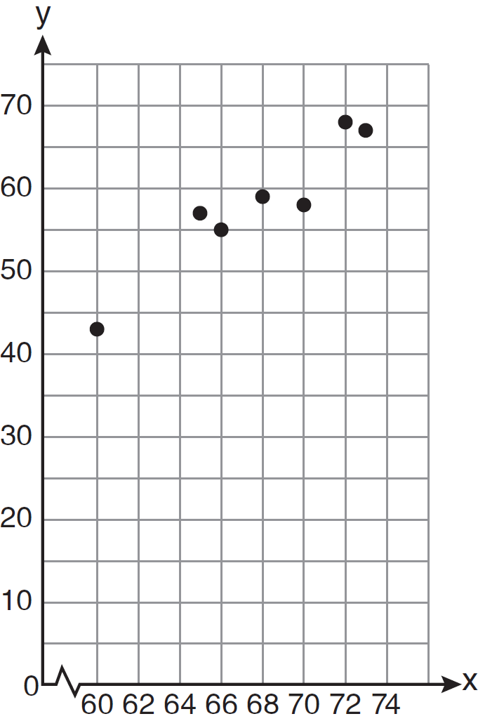
This scatter plot shows
1) | no correlation
2) | positive correlation
3) | negative correlation
4) | undefined correlation

7 The scatter plot shown below represents a relationship between x and y.
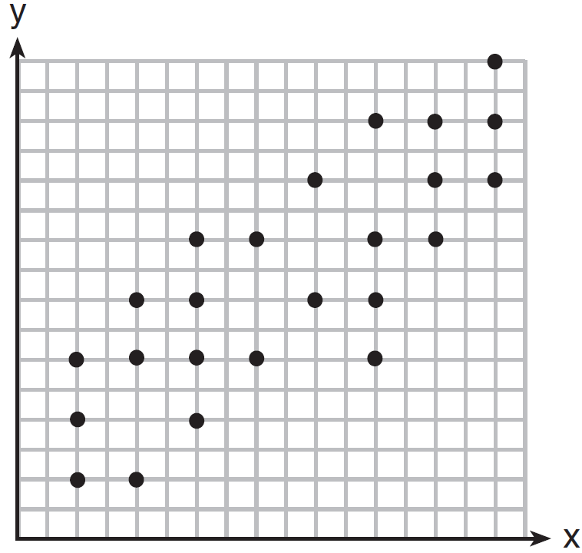
This type of relationship is
1) | a positive correlation
2) | a negative correlation
3) | a zero correlation
4) | not able to be determined

8 The number of hours spent on math homework during one week and the math exam grades for eleven students in Ms. Smith’s algebra class are plotted below.
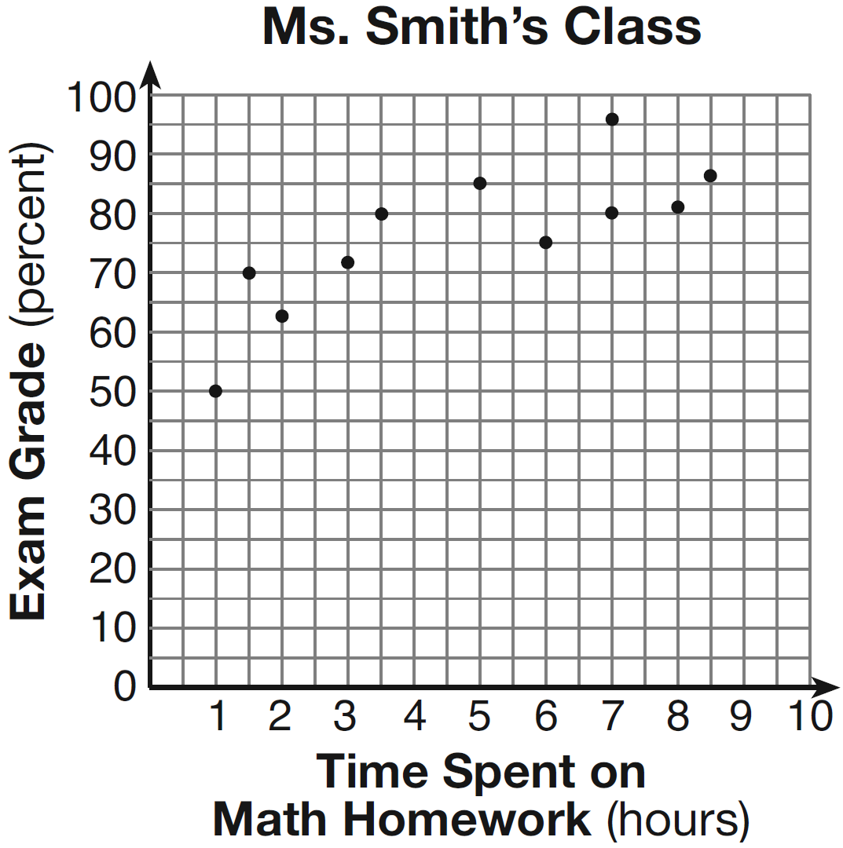
Based on the plotted data, what is the correlation between the time spent on homework and the exam grade?
1) | positive
2) | negative
3) | no correlation
4) | cannot be determined

9 Which statement is true about the data shown in the scatter plot below?

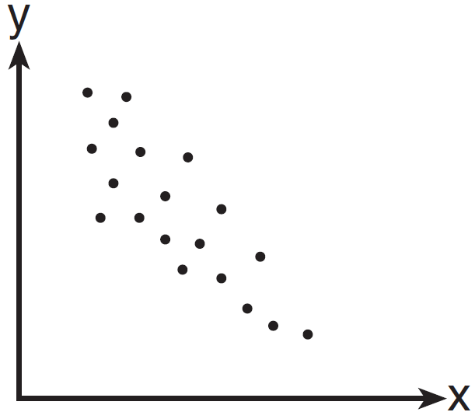
1) | There is no correlation between the two sets of data.
2) | There is a positive correlation between the two sets of data.
3) | There is a negative correlation between the two sets of data.
4) | The correlation between the data is both positive and negative.

10 A positive correlation always exists on a scatter plot when
1) | y remains unchanged as x increases
2) | y changes randomly as x increases
3) | y decreases as x increases
4) | y increases as x increases

11 Which situation describes a negative correlation?
1) | the amount of gas left in a car's tank and the amount of gas used from it
2) | the number of gallons of gas purchased and the amount paid for the gas
3) | the size of a car's gas tank and the number of gallons it holds
4) | the number of miles driven and the amount of gas used

1 ANS: 4 REF: 060805ia

2 ANS: 2 REF: 011019ia

3 ANS: 3 REF: 061601ia

4 ANS: 3 REF: 011103ia

5 ANS: 1 REF: 081102ia

6 ANS: 2 REF: 061205ia

7 ANS: 1 REF: 081204ia

8 ANS: 1 REF: 011301ia

9 ANS: 3 REF: 061512ia

10 ANS: 4 REF: 081412ia

11 ANS: 1 REF: 081301ia

