1 For 10 days, Romero kept a record of the number of hours he spent listening to music. The information is shown in the table below.

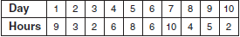

Which scatter plot shows Romero’s data graphically?
1) | 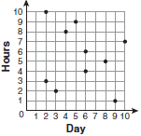
2) | 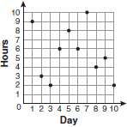
3) | 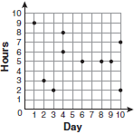
4) | 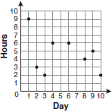

2 The school store did a study comparing the cost of a sweatshirt with the number of sweatshirts sold. The price was changed several times and the numbers of sweatshirts sold were recorded. The data are shown in the table below.

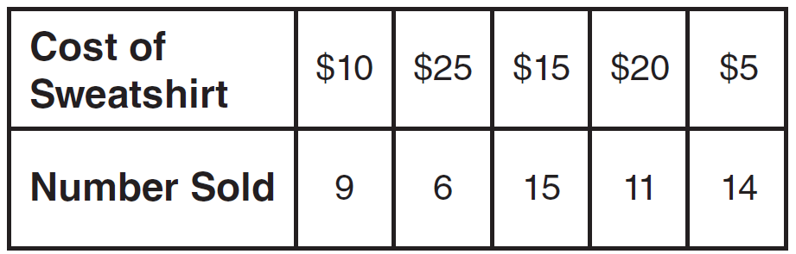

Which scatter plot represents the data?
1) | 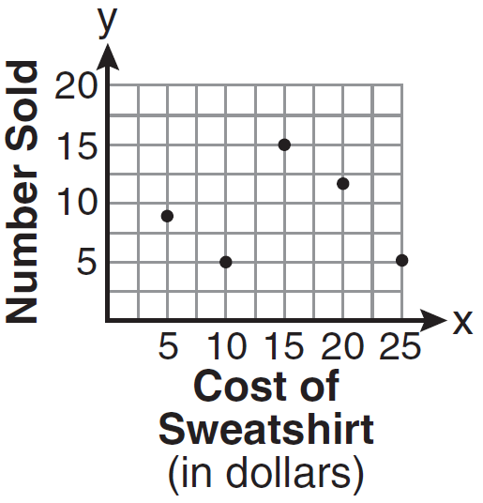
2) | 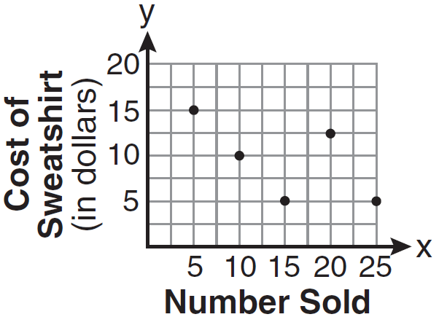
3) | 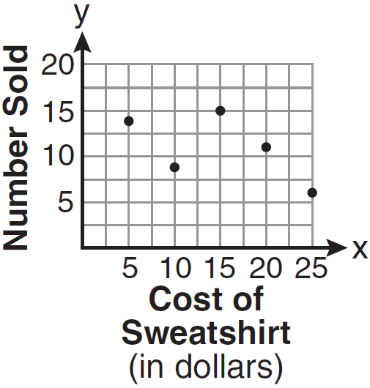
4) | 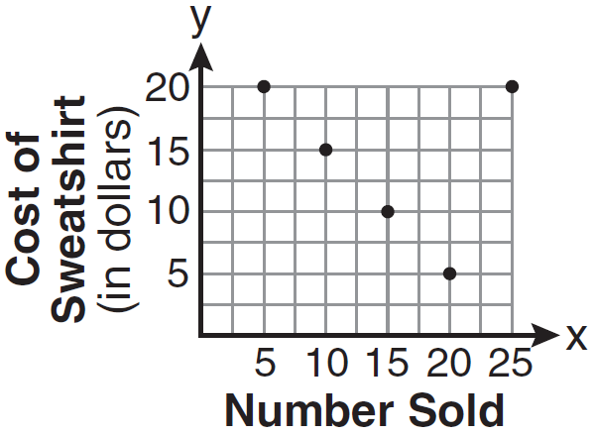

3 The maximum height and speed of various roller coasters in North America are shown in the table below.

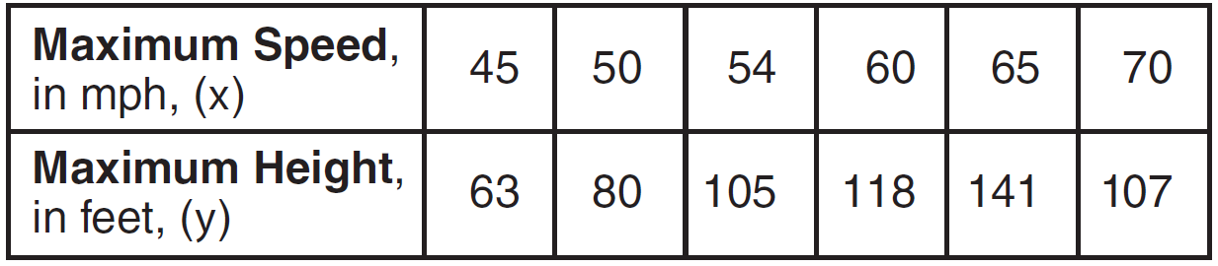

Which graph represents a correct scatter plot of the data?
1) | 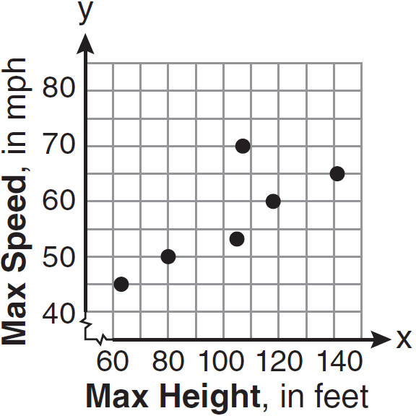
2) | 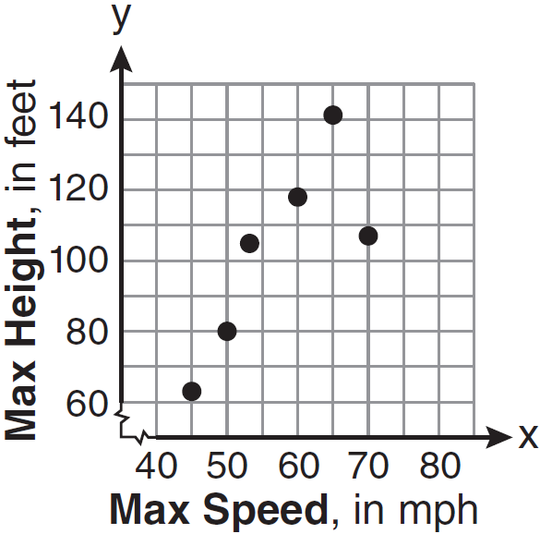
3) | 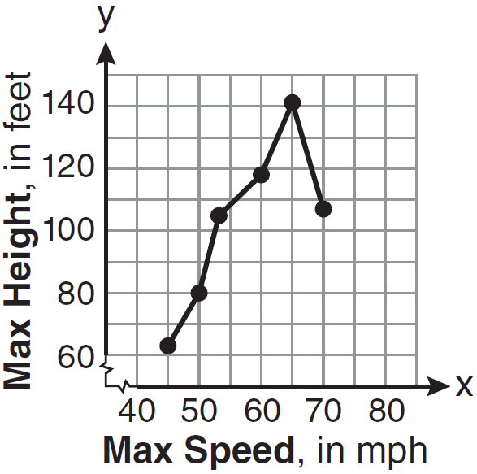
4) | 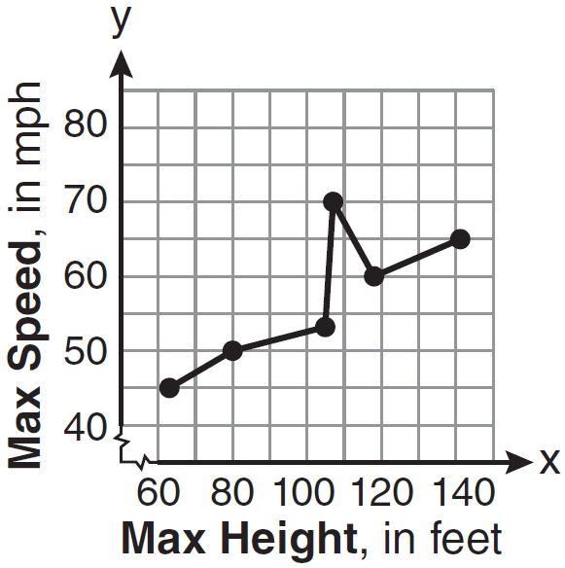

1 ANS: 2 REF: fall0701ia

2 ANS: 3 REF: 081001ia

3 ANS: 2 REF: 061115ia

