1 After performing analyses on a set of data, Jackie examined the scatter plot of the residual values for each analysis. Which scatter plot indicates the best linear fit for the data?
1) | 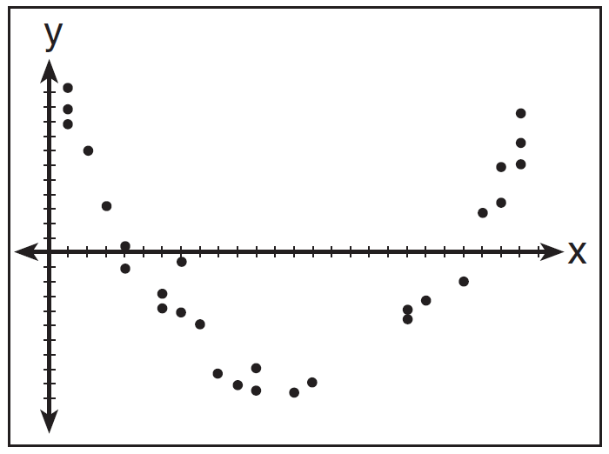
2) | 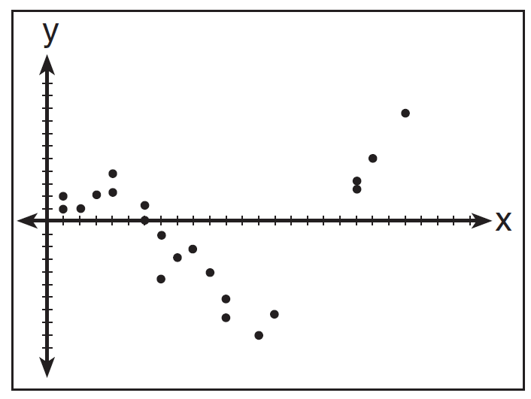
3) | 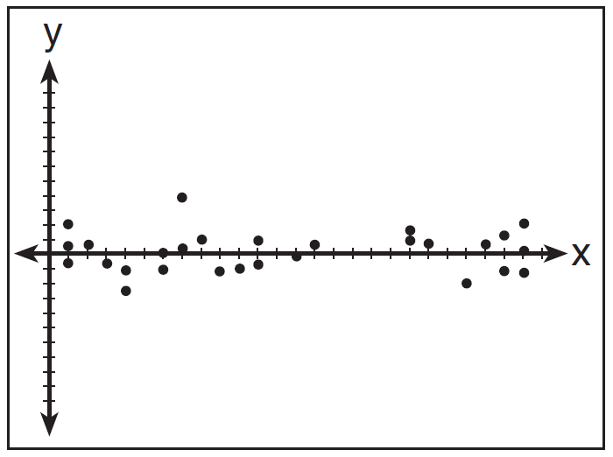
4) | 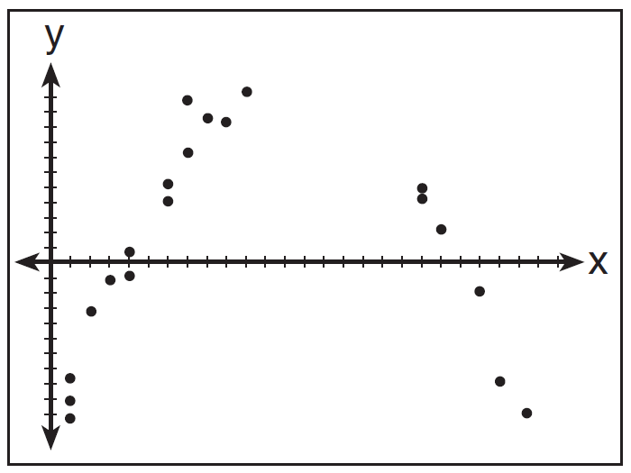

2 Which statistic would indicate that a linear function would not be a good fit to model a data set?
1)
2)
3) | 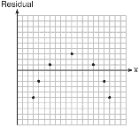
4) | 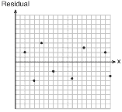

3 Use the data below to write the regression equation () for the raw test score based on the hours tutored. Round all values to the nearest hundredth.

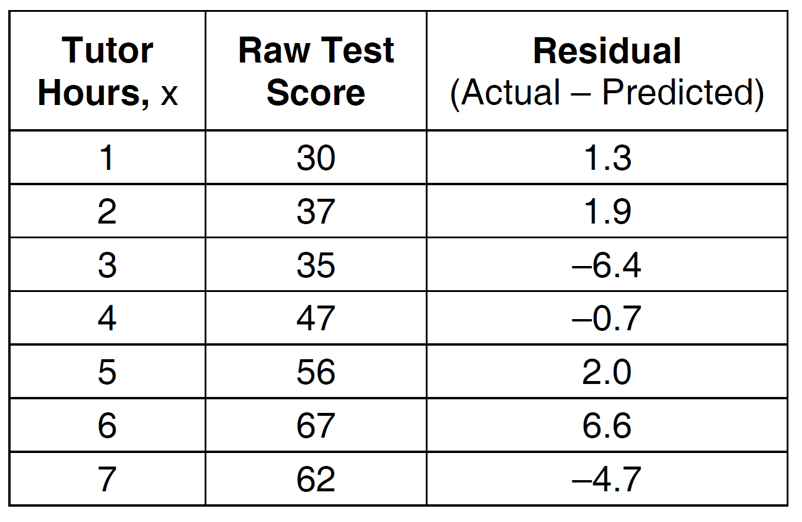

Equation: ___________________________

Create a residual plot on the axes below, using the residual scores in the table above.

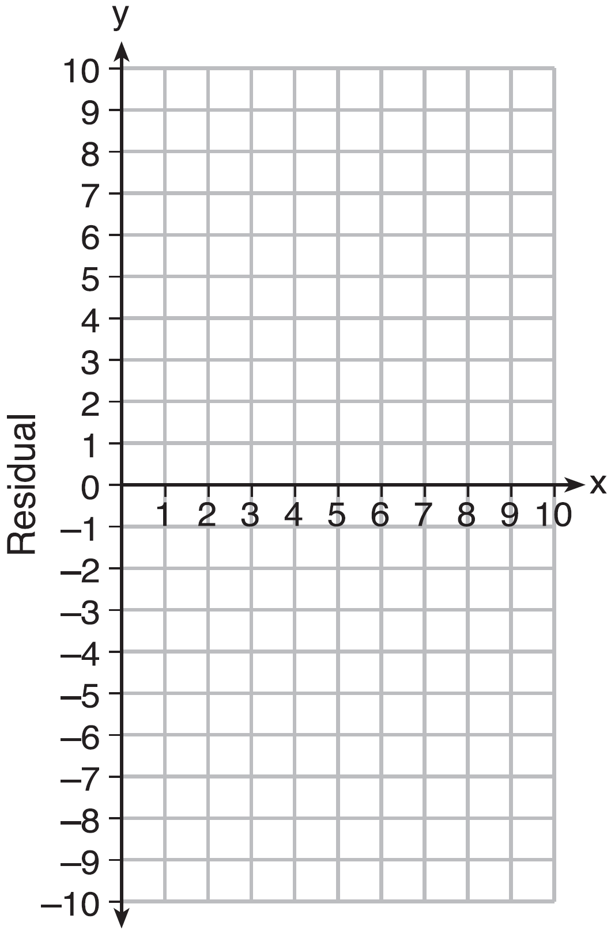

Based on the residual plot, state whether the equation is a good fit for the data. Justify your answer.

4 The table below represents the residuals for a line of best fit.

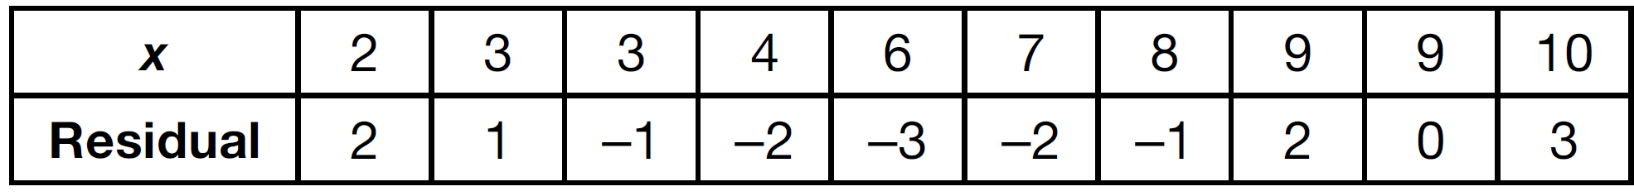

Plot these residuals on the set of axes below.

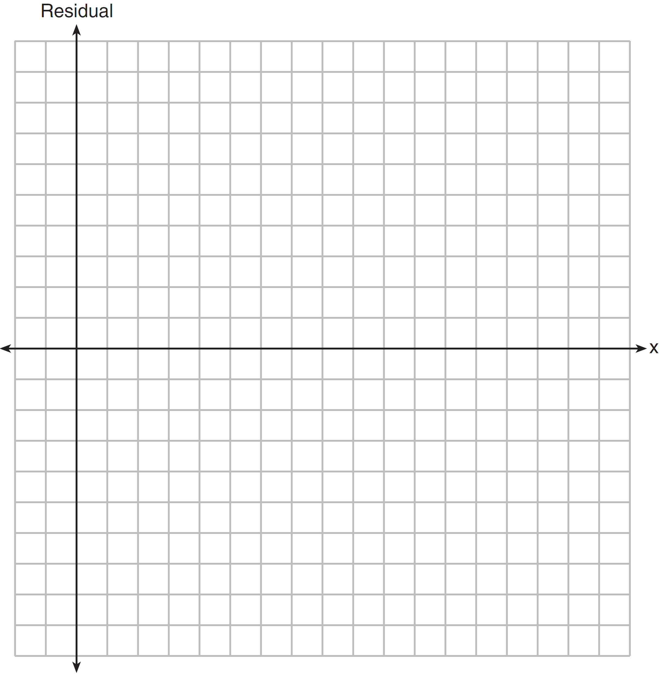

Using the plot, assess the fit of the line for these residuals and justify your answer.

5 The residual plots from two different sets of bivariate data are graphed below.

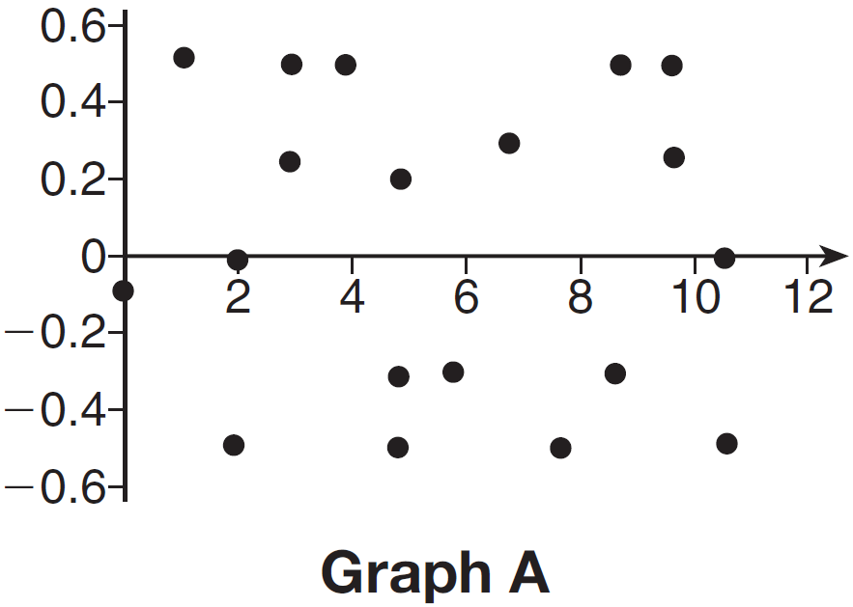

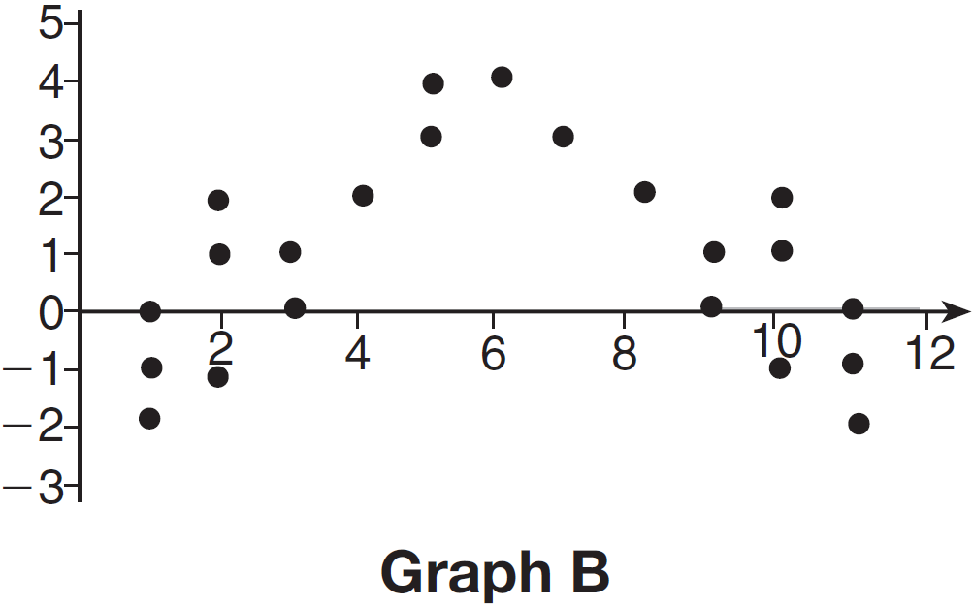

Explain, using evidence from graph A and graph B, which graph indicates that the model for the data is a good fit.

1 ANS: 3
For a residual plot, there should be no observable pattern and a similar distribution of residuals above and below the x-axis.

REF: 011624ai

2 ANS: 3
A correlation coefficient close to –1 or 1 indicates a good fit. For a residual plot, there should be no observable pattern and a similar distribution of residuals above and below the x-axis.

REF: fall1303ai

3 ANS:
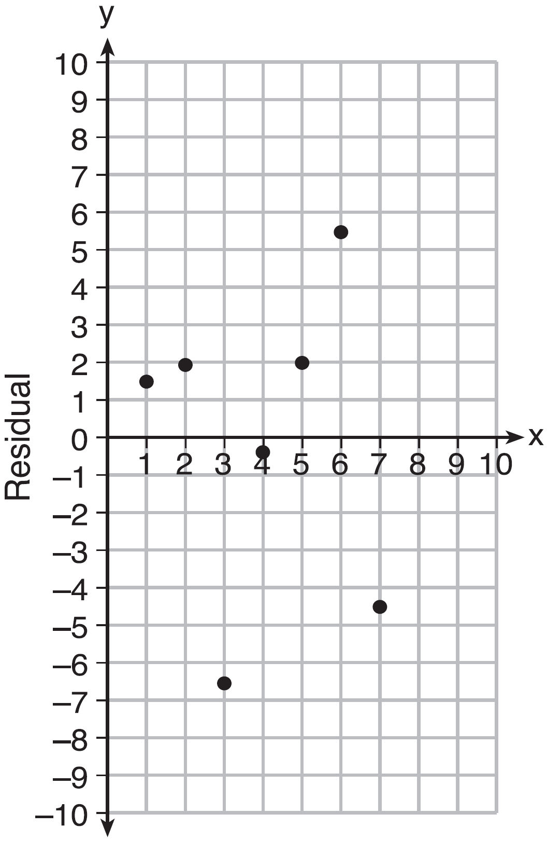Based on the residual plot, the equation is a good fit for the data because the residual values are scattered without a pattern and are fairly evenly distributed above and below the x-axis.

REF: fall1314ai

4 ANS:
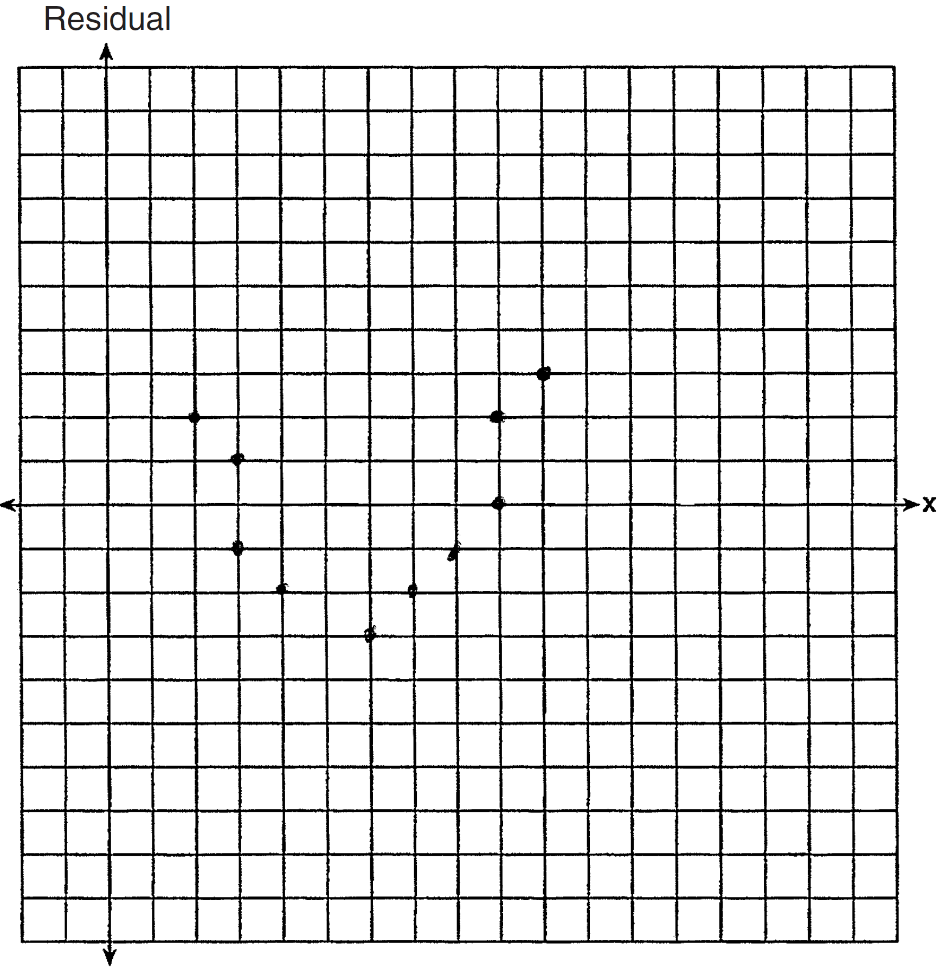 The line is a poor fit because the residuals form a pattern.

REF: 081431ai

5 ANS:
Graph A is a good fit because it does not have a clear pattern, whereas Graph B does.

REF: 061531ai

