1 The accompanying table shows wind speed and the corresponding wind chill factor when the air temperature is 10ºF.

Wind Speed (mi/h)  x | Wind Chill Factor (ºF)  y
4 | 3
5 | 1
12
16
22
31

Write the logarithmic regression equation for this set of data, rounding coefficients to the nearest ten thousandth. Using this equation, find the wind chill factor, to the nearest degree, when the wind speed is 50 miles per hour. Based on your equation, if the wind chill factor is 0, what is the wind speed, to the nearest mile per hour?

2 The table below shows the results of an experiment involving the growth of bacteria.

Time (x) (in minutes) | 1 | 3 | 5 | 7 | 9 | 11
Number of Bacteria (y) | 2 | 25 | 81 | 175 | 310 | 497

Write a power regression equation for this set of data, rounding all values to three decimal places. Using this equation, predict the bacteria’s growth, to the nearest integer, after 15 minutes.

3 The accompanying table shows the number of new cases reported by the Nassau and Suffolk County Police Crime Stoppers program for the years 2000 through 2002.

Year (x) | New Cases (y)
2000 | 457
2001 | 369
2002 | 353

If represents the year 2000, and y represents the number of new cases, find the equation of best fit using a power regression, rounding all values to the nearest thousandth. Using this equation, find the estimated number of new cases, to the nearest whole number, for the year 2007.

4 Water is draining from a tank maintained by the Yorkville Fire Department. Students measured the depth of the water in 15-second intervals and recorded the results in the accompanying table.

Time (x)  (in seconds) | Depth of Water (y)  (in feet)
15 | 11.8
30 | 9.9
45 | 8.2
60 | 6.3
75 | 5.9

Write the power regression equation for this set of data, rounding all values to the nearest ten thousandth. Using this equation, predict the depth of the water at 2 minutes, to the nearest tenth of a foot.

5 Kathy swims laps at the local fitness club. As she times her laps, she finds that each succeeding lap takes a little longer as she gets tired. If the first lap takes her 33 seconds, the second lap takes 38 seconds, the third takes 42 seconds, the fifth takes 50 seconds, and the seventh lap takes 54 seconds, state the power regression equation for this set of data, rounding all coefficients to the nearest hundredth. Using your written regression equation, estimate the number of seconds that it would take Kathy to complete her tenth lap, to the nearest tenth of a second.

6 The volume of a particular gas was determined at various pressures. P is the pressure (in atmospheres) and is the independent variable on the horizontal axis, and V is the volume (in liters) and is the dependent variable on the vertical axis. Create a scatter plot and find the equation of the curve of best fit. (Round answer constants to nearest tenth.) Then, using the regression equation found, estimate V if .

P | P
0.1 | 225
0.3 | 74.999
0.5 | 45
0.7 | 32.139
0.9 | 25
1.1 | 20.45
1.5 | 15
1.7 | 13.24
1.9 | 11.84
2.1 | 10.71
2.3 | 9.78

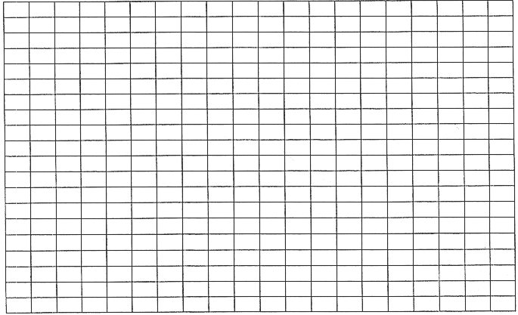
1 ANS:
. . 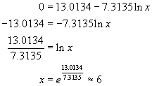

REF: 010933b

2 ANS:
, 1,009.

REF: fall0938a2

3 ANS:
.

REF: 010730b

4 ANS:
, 4.9.

REF: 010831b

5 ANS:
and 58.9.

REF: 080927b

6 ANS:
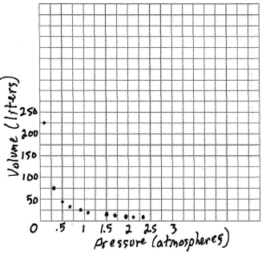 and
REF: fall9934b

