1 Samantha constructs the scatter plot below from a set of data.

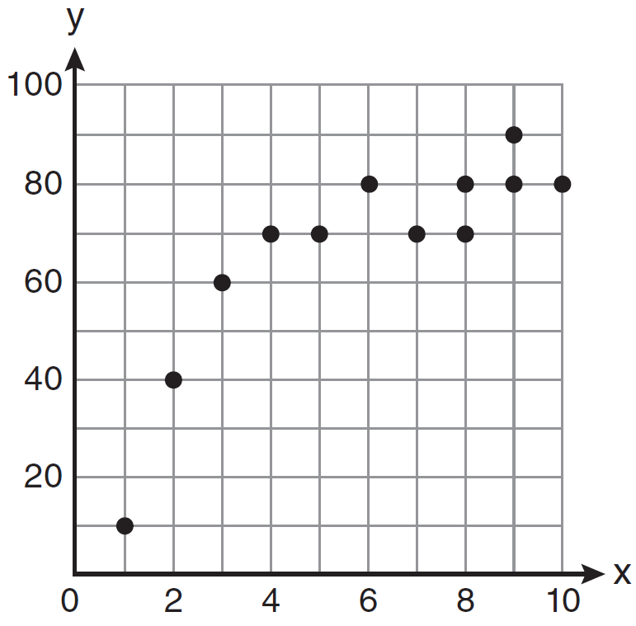

Based on her scatter plot, which regression model would be most appropriate?
1) | exponential | 3) | logarithmic
2) | linear | 4) | power

2 A scatterplot showing the weight, w, in grams, of each crystal after growing t hours is shown below.

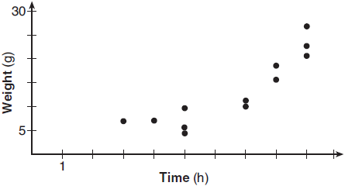

The relationship between weight, w, and time, t, is best modeled by
1) |  | 3)
2) |  | 4)

3 The price of a postage stamp in the years since the end of World War I is shown in the scatterplot below.
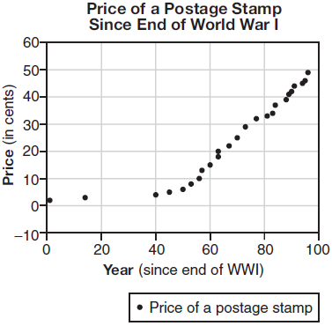

The equation that best models the price, in cents, of a postage stamp based on these data is
1) |  | 3)
2) |  | 4)

4 The cost, in dollars, of a single-ride fare in the New York City subway in the years since 1904 is listed in the table below.

Years since 1904 (x) | 0 | 49 | 72 | 91 | 99 | 111
Fare (y) | $0.05 | $0.15 | $0.50 | $1.50 | $2.00 | $2.75

Which equation best models the cost of a single-ride fare based on these data?
1) |  | 3)
2) |  | 4)

5 About a year ago, Joey watched an online video of a band and noticed that it had been viewed only 843 times. One month later, Joey noticed that the band’s video had 1708 views. Joey made the table below to keep track of the cumulative number of views the video was getting online.

Months Since First Viewing | Total Views
0 | 843
1 | 1708
2 | forgot to record
3 | 7124
4 | 14,684
5 | 29,787
6 | 62,381

a) Write a regression equation that best models these data. Round all values to the nearest hundredth. Justify your choice of regression equation. b) As shown in the table, Joey forgot to record the number of views after the second month. Use the equation from part a to estimate the number of full views of the online video that Joey forgot to record.
1 ANS: 3 REF: 061127a2

2 ANS: 2 REF: 061804aii

3 ANS: 3
The pattern suggests an exponential pattern, not linear or sinusoidal. A 4% growth rate is accurate, while a 43% growth rate is not.

REF: 011713aii

4 ANS: 1 REF: 082406aii

5 ANS:
The data appear to grow at an exponential rate. .

REF: fall1313ai

