1 The population growth of Boomtown is shown in the accompanying graph.

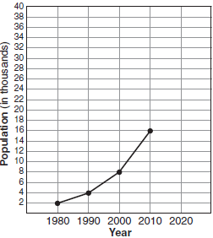

If the same pattern of population growth continues, what will the population of Boomtown be in the year 2020?
1) | 20,000 | 3) | 40,000
2) | 32,000 | 4) | 64,000

2 The population of a small town over four years is recorded in the chart below, where 2013 is represented by . [Population is rounded to the nearest person]

Year | 2013 | 2014 | 2015 | 2016
Population | 3810 | 3943 | 4081 | 4224

The population, , for these years can be modeled by the function where b is rounded to the nearest thousandth. Which statements about this function are true?
I.
II.
III.
IV.
1) | I and III | 3) | II and III
2) | I and IV | 4) | II and IV

3 A colony of bacteria grows exponentially. The table below shows the data collected daily.

Day  (x) | Population  (y)
0 | 200
1 | 425
2 | 570
3 | 800
4 | 1035
5 | 1650
6 | 2600

State the exponential regression equation for the data, rounding all values to the nearest hundredth.

4 The table below shows the concentration of ozone in Earth’s atmosphere at different altitudes. Write the exponential regression equation that models these data, rounding all values to the nearest thousandth.

Concentration of Ozone
Altitude (x) | Ozone Units (y)
0 | 0.7
5 | 0.6
10 | 1.1
15 | 3.0
20 | 4.9

5 A cup of soup is left on a countertop to cool. The table below gives the temperatures, in degrees Fahrenheit, of the soup recorded over a 10-minute period.

Time in Minutes (x) | Temperature in ºF (y)
0 | 180.2
2 | 165.8
4 | 146.3
6 | 135.4
8 | 127.7
10 | 110.5

Write an exponential regression equation for the data, rounding all values to the nearest thousandth.

6 The table below shows the number of new stores in a coffee shop chain that opened during the years 1986 through 1994.

Year | Number of New Stores
1986 | 14
1987 | 27
1988 | 48
1989 | 80
1990 | 110
1991 | 153
1992 | 261
1993 | 403
1994 | 681

Using to represent the year 1986 and y to represent the number of new stores, write the exponential regression equation for these data. Round all values to the nearest thousandth.

7 Bacteria are being grown in a Petri dish in a biology lab. The number of bacteria in the culture after a given number of hours is shown in the table below.

Hour | 1 | 2 | 3 | 4 | 5
Bacteria | 1990 | 2200 | 2430 | 2685 | 2965

Assuming this exponential trend continues, is it reasonable to expect at least 3500 bacteria at hour 7? Justify your answer.

8 The accompanying table shows the number of bacteria present in a certain culture over a 5-hour period, where x is the time, in hours, and y is the number of bacteria.

x | y
0 | 1,000
1 | 1,049
2 | 1,100
3 | 1,157
4 | 1,212
5 | 1,271

Write an exponential regression equation for this set of data, rounding all values to four decimal places. Using this equation, determine the number of whole bacteria present when x equals 6.5 hours.

9 A population of single-celled organisms was grown in a Petri dish over a period of 16 hours. The number of organisms at a given time is recorded in the table below.

Time, hrs  (x) | Number of Organisms  (y)
0 | 25
2 | 36
4 | 52
6 | 68
8 | 85
10 | 104
12 | 142
16 | 260

Determine the exponential regression equation model for these data, rounding all values to the nearest ten-thousandth. Using this equation, predict the number of single-celled organisms, to the nearest whole number, at the end of the 18th hour.

10 The data collected by a biologist showing the growth of a colony of bacteria at the end of each hour are displayed in the table below.

Time, hour, (x) | Population (y)
0 | 250
1 | 330
2 | 580
3 | 800
4 | 1650
5 | 3000

Write an exponential regression equation to model these data. Round all values to the nearest thousandth. Assuming this trend continues, use this equation to estimate, to the nearest ten, the number of bacteria in the colony at the end of 7 hours.

11 The table below shows the amount of a decaying radioactive substance that remained for selected years after 1990.

Years After 1990 (x) | 0 | 2 | 5 | 9 | 14 | 17 | 19
Amount (y) | 750 | 451 | 219 | 84 | 25 | 12 | 8

Write an exponential regression equation for this set of data, rounding all values to the nearest thousandth. Using this equation, determine the amount of the substance that remained in 2002, to the nearest integer.

12 A box containing 1,000 coins is shaken, and the coins are emptied onto a table. Only the coins that land heads up are returned to the box, and then the process is repeated. The accompanying table shows the number of trials and the number of coins returned to the box after each trial.

Trial | 0 | 1 | 3 | 4 | 6
Coins Returned | 1,000 | 610 | 220 | 132 | 45

Write an exponential regression equation, rounding the calculated values to the nearest ten-thousandth. Use the equation to predict how many coins would be returned to the box after the eighth trial.

13 Jean invested $380 in stocks. Over the next 5 years, the value of her investment grew, as shown in the accompanying table.
Years Since  Investment (x) | Value of Stock,  in Dollars (y)
0 | 380
1 | 395
2 | 411
3 | 427
4 | 445
5 | 462

Write the exponential regression equation for this set of data, rounding all values to two decimal places. Using this equation, find the value of her stock, to the nearest dollar, 10 years after her initial purchase.

14 The accompanying table shows the amount of water vapor, y, that will saturate 1 cubic meter of air at different temperatures, x.
Amount of Water Vapor That Will Saturate
1 Cubic Meter of Air at Different Temperatures
Air  Temperature (x) | Water Vapor (y)
-20 | 1
-10 | 2
0 | 5
10 | 9
20 | 17
30 | 29
40 | 50

Write an exponential regression equation for this set of data, rounding all values to the nearest thousandth. Using this equation, predict the amount of water vapor that will saturate 1 cubic meter of air at a temperature of 50°C, and round your answer to the nearest tenth of a gram.

15 An application developer released a new app to be downloaded. The table below gives the number of downloads for the first four weeks after the launch of the app.

Number of Weeks | 1 | 2 | 3 | 4
Number of Downloads | 120 | 180 | 270 | 405

Write an exponential equation that models these data. Use this model to predict how many downloads the developer would expect in the 26th week if this trend continues. Round your answer to the nearest download. Would it be reasonable to use this model to predict the number of downloads past one year? Explain your reasoning.

16 The table below gives the relationship between x and y.

x | 1 | 2 | 3 | 4 | 5
y | 4.2 | 33.5 | 113.1 | 268.1 | 523.6

Use exponential regression to find an equation for y as a function of x, rounding all values to the nearest hundredth. Using this equation, predict the value of x if y is 426.21, rounding to the nearest tenth. [Only an algebraic solution can receive full credit.]

17 The breaking strength, y, in tons, of steel cable with diameter d, in inches, is given in the table below.

d  (in) | 0.50 | 0.75 | 1.00 | 1.25 | 1.50 | 1.75
y  (tons) | 9.85 | 21.80 | 38.30 | 59.20 | 84.40 | 114.00

On the accompanying grid, make a scatter plot of these data. Write the exponential regression equation, expressing the regression coefficients to the nearest tenth.


18 The table below, created in 1996, shows a history of transit fares from 1955 to 1995. On the accompanying grid, construct a scatter plot where the independent variable is years. State the exponential regression equation with the coefficient and base rounded to the nearest thousandth. Using this equation, determine the prediction that should have been made for the year 1998, to the nearest cent.

Year | 55 | 60 | 65 | 70 | 75 | 80 | 85 | 90 | 95
Fare ($) | 0.10 | 0.15 | 0.20 | 0.30 | 0.40 | 0.60 | 0.80 | 1.15 | 1.50

19 The accompanying table shows the average salary of baseball players since 1984. Using the data in the table, create a scatter plot on the grid and state the exponential regression equation with the coefficient and base rounded to the nearest hundredth. Using your written regression equation, estimate the salary of a baseball player in the year 2005, to the nearest thousand dollars.

Baseball Players’ Salaries
Number of Years  Since 1984 | Average Salary  (thousands of dollars)
0 | 290
1 | 320
2 | 400
3 | 495
4 | 600
5 | 700
6 | 820
7 | 1,000
8 | 1,250
9 | 1,580

1 ANS: 2
The population doubles every ten years.

REF: 080705a

2 ANS: 2 REF: 061916ai

3 ANS:

REF: 061630a2

4 ANS:

REF: 061429a2

5 ANS:

REF: 061231a2

6 ANS:

REF: 081031a2

7 ANS:
yes.

REF: 081632a2

8 ANS:
, 1,367.

REF: 080827b

9 ANS:
.

REF: 011238a2

10 ANS:
.

REF: 011337a2

11 ANS:

REF: 011536a2

12 ANS:
, 16.

REF: 080429b

13 ANS:
, 562.

REF: 080631b

14 ANS:
, 112.5.

REF: 060827b

15 ANS:
. No, because the prediction at is already too large.

REF: 061536ai

16 ANS:
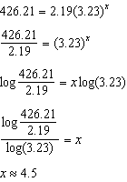

REF: 011637a2

17 ANS:
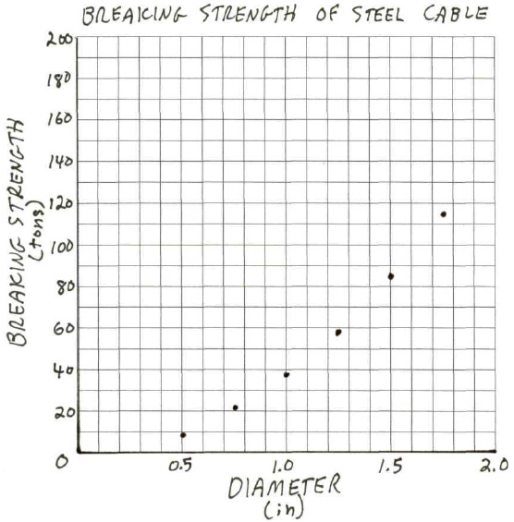

REF: 080232b

18 ANS:
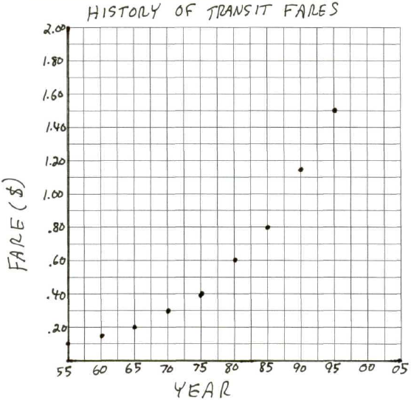 . 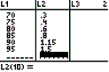 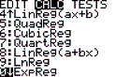 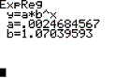 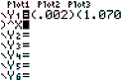 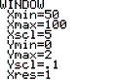 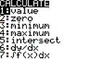 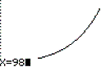 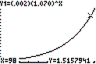

REF: 060234b

19 ANS:
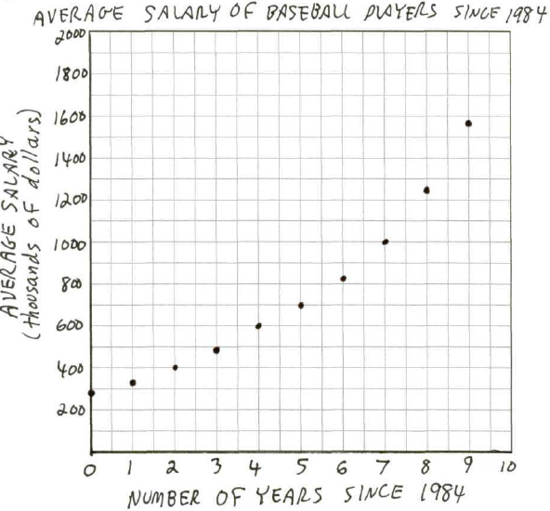, $15,151,000.

REF: 010433b

