1 The test scores for 10 students in Ms. Sampson’s homeroom were 61, 67, 81, 83, 87, 88, 89, 90, 98, and 100. Which frequency table is accurate for this set of data?
1) | 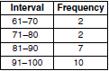
2) | 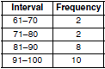
3) | 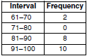
4) | 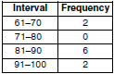

2 The table below shows a cumulative frequency distribution of runners' ages.

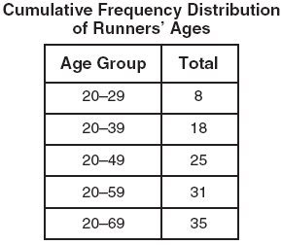

According to the table, how many runners are in their forties?
1) | 25
2) | 10
3) | 7
4) | 6

3 The cumulative frequency table below shows the length of time that 30 students spent text messaging on a weekend.

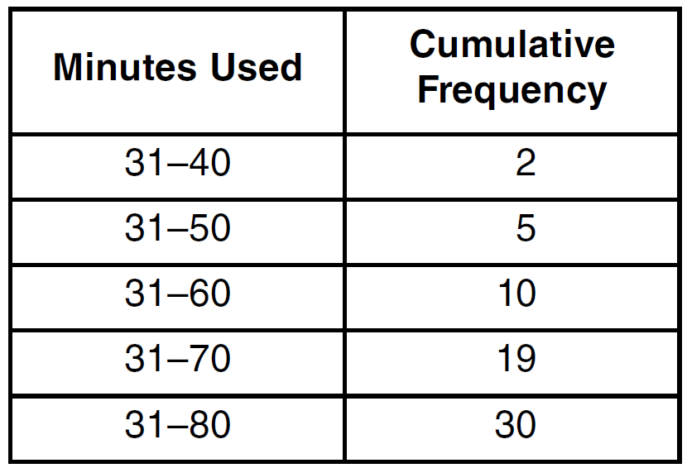

Which 10-minute interval contains the first quartile?
1)
2)
3)
4)

4 The cumulative frequency table below shows the number of minutes 31 students spent text messaging on a weekend.

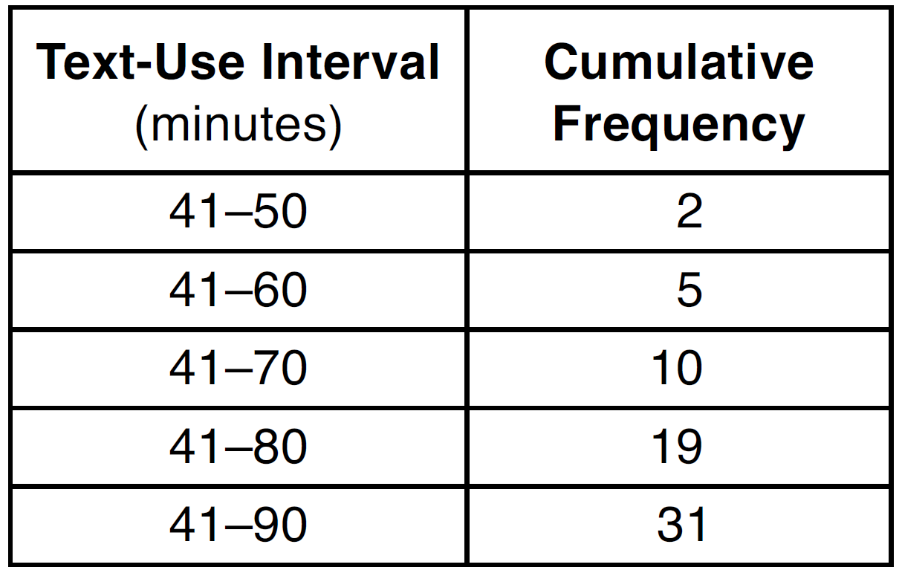

Determine which 10-minute interval contains the median. Justify your choice.

1 ANS: 4 REF: 060401a

2 ANS: 3

REF: 060822ia

3 ANS: 3 REF: 061230ia

4 ANS:
If there are 31 students. the 16th student’s time represents the median. The 16th time is in the 41-80 interval on the cumulative frequency table and the 71-80 interval on the related frequency table.

REF: 011432ia

