1 The scores on a 100 point exam are normally distributed with a mean of 80 and a standard deviation of 6. A student's score places him between the 69th and 70th percentile. Which of the following best represents his score?
1) 66 2) 81 3) 84 4) 86

2 In a standardized test with a normal distribution of scores, the mean is 63 and the standard deviation is 5. Which score can be expected to occur most often?
1) 45 2) 55 3) 65 4) 74

3 In a certain population, the mean score on a test is 420. The standard deviation is 105. If the distribution of scores is normal, which of these scores should occur most often?
1) 540 2) 526 3) 385 4) 314

4 If a set of scores has a normal distribution and the mean is 200, which score has the greatest probability of being chosen at random?
1) 230 2) 228 3) 176 4) 168

5 A set of scores with a normal distribution has a mean of 32 and a standard deviation of 3.7. Which score could be expected to occur the least often?
1) 26 2) 29 3) 36 4) 40

6 The mean score on a normally distributed exam is 42 with a standard deviation of 12.1. Which score would be expected to occur less than 5% of the time?
1) 25 2) 32 3) 60 4) 67

7 If the mean of a test score is 30 and the standard deviation is 3.7, which score could be expected to occur less than 5% of the time?
1) 35 2) 33.8 3) 25 4) 22

8 On a standardized test, the mean is 61 and the standard deviation is 3.2. Which score can be expected to occur less than 3% of the time?
1) 50 2) 56 3) 62 4) 65

9 On a test, the mean score is 25 and the standard deviation is 2.3. Which score could be expected to occur less than 5% of the time?
1) 20 2) 28 3) 23 4) 24

10 Liz has applied to a college that requires students to score in the top 6.7% on the mathematics portion of an aptitude test. The scores on the test are approximately normally distributed with a mean score of 576 and a standard deviation of 104. What is the minimum score Liz must earn to meet this requirement?
1) 680 2) 732 3) 740 4) 784

11 One thousand students took a test resulting in a normal distribution of the scores with a mean of 80 and a standard deviation of 5. Approximately how many students scored between 75 and 85?
1) 950 2) 815 3) 680 4) 475

12 On a standardized test with normal distribution, the mean is 75 and the standard deviation is 6. If 1200 students took the test, approximately how many students would be expected to score between 69 and 81?
1) 408 2) 600 3) 816 4) 1140

13 The amount of ketchup dispensed from a machine at Hamburger Palace is normally distributed with a mean of 0.9 ounce and a standard deviation of 0.1 ounce. If the machine is used 500 times, approximately how many times will it be expected to dispense 1 or more ounces of ketchup?
1) 5 2) 16 3) 80 4) 100

14 The scores of 1000 students on a standardized test were normally distributed with a mean of 50 and a standard deviation of 5. What is the expected number of students who had scores greater than 60?
1) 1.7 2) 23 3) 46 4) 304

15 An amateur bowler calculated his bowling average for the season. If the data are normally distributed, about how many of his 50 games were within one standard deviation of the mean?
1) 14 2) 17 3) 34 4) 48

16 The heights of a group of 1000 women are normally distributed. The mean height of the group is 170 centimeters (cm) with a standard deviation of 10 cm. What is the best approximation of the number of women between 170 cm and 180 cm tall?
1) 950 2) 680 3) 340 4) 170

17 The weights of the boxes of animal crackers coming off an assembly line differ slightly and form a normal distribution whose mean is 9.8 ounces and whose standard deviation is 0.6 ounce. Determine the number of boxes of animal crackers in a shipment of 5,000 boxes that are expected to weigh more than 11 ounces.

18 In a certain school, the heights of the population of girls are normally distributed, with a mean of 63 inches and a standard deviation of 2 inches. If there are 450 girls in the school, determine how many of the girls are shorter than 60 inches. Round the answer to the nearest integer.

19 Professor Bartrich has 184 students in her mathematics class. The scores on the final examination are normally distributed and have a mean of 72.3 and a standard deviation of 8.9. How many students in the class can be expected to receive a score between 82 and 90?

20 On the Algebra 2/Trigonometry midterm at Champion High School, the scores of 210 students were normally distributed with a mean of 82 and a standard deviation of 4.2. Determine how many students scored between 79.9 and 88.3.

21 In a study of 82 video game players, the researchers found that the ages of these players were normally distributed, with a mean age of 17 years and a standard deviation of 3 years. Determine if there were 15 video game players in this study over the age of 20. Justify your answer.

1 ANS: 3
The 69th percentile occurs at about ½ standard deviation above the mean, or 83 in this case. 84 is the closest choice. 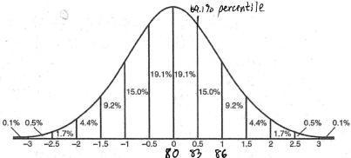

REF: fall9912b

2 ANS: 3 REF: 019018siii

3 ANS: 3 REF: 069431siii

4 ANS: 3 REF: 089520siii

5 ANS: 4 REF: 089724siii

6 ANS: 4
The most extreme score (farthest from the mean) out of the four choices is 67, which is more than 2 standard deviations above the mean, and occurs 2.3% of the time. 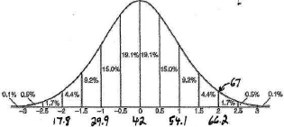

REF: 080515b

7 ANS: 4 REF: 068032siii

8 ANS: 1 REF: 068135siii

9 ANS: 1 REF: 018423siii

10 ANS: 2
Top

REF: 011420a2

11 ANS: 3 REF: 068732siii

12 ANS: 3 REF: 088918siii

13 ANS: 3
1 ounce of ketchup is 1 standard deviation above the mean amount dispensed from the machine. An amount greater than 1 ounce of ketchup will be dispensed 15.9% of the time. . 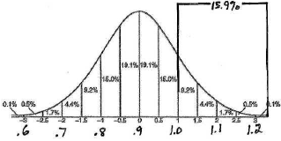

REF: 080317b

14 ANS: 2
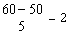 standards above the mean or 2.3%

REF: 011614a2

15 ANS: 3

REF: 081013a2

16 ANS: 3 REF: 019830siii

17 ANS:
115. 11 ounces is 2 standard deviations above the mean. Weights greater than 11 ounces occur 2.3% of the time. 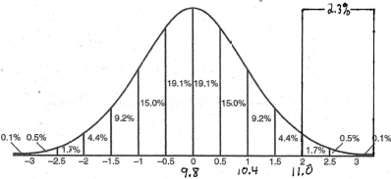. boxes.

REF: 060826b

18 ANS:
Less than 60 inches is below 1.5 standard deviations from the mean.

REF: 061428a2

19 ANS:
25. The given range of test scores, 82-90, is between 1-2 standard deviations above the mean, and represents13.6% of the class. students. 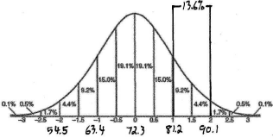

REF: 060126b

20 ANS:

REF: 061634a2

21 ANS:
no. over 20 is more than 1 standard deviation above the mean.

REF: 061129a2

