1 In a New York City high school, a survey revealed the mean amount of cola consumed each week was 12 bottles and the standard deviation was 2.8 bottles. Assuming the survey represents a normal distribution, how many bottles of cola per week will approximately 68.2% of the students drink?
1) | 6.4 to 12 | 3) | 9.2 to 14.8
2) | 6.4 to 17.6 | 4) | 12 to 20.4

2 The amount of juice dispensed from a machine is normally distributed with a mean of 10.50 ounces and a standard deviation of 0.75 ounce. Which interval represents the amount of juice dispensed about 68.2% of the time?
1) | 9.00–12.00 | 3) | 9.75–11.25
2) | 9.75–10.50 | 4) | 10.50–11.25

3 On a standardized test, the mean is 76 and the standard deviation is 4. Between which two scores will approximately 68% of the scores fall?
1) | 68 and 84 | 3) | 74 and 78
2) | 72 and 80 | 4) | 76 and 80

4 In a certain high school, a survey revealed the mean amount of bottled water consumed by students each day was 153 bottles with a standard deviation of 22 bottles. Assuming the survey represented a normal distribution, what is the range of the number of bottled waters that approximately 68.2% of the students drink?
1) |  | 3)
2) |  | 4)

5 A survey of high school girls found that the mean number of text messages sent per day by the girls was 62, with a standard deviation of 12. If a normal distribution is assumed, which interval represents the number of texts sent by 68.2% of the girls?
1) | 38–86 | 3) | 50–74
2) | 44–80 | 4) | 56–68

6 The mean of a normally distributed set of data is 56, and the standard deviation is 5. In which interval do approximately 95.4% of all cases lie?
1) | 46–56 | 3) | 51–61
2) | 46–66 | 4) | 56–71

7 The heights of the girls in the eleventh grade are normally distributed with a mean of 66 inches and a standard deviation of 2.5 inches. In which interval do approximately 95% of the heights fall?
1) | inches | 3) | inches
2) | inches | 4) | inches

8 The mean of a normally distributed set of data is 52 and the standard deviation is 4. Approximately 95% of all the cases will lie between which measures?
1) | 44 and 52 | 3) | 48 and 56
2) | 44 and 60 | 4) | 52 and 64

9 On a standardized test with a normal distribution of scores, the mean score is 82 and the standard deviation is 6. Which interval contains 95% of the scores?
1) |  | 3)
2) |  | 4)

10 A standardized test with a normal distribution of scores has a mean score of 43 and a standard deviation of 6.3. Which range would contain the score of a student in the 90th percentile?
1) |  | 3)
2) |  | 4)

11 On a standardized test with a normal distribution, the mean is 20 and the standard deviation is 2.6. In which interval would the greatest number of scores occur?
1) |  | 3)
2) |  | 4)

12 A set of test scores is normally distributed with a mean of 80 and a standard deviation of 8. Between what two scores should 68 percent of the scores fall?

13 A set of test scores is distributed normally with a mean of 70 and a standard deviation of 6. Between which two scores could 68% of the scores lie?

14 A set of boys’ heights is distributed normally with a mean of 58 inches and a standard deviation of 2 inches. Express, in inches, between which two heights should 95% of the heights fall.

15 A survey of the soda drinking habits of the population in a high school revealed the mean number of cans of soda consumed per person per week to be 20 with a standard deviation of 3.5. If a normal distribution is assumed, find an interval that the total number of cans per week approximately 95% of the population of this school will drink. Explain why you selected that interval.

16 Mrs. Ramírez is a real estate broker. Last month, the sale prices of homes in her area approximated a normal distribution with a mean of $150,000 and a standard deviation of $25,000. A house had a sale price of $175,000. What is the percentile rank of its sale price, to the nearest whole number? Explain what that percentile means. Mrs. Ramírez told a customer that most of the houses sold last month had selling prices between $125,000 and $175,000. Explain why she is correct.
1 ANS: 3
68.2% of the population of a normal distribution will be within 1 standard deviation of the mean, and will drink 9.2-14.8 bottles of cola per week. 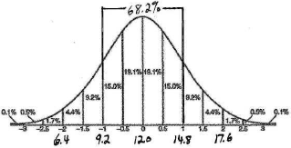

REF: 080202b

2 ANS: 3
68.2% of the population of a normal distribution will be within 1 standard deviation of the mean. Therefore the relevant range is 9.75-11.25. 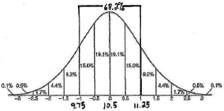

REF: 060412b

3 ANS: 2 REF: 068426siii

4 ANS: 2
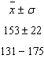

REF: 011307a2

5 ANS: 3
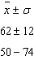

REF: 011706a2

6 ANS: 2
95.4% of the population of a normal distribution will be within 2 standard deviations of the mean. Therefore the relevant range is 46-66. 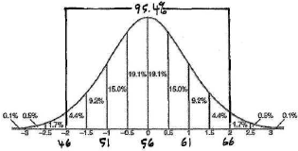

REF: 080405b

7 ANS: 2 REF: 010426siii

8 ANS: 2 REF: 089035siii

9 ANS: 2 REF: 089831siii

10 ANS: 4 REF: 019930siii

11 ANS: 2 REF: 088721siii

12 ANS:
72-88

REF: 088610siii

13 ANS:
64-76

REF: 089402siii

14 ANS:

REF: 089606siii

15 ANS:
95% of the population of a normal distribution will be within 2 standard deviations of the mean. Therefore the relevant range is 13-27. 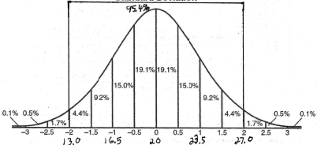

REF: fall9924b

16 ANS:
84. A sales price of $175,000 is 1 standard deviation greater than the mean, and has a 84th percentile rank. This means that 84% of the homes in Ms. Ramírez’ area sold for $175,000 or less and that 16% sold for more than $175,000. Selling prices between $125,000 and $175,000 represent a range within 1 standard of the mean of $150,000, or 68.2% of the selling prices. Since 68.2% > 50%, Ms. Ramírez is correct. 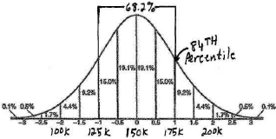

REF: 060432b

