1 The scores on a test have a normal distribution. The mean of the scores is 40 and the standard deviation is 6. The probability that a score chosen at random lies between 34 and 46 is closest to
1) | .34 | 3) | .95
2) | .68 | 4) | .99

2 The average score for a Latin test is 77 and the standard deviation is 8. Which percent best represents the probability that any one student scored between 61 and 93 on the test?
1) | 95% | 3) | 68%
2) | 99.5% | 4) | 34%

3 If the amount of time students work in any given week is normally distributed with a mean of 10 hours per week and a standard deviation of 2 hours, what is the probability a student works between 8 and 11 hours per week?
1) | 34.1% | 3) | 53.2%
2) | 38.2% | 4) | 68.2%

4 A set of normally distributed student test scores has a mean of 80 and a standard deviation of 4. Determine the probability that a randomly selected score will be between 74 and 82.

5 The amount of time that a teenager plays video games in any given week is normally distributed. If a teenager plays video games an average of 15 hours per week, with a standard deviation of 3 hours, what is the probability of a teenager playing video games between 15 and 18 hours a week?

6 A shoe manufacturer collected data regarding men’s shoe sizes and found that the distribution of sizes exactly fits the normal curve. If the mean shoe size is 11 and the standard deviation is 1.5, find:
a the probability that a man’s shoe size is greater than or equal to 11
b the probability that a man’s shoe size is greater than or equal to 12.5
c 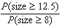
1 ANS: 2 REF: 068527siii

2 ANS: 1 REF: 010131siii

3 ANS: 3

REF: 011212a2

4 ANS:
.624. 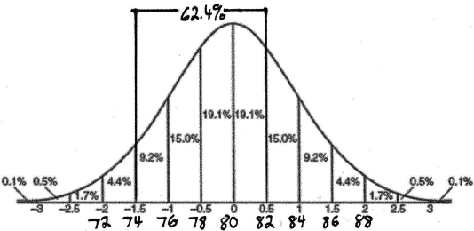

REF: 010226b

5 ANS:
0.341. 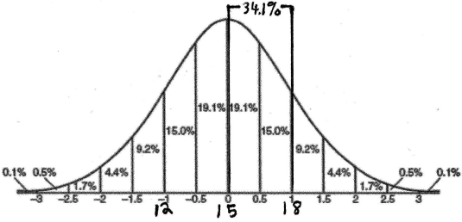

REF: 080222b

6 ANS:
0.5, 0.159, 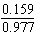. 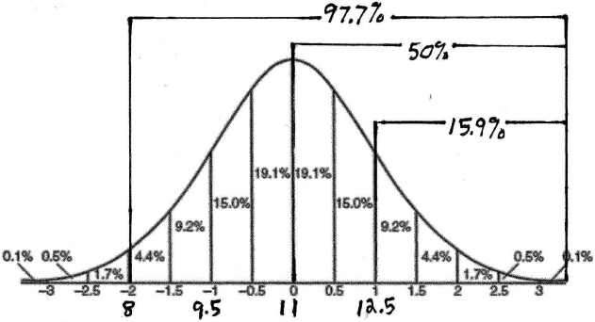

REF: 010327b

