1 In a standard distribution, what is the greatest percent of the data that falls within 2 standard deviations of the mean?
1) | 95 | 3) | 68
2) | 81.5 | 4) | 34

2 The national mean for verbal scores on an exam was 428 and the standard deviation was 113. Approximately what percent of those taking this test had verbal scores between 315 and 541?
1) | 68.2% | 3) | 38.2%
2) | 52.8% | 4) | 26.4%

3 On a standardized test with a normal distribution, the mean was 64.3 and the standard deviation was 5.4. What is the best approximation of the percent of scores that fell between 61.6 and 75.1?
1) | 38.2% | 3) | 68.2%
2) | 66.8% | 4) | 95%

4 A set of scores with a normal distribution has a mean of 50 and a standard deviation of 7. Approximately what percent of the scores fall in the range 36-64?
1) |  | 3)
2) |  | 4)

5 The scores of an exam have a normal distribution. The mean of the scores is 48 and the standard deviation is 5. Approximately what percent of the students taking the exam can be expected to score between 43 and 53?
1) | 95% | 3) | 34%
2) |  | 4) | 13%

6 On a standardized test, the mean is 48 and the standard deviation is 4. Approximately what percent of the scores will fall in the range from 36-60?
1) | 34% | 3) | 95%
2) | 68% | 4) | 98%

7 The scores on an examination have a normal distribution. The mean of the scores is 50, and the standard deviation is 4. What is the best approximation of the percentage of students who can be expected to score between 46 and 54?
1) | 95% | 3) | 50%
2) | 68% | 4) | 34%

8 On a standardized test, the mean is 68 and the standard deviation is 4.5. What is the best approximation of the percent of scores that will fall in the range ?
1) | 34% | 3) | 95%
2) | 68% | 4) | 99%

9 If the mean on a standardized test with a normal distribution is 54.3 and the standard deviation is 4.6, what is the best approximation of the percent of the scores that fall between 54.3 and 63.5?
1) | 34 | 3) | 68
2) | 47.5 | 4) | 95

10 On a standardized test with a normal distribution, the mean is 88. If the standard deviation is 4, the percentage of grades that would be expected to lie between 80 and 96 is closest to
1) | 5 | 3) | 68
2) | 34 | 4) | 95

11 On a standardized test, the mean is 83 and the standard deviation is 3.5. What is the best approximation of the percentage of scores that fall in the range ?
1) | 34 | 3) | 95
2) | 68 | 4) | 99

12 The students’ scores on a standardized test with a normal distribution have a mean of 500 and a standard deviation of 40. What percent of the students scored between 420 and 580?
1) | 47.5% | 3) | 95%
2) | 68% | 4) | 99.5%

13 On a mathematics quiz with a normal distribution, the mean is 8. If the standard deviation is 0.5, what is the best approximation of the percentage of grades that lie between 7 and 9?
1) | 5% | 3) | 68%
2) | 34% | 4) | 95%

14 Battery lifetime is normally distributed for large samples. The mean lifetime is 500 days and the standard deviation is 61 days. Approximately what percent of batteries have lifetimes longer than 561 days?
1) | 16% | 3) | 68%
2) | 34% | 4) | 84%

15 The scores on a test approximate a normal distribution with a mean score of 72 and a standard deviation of 9. Approximately what percent of the students taking the test received a score greater than 90?
1) | 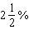 | 3)
2) |  | 4)

16 A test was given to 120 students, and the scores approximated a normal distribution. If the mean score was 72 with a standard deviation of 7, approximately what percent of the scores were 65 or higher?
1) | 50% | 3) | 76%
2) | 68% | 4) | 84%

17 Assume that the ages of first-year college students are normally distributed with a mean of 19 years and standard deviation of 1 year. To the nearest integer, find the percentage of first-year college students who are between the ages of 18 years and 20 years, inclusive. To the nearest integer, find the percentage of first-year college students who are 20 years old or older.

18 The heights of a sample of female students at Oriskany High School are normally distributed with a mean height of 65 inches and a standard deviation of 0.6 inch. What percent of this sample is between 63.8 inches and 66.2 inches? Above what height, in inches, would the top 2.3% of this sample population be found?

19 Twenty high school students took an examination and received the following scores:
70, 60, 75, 68, 85, 86, 78, 72, 82, 88,
88, 73, 74, 79, 86, 82, 90, 92, 93, 73
Determine what percent of the students scored within one standard deviation of the mean. Do the results of the examination approximate a normal distribution? Justify your answer.

20 On a standardized test, the distribution of scores is normal, the mean of the scores is 75, and the standard deviation is 5.8. If a student scored 83, the student’s score ranks
1) | below the 75th percentile
2) | between the 75th percentile and the 84th percentile
3) | between the 84th percentile and the 97th percentile
4) | above the 97th percentile

21 The scores on a standardized exam have a mean of 82 and a standard deviation of 3.6. Assuming a normal distribution, a student's score of 91 would rank
1) | below the 75th percentile | 3) | between the 85th and 95th percentiles
2) | between the 75th and 85th percentiles | 4) | above the 95th percentile

22 The lengths of 100 pipes have a normal distribution with a mean of 102.4 inches and a standard deviation of 0.2 inch. If one of the pipes measures exactly 102.1 inches, its length lies
1) | below the 16th percentile | 3) | between the 50th and 84th percentiles
2) | between the 16th and 50th percentiles | 4) | above the 84th percentile

1 ANS: 1 REF: 010030siii

2 ANS: 1
It is not stated whether the data in this problem is normally distributed. But when dealing with the test results of a large population, the data usually represents a normal distribution. The range of 315-541 represents verbal scores within 1 standard deviation of the mean, or 68.2% of the population. 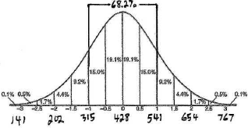

REF: 010308b

3 ANS: 2
61.6 is 2.7 below 64.3. 2.7 is half a standard deviation. 75.1 is 10.8 above the mean. 10.8 is 2 standard deviations. . 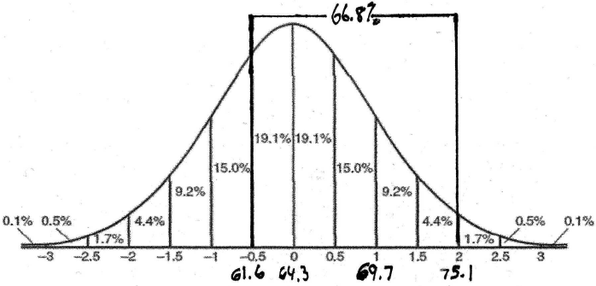

REF: 010809b

4 ANS: 3 REF: 088532siii

5 ANS: 2 REF: 018618siii

6 ANS: 4 REF: 019527siii

7 ANS: 2 REF: 019618siii

8 ANS: 3 REF: 069631siii

9 ANS: 2 REF: 069831siii

10 ANS: 4 REF: 060125siii

11 ANS: 3 REF: 080124siii

12 ANS: 3 REF: 080219siii

13 ANS: 4 REF: 060323siii

14 ANS: 1
A battery lifetime of 561 days is 1 standard deviation above the mean lifetime. Batteries will last longer than 561 days 15.9% of the time. 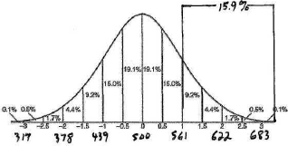

REF: 010411b

15 ANS: 1 REF: 060034siii

16 ANS: 4 REF: 080331siii

17 ANS:
68% of the students are within one standard deviation of the mean. 16% of the students are more than one standard deviation above the mean.

REF: 011134a2

18 ANS:
95.4 and 66.2. The range of 63.8-66.2 represents heights within 2 standard deviations of the mean, or 95.4% of the population. The top 2.3% of the sample population occurs at more than 2 standard deviations above the mean, or 66.2. 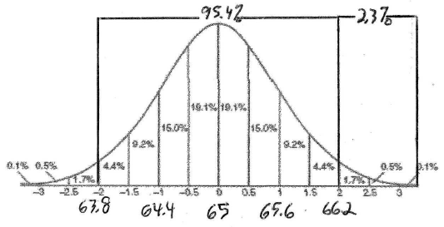

REF: 080929b

19 ANS:
70%. An argument can be made either way whether these exam scores approximate a normal distribution. In a normal distribution, 68.2% of the exam scores fall within 1 standard deviation of the mean. Since 70% > 68.2%, one might argue against a normal distribution. Since the numbers are so close, another might argue the data “approximates” a normal distribution. . The relevant range is . 14/20 scores fall within this range, or 70%. 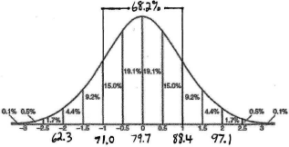

REF: 080129b

20 ANS: 3
If the student scored an 83, this score would be about 1½ standard deviations above the mean, or at about the 93rd percentile. 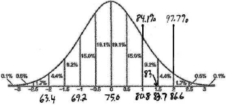

REF: 060206b

21 ANS: 4
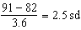

REF: 081521a2

22 ANS: 1
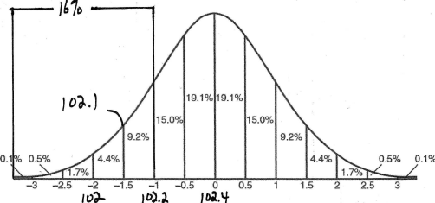

REF: fall0915a2

