1 Suppose two sets of test scores have the same mean, but different standard deviations, and , with . Which statement best describes the variability of these data sets?
1) | Data set one has the greater variability. | 3) | The variability will be the same for each data set.
2) | Data set two has the greater variability. | 4) | No conclusion can be made regarding the variability of either set.

2 The heights of women in the United States are normally distributed with a mean of 64 inches and a standard deviation of 2.75 inches. The percent of women whose heights are between 64 and 69.5 inches, to the nearest whole percent, is
1) | 6 | 3) | 68
2) | 48 | 4) | 95

3 The scores on a collegiate mathematics readiness assessment are approximately normally distributed with a mean of 680 and a standard deviation of 120. Determine the percentage of scores between 690 and 900, to the nearest percent.

4 The heights of the members of a ski club are normally distributed. The average height is 64.7 inches with a standard deviation of 4.3 inches. Determine the percentage of club members, to the nearest percent, who are between 67 inches and 72 inches tall.

5 A population is normally distributed with a mean of 23 and a standard deviation of 1.2. The percentage of the population that falls below 21, to the nearest hundredth, is
1) | 0.05 | 3) | 8.29
2) | 4.78 | 4) | 91.30

6 The distribution of the diameters of ball bearings made under a given manufacturing process is normally distributed with a mean of 4 cm and a standard deviation of 0.2 cm. What proportion of the ball bearings will have a diameter less than 3.7 cm?
1) | 0.0668 | 3) | 0.8664
2) | 0.4332 | 4) | 0.9500

7 The mean intelligence quotient (IQ) score is 100, with a standard deviation of 15, and the scores are normally distributed. Given this information, the approximate percentage of the population with an IQ greater than 130 is closest to
1) | 2% | 3) | 48%
2) | 31% | 4) | 95%

8 The heights of the students at Central High School can be modeled by a normal distribution with a mean of 68.1 and a standard deviation of 3.4 inches. According to this model, approximately what percent of the students would have a height less than 60 inches or greater than 75 inches?
1) | 0.86% | 3) | 2.12%
2) | 1.26% | 4) | 2.98%

9 The weight of a bag of pears at the local market averages 8 pounds with a standard deviation of 0.5 pound. The weights of all the bags of pears at the market closely follow a normal distribution. Determine what percentage of bags, to the nearest integer, weighed less than 8.25 pounds.

10 The monthly unemployment rate of towns in the United States is approximately normally distributed with a mean rate of 5.2% and a standard deviation of 1.6%. Determine the percentage of towns, to the nearest integer, that have a monthly unemployment rate greater than 6%.

11 The lifespan of a 60-watt lightbulb produced by a company is normally distributed with a mean of 1450 hours and a standard deviation of 8.5 hours. If a 60-watt lightbulb produced by this company is selected at random, what is the probability that its lifespan will be between 1440 and 1465 hours?
1) | 0.3803 | 3) | 0.8415
2) | 0.4612 | 4) | 0.9612

12 The weights of bags of Graseck's Chocolate Candies are normally distributed with a mean of 4.3 ounces and a standard deviation of 0.05 ounces. What is the probability that a bag of these chocolate candies weighs less than 4.27 ounces?
1) | 0.2257 | 3) | 0.7257
2) | 0.2743 | 4) | 0.7757

13 Two versions of a standardized test are given, an April version and a May version. The statistics for the April version show a mean score of 480 and a standard deviation of 24. The statistics for the May version show a mean score of 510 and a standard deviation of 20. Assume the scores are normally distributed. Joanne took the April version and scored in the interval 510-540. What is the probability, to the nearest ten thousandth, that a test paper selected at random from the April version scored in the same interval? Maria took the May version. In what interval must Maria score to claim she scored as well as Joanne?

14 In 2013, approximately 1.6 million students took the Critical Reading portion of the SAT exam. The mean score, the modal score, and the standard deviation were calculated to be 496, 430, and 115, respectively. Which interval reflects 95% of the Critical Reading scores?
1) |  | 3)
2) |  | 4)

15 The heights of the 3300 students at Oceanview High School are approximately normally distributed with a mean of 65.5 inches and a standard deviation of 2.9 inches. The number of students at Oceanview who are between 64 and 68 inches tall is closest to
1) | 1660 | 3) | 2244
2) | 1070 | 4) | 1640

16 There are 440 students at Thomas Paine High School enrolled in U.S. History. On the April report card, the students' grades are approximately normally distributed with a mean of 79 and a standard deviation of 7. Students who earn a grade less than or equal to 64.9 must attend summer school. The number of students who must attend summer school for U.S. History is closest to
1) | 3 | 3) | 10
2) | 5 | 4) | 22

17 A family owned grocery store in New Hartford, NY employs 49 people whose ages are approximately normally distributed with a mean of 36 years and a standard deviation of 6.2 years. Ryan has been hired to work at this store. He is 30 years old. How many people who work at this store would you expect to be younger than Ryan?
1) | 17 | 3) | 41
2) | 7 | 4) | 8

18 The scores on a mathematics college-entry exam are normally distributed with a mean of 68 and standard deviation 7.2. Students scoring higher than one standard deviation above the mean will not be enrolled in the mathematics tutoring program. How many of the 750 incoming students can be expected to be enrolled in the tutoring program?
1) | 631 | 3) | 238
2) | 512 | 4) | 119

19 There are 400 students in the senior class at Oak Creek High School. All of these students took the SAT. The distribution of their SAT scores is approximately normal. The number of students who scored within 2 standard deviations of the mean is approximately
1) | 75 | 3) | 300
2) | 95 | 4) | 380

20 The scores of a recent test taken by 1200 students had an approximately normal distribution with a mean of 225 and a standard deviation of 18. Determine the number of students who scored between 200 and 245.

21 According to a study done at a hospital, the average weight of a newborn baby is 3.39 kg, with a standard deviation of 0.55 kg. The weights of all the newborns in this hospital closely follow a normal distribution. Last year, 9256 babies were born at this hospital. Determine, to the nearest integer, approximately how many babies weighed more than 4 kg.
1 ANS: 2 REF: 011901aii

2 ANS: 2
 represents approximately 48% of the data.

REF: 061609aii

3 ANS:
 43

REF: 012328aii

4 ANS:
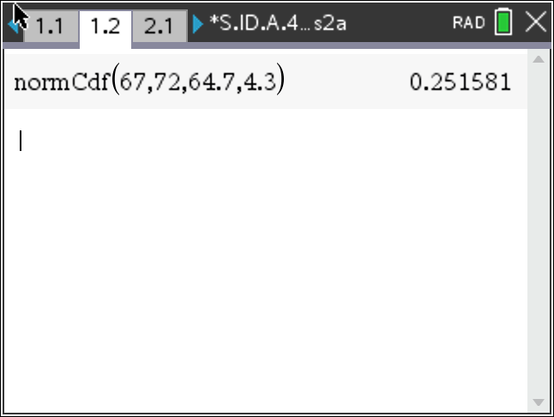 25

REF: 012429aii

5 ANS: 2 REF: 082313aii

6 ANS: 1


REF: 081711aii

7 ANS: 1


REF: 081919aii

8 ANS: 4
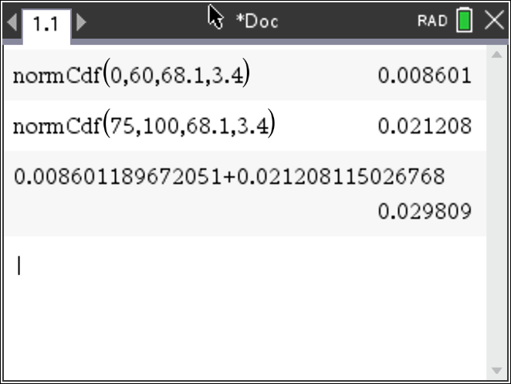

REF: 062316aii

9 ANS:
 69

REF: 061726aii

10 ANS:


REF: 082428aii

11 ANS: 3
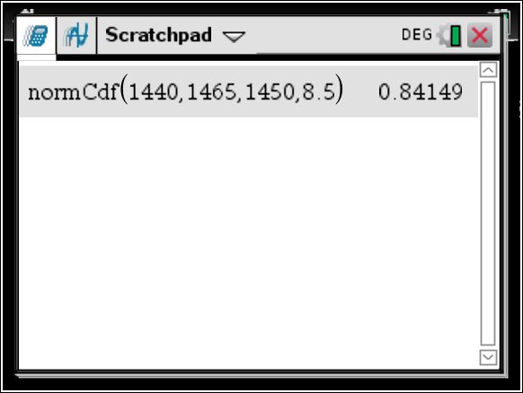

REF: 081604aii

12 ANS: 2


REF: 061817aii

13 ANS:
normcdf(510, 540, 480, 24) = 0.0994 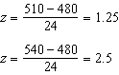 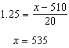 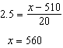 535-560

REF: fall1516aii

14 ANS: 4

REF: 011718aii

15 ANS: 1 REF: 062214aii

16 ANS: 3

REF: 011807aii

17 ANS: 4

REF: 062418aii

18 ANS: 1

REF: 011923aii

19 ANS: 4

REF: 061918aii

20 ANS:

REF: 081828aii

21 ANS:

REF: 082230aii

