1 The table below shows the annual salaries for the 24 members of a professional sports team in terms of millions of dollars.

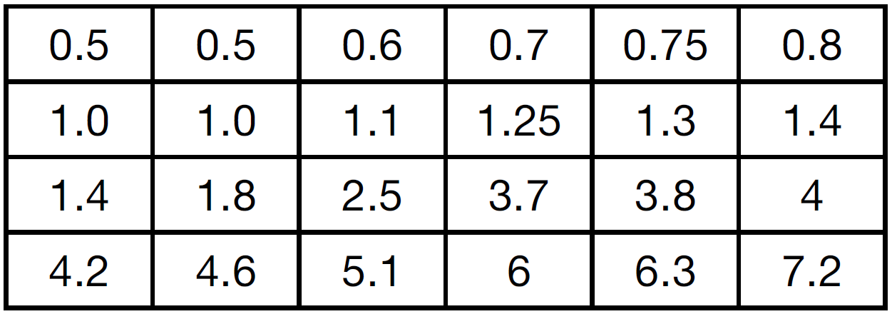

The team signs an additional player to a contract worth 10 million dollars per year. Which statement about the median and mean is true?
1) | Both will increase. | 3) | Only the mean will increase.
2) | Only the median will increase. | 4) | Neither will change.

2 The heights, in inches, of 12 students are listed below.
61,67,72,62,65,59,60,79,60,61,64,63
Which statement best describes the spread of these data?
1) | The set of data is evenly spread. | 3) | The set of data is skewed because 59 is the only value below 60.
2) | The median of the data is 59.5. | 4) | 79 is an outlier, which would affect the standard deviation of these data.

3 The 15 members of the French Club sold candy bars to help fund their trip to Quebec. The table below shows the number of candy bars each member sold.

Number of Candy Bars Sold
0 | 35 | 38 | 41 | 43
45 | 50 | 53 | 53 | 55
68 | 68 | 68 | 72 | 120

When referring to the data, which statement is false?
1) | The mode is the best measure of central tendency for the data. | 3) | The median is 53.
2) | The data have two outliers. | 4) | The range is 120.

1 ANS: 3
Median remains at 1.4.

REF: 061520ai

2 ANS: 4
(1) The box plot indicates the data is not evenly spread. (2) The median is 62.5. (3) The data is skewed because the mean does not equal the median. (4) an outlier is greater than .
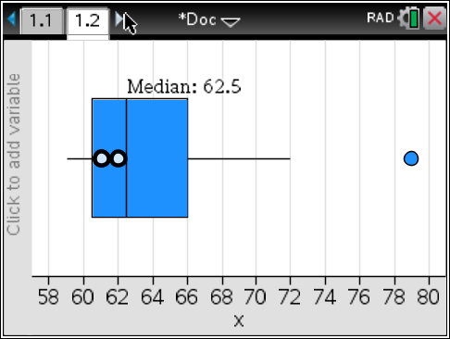

REF: 061715ai

3 ANS: 1
(1) the mode is a bit high (2) , , 1.5 times the IQR of 27 is 40.5, , , so the data have two outliers.

REF: 011816ai

