` 1 Rosario and Enrique are in the same mathematics class. On the first five tests, Rosario received scores of 78, 77, 64, 86, and 70. Enrique received scores of 90, 61, 79, 73, and 87. How much higher was Enrique’s average than Rosario’s average?
1) | 15 points | 3) | 3 points
2) | 2 points | 4) | 4 points

2 Corinne is planning a beach vacation in July and is analyzing the daily high temperatures for her potential destination. She would like to choose a destination with a high median temperature and a small interquartile range. She constructed box plots shown in the diagram below.

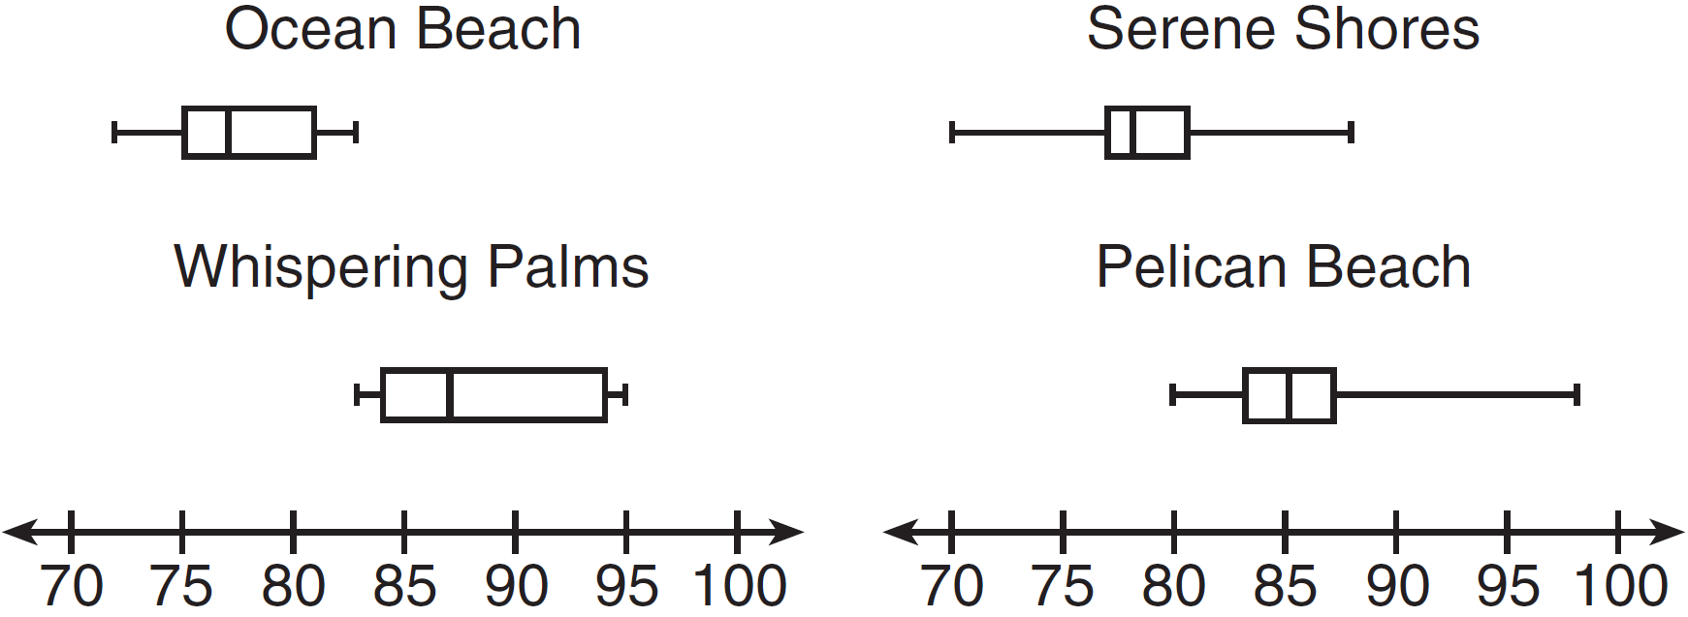

Which destination has a median temperature above 80 degrees and the smallest interquartile range?
1) | Ocean Beach | 3) | Serene Shores
2) | Whispering Palms | 4) | Pelican Beach

3 The accompanying box-and-whisker plots can be used to compare the annual incomes of three professions.

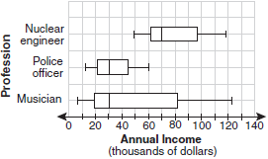

Based on the box-and-whisker plots, which statement is true?
1) | The median income for nuclear engineers is greater than the income of all musicians. | 3) | All nuclear engineers earn more than all police officers.
2) | The median income for police officers and musicians is the same. | 4) | A musician will eventually earn more than a police officer.

4 Noah conducted a survey on sports participation. He created the following two dot plots to represent the number of students participating, by age, in soccer and basketball.
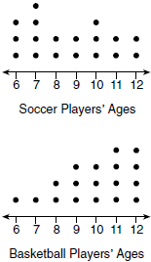
Which statement about the given data sets is correct?
1) | The data for soccer players are skewed right. | 3) | The data for basketball players have the same median as the data for soccer players.
2) | The data for soccer players have less spread than the data for basketball players. | 4) | The data for basketball players have a greater mean than the data for soccer players.

5 Donna and Andrew compared their math final exam scores from grade 8 through grade 12. Their scores are shown below.
Donna
8th | 90
9th | 92
10th | 87
11th | 94
12th | 95

Andrew
8th | 78
9th | 96
10th | 87
11th | 94
12th | 93

Which statement about their final exam scores is correct?
1) | Andrew has a higher mean than Donna. | 3) | Andrew has a larger interquartile range than Donna.
2) | Donna and Andrew have the same median. | 4) | The 3rd quartile for Donna is greater than the 3rd quartile for Andrew.

6 Isaiah collects data from two different companies, each with four employees. The results of the study, based on each worker’s age and salary, are listed in the tables below.

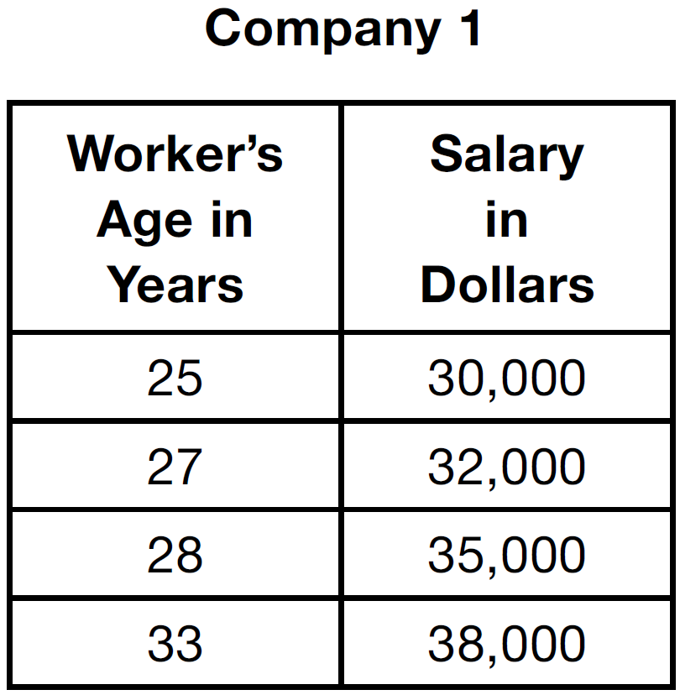

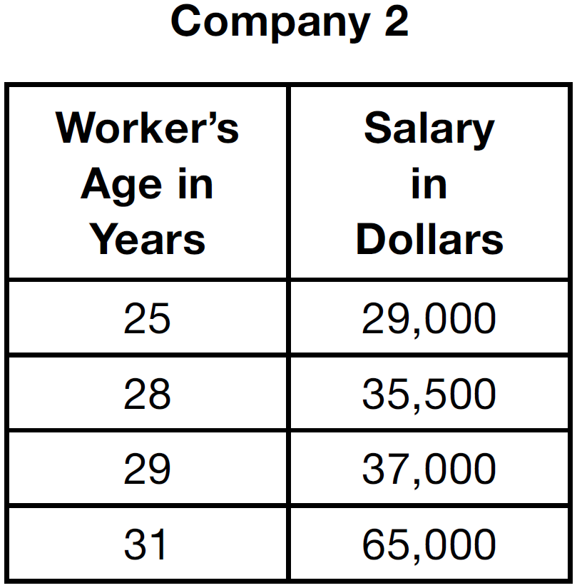

Which statement is true about these data?
1) | The median salaries in both companies are greater than $37,000. | 3) | The salary range in company 2 is greater than the salary range in company 1.
2) | The mean salary in company 1 is greater than the mean salary in company 2. | 4) | The mean age of workers at company 1 is greater than the mean age of workers at company 2.

7 Christopher looked at his quiz scores shown below for the first and second semester of his Algebra class.
Semester 1: 78, 91, 88, 83, 94
Semester 2: 91, 96, 80, 77, 88, 85, 92
Which statement about Christopher's performance is correct?
1) | The interquartile range for semester 1 is greater than the interquartile range for semester 2. | 3) | The mean score for semester 2 is greater than the mean score for semester 1.
2) | The median score for semester 1 is greater than the median score for semester 2. | 4) | The third quartile for semester 2 is greater than the third quartile for semester 1.

8 The two sets of data below represent the number of runs scored by two different youth baseball teams over the course of a season.
Team A: 4, 8, 5, 12, 3, 9, 5, 2
Team B: 5, 9, 11, 4, 6, 11, 2, 7
Which set of statements about the mean and standard deviation is true?
1) |  | 3)
2) |  | 4)

9 The sets below represent test scores for two students in Mrs. Silvio’s trigonometry class.
Michelle: {71, 68, 84, 88}
Valerie: {78, 82, 76, 80}
Which statement correctly describes the relationship between the two students’ test scores?
1) | Michelle’s mean test score is greater and her test scores have a greater interquartile range. | 3) | Valerie’s mean test score is greater and her interquartile range is greater.
2) | Michelle’s population standard deviation is greater, but her range is smaller. | 4) | Valerie’s mean test score is greater, but her population standard deviation is smaller.

10 Jean’s scores on five mathematics tests were 98, 97, 99, 98, and 96. Her scores on five English tests were 78, 84, 95, 72, and 79. Which statement is true about the standard deviations for the scores?
1) | The standard deviation for the English scores is greater than the standard deviation for the math scores.
2) | The standard deviation for the math scores is greater than the standard deviation for the English scores.
3) | The standard deviations for both sets of scores are equal.
4) | More information is needed to determine the relationship between the standard deviations.

11 Tanner and Robbie discovered that the means of their grades for the first semester in Mrs. Merrell’s mathematics class are identical. They also noticed that the standard deviation of Tanner's scores is 20.7, while the standard deviation of Robbie's scores is 2.7. Which statement must be true?
1) | In general, Robbie's grades are lower than Tanner's grades.
2) | Robbie's grades are more consistent than Tanner's grades.
3) | Robbie had more failing grades during the semester than Tanner had.
4) | The median for Robbie's grades is lower than the median for Tanner's grades.

12 On a nationwide examination, the Adams School had a mean score of 875 and a standard deviation of 12. The Boswell School had a mean score of 855 and a standard deviation of 20. In which school was there greater consistency in the scores? Explain how you arrived at your answer.

13 Two social studies classes took the same current events examination that was scored on the basis of 100 points. Mr. Wong’s class had a median score of 78 and a range of 4 points, while Ms. Rizzo’s class had a median score of 78 and a range of 22 points. Explain how these classes could have the same median score while having very different ranges.

14 The students in Mrs. Lankford's 4th and 6th period Algebra classes took the same test. The results of the scores are shown in the following table:

 |  |  | n | min |  | med |  | max
4th Period | 77.75 | 10.79 | 20 | 58 | 69 | 76.5 | 87.5 | 96
6th Period | 78.4 | 9.83 | 20 | 59 | 71.5 | 78 | 88 | 96

Based on these data, which class has the larger spread of test scores? Explain how you arrived at your answer.

15 Santina is considering a vacation and has obtained high-temperature data from the last two weeks for Miami and Los Angeles.

Miami | 76 | 75 | 83 | 73 | 60 | 66 | 76
Miami | 81 | 83 | 85 | 83 | 87 | 80 | 80

Los Angeles | 74 | 63 | 65 | 67 | 65 | 65 | 65
Los Angeles | 62 | 62 | 72 | 69 | 64 | 64 | 61

Which location has less variability in temperatures? Explain how you arrived at your answer.
1 ANS: 3
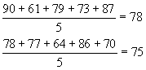

REF: 080402a

2 ANS: 4 REF: 011514ai

3 ANS: 2 REF: 010916a

4 ANS: 4 REF: 011720ai

5 ANS: 3
 | Donna | Andrew
mean | 91.6 | 89.6
median | 92 | 93
IQR | 6 | 12.5
3rd Q | 94.5 | 95

REF: 062214ai

6 ANS: 3
 | Company 1 | Company 2
median salary | 33,500 | 36,250
mean salary | 33,750 | 44,125
salary range | 8,000 | 36,000
mean age | 28.25 | 28.25

REF: 081404ai

7 ANS: 3
 | Mean | Q1 | Median | Q3 | IQR
Semester 1 | 86.8 | 80.5 | 88 | 92.5 | 12
Semester 2 | 87 | 80 | 88 | 92 | 12

REF: 061419ai

8 ANS: 1

REF: 081519ai

9 ANS: 4
 |  | IQR |  | Range
Michelle | 77.8 | 16.5 | 8.4 | 20
Valerie | 79 | 4 | 2.2 | 6

REF: 011724a2

10 ANS: 1
Jean’s English test scores have a greater range (72-95) than her math test scores (96-99). Therefore the standard deviation for the English scores is greater than the standard deviation for the math scores.

REF: 010406b

11 ANS: 2
Robbie's grades are more consistent than Tanner's grades because Robbie’s grades have a lower standard deviation.

REF: 080802b

12 ANS:
The Adams School had the greater consistency in the scores. The school with the smaller standard deviation would have the more consistent scores.

REF: 060221b

13 ANS:
One very high or very low score in either class would have a great effect on the range for that class, but might not affect the median at all. The range is the difference between the two most extreme values, the lowest and the highest. The median, being the middle value, is not very sensitive to outliers or to extreme values.

REF: 010321b

14 ANS:
4th because IQR and are greater for 4th Period.

REF: 081831ai

15 ANS:
Los Angeles because range, IQR and are less.
 |  | Min | Q1 | Q3 | Max | Range | IQR
Miami | 7.2 | 60 | 75 | 83 | 87 | 27 | 8
Los Angeles | 3.6 | 61 | 63 | 67 | 74 | 13 | 4

REF: 011931ai

