1 Jorge made the accompanying stem-and-leaf plot of the weights, in pounds, of each member of the wrestling team he was coaching.

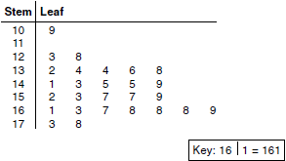

What is the mode of the weights?
1) | 145
2) | 150
3) | 152
4) | 168

2 The accompanying stem-and-leaf plot represents Ben’s test scores this year.

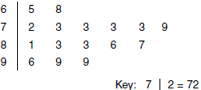

What is the median score for this set of data?
1) | 73
2) | 79
3) | 80
4) | 81

3 The student scores on Mrs. Frederick’s mathematics test are shown on the stem-and-leaf plot below.

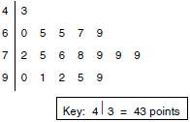

Find the median of these scores.

4 Construct a stem-and-leaf plot listing the scores below in order from lowest to highest.
15, 25, 28, 32, 39, 40, 43, 26, 50, 75, 65, 19, 55, 72, 50

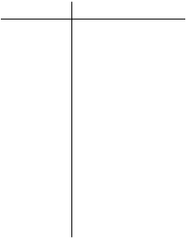
1 ANS: 4
The mode of the weights is 168, as it appears most frequently.

REF: 060509a

2 ANS: 3
There are 16 test scores, so average the 8th and 9th scores to compute the median. 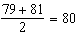.

REF: 080714a

3 ANS:
77. There are 18 test scores, so average the 9th and 10th scores to compute the median, or (76 + 78)/2 = 77.

REF: 060321a

4 ANS:
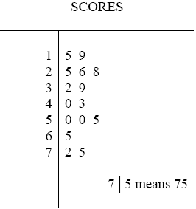

REF: 010535a

