1 The weights of 40 students were recorded. If the 75th percentile of their weights was 140 pounds, what is the total number of students who weighed more than 140 pounds?
1) | 10
2) | 20
3) | 30
4) | 4

2 The freshman class held a canned food drive for 12 weeks. The results are summarized in the table below.

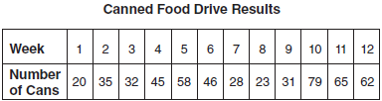

Which number represents the second quartile of the number of cans of food collected?
1) | 29.5
2) | 30.5
3) | 40
4) | 60

3 Brianna's score on a national math assessment exceeded the scores of 95,000 of the 125,000 students who took the assessment. What was her percentile rank?
1) | 6
2) | 24
3) | 31
4) | 76

1 ANS: 1

REF: 011515ia

2 ANS: 3 REF: 061017ia

3 ANS: 4


REF: 061207ia

