1 Twenty students were surveyed about the number of days they played outside in one week. The results of this survey are shown below.
{6,5,4,3,0,7,1,5,4,4,3,2,2,3,2,4,3,4,0,7}
Complete the frequency table below for these data.

Interval | Tally | Frequency
0-1
2-3
4-5
6-7

Complete the cumulative frequency table below using these data.

Interval | Cumulative  Frequency
0-1
0-3
0-5
0-7

On the grid below, create a cumulative frequency histogram based on the table you made.

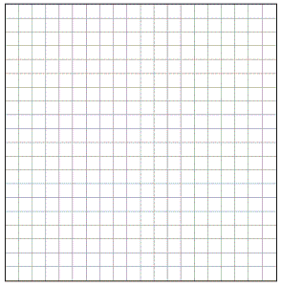

2 The following data consists of the weights, in pounds, of 30 adults:
195, 206, 100, 98, 150, 210, 195, 106, 195, 168,
180, 212, 104, 195, 100, 216, 195, 209, 112, 99,
206, 116, 195, 100, 142, 100, 135, 98, 160, 155
Using the data, complete the accompanying cumulative frequency table and construct a cumulative frequency histogram on the grid below.

Interval | Frequency | Cumulative Frequency
51-100
101-150
151-200
201-250



3 Mr. Suppe recorded the height, in inches, of each student in his class. The results are recorded in the table below.

60 | 59 | 70 | 65 | 64
61 | 58 | 72 | 75 | 66
65 | 67 | 63 | 62 | 68
68 | 69 | 74 | 61 | 70

Which cumulative frequency histogram represents the data?
1) | 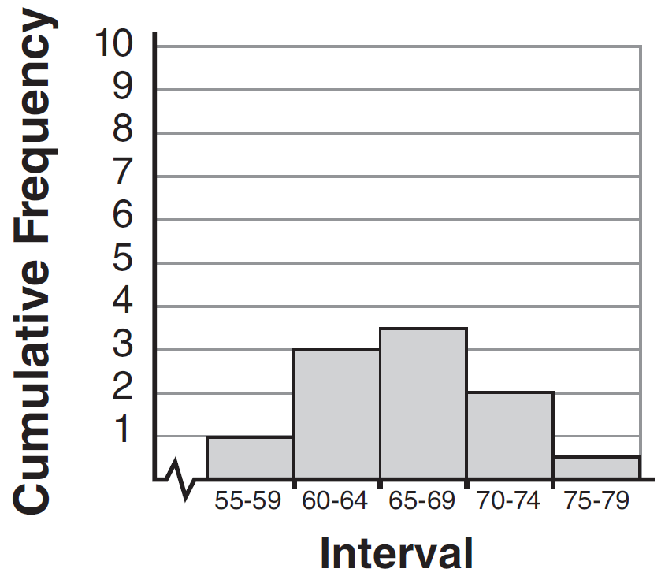 | 3) | 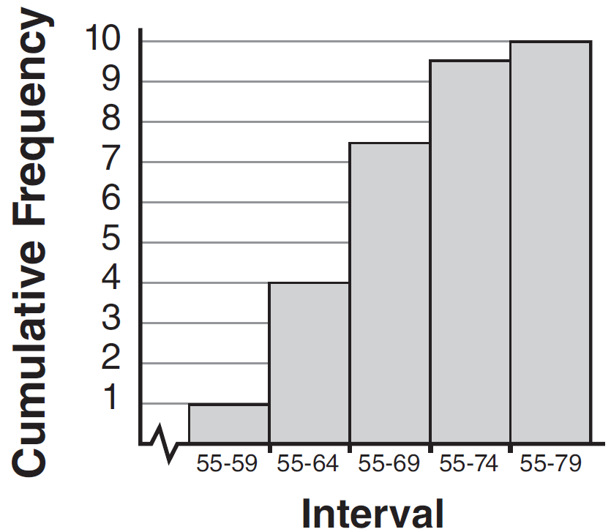
2) | 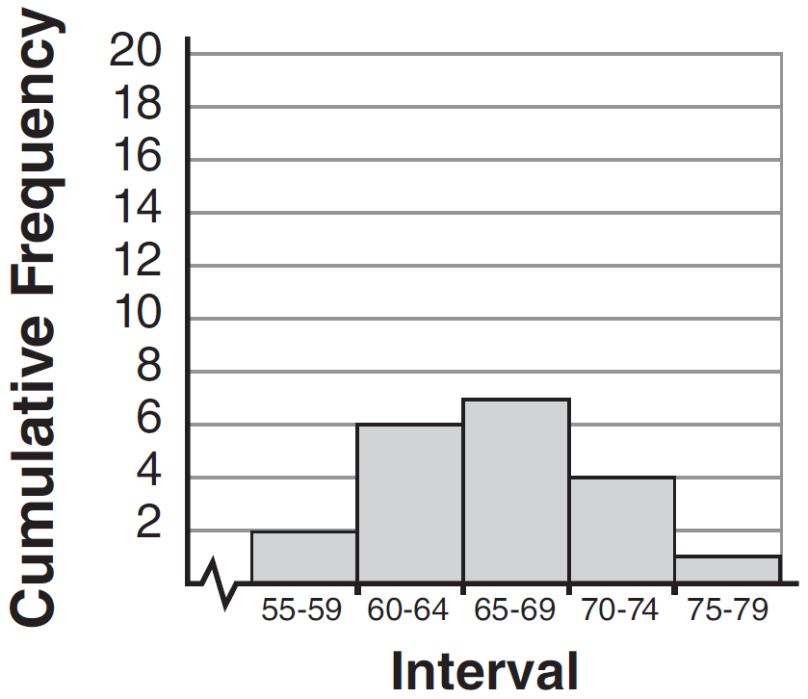 | 4) | 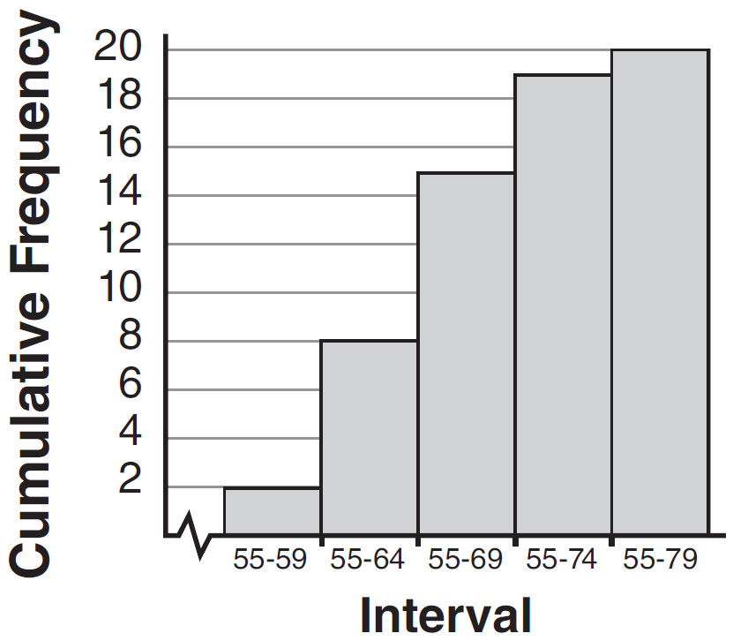

4 The accompanying table shows the weights, in pounds, for the students in an algebra class. Using the data, complete the cumulative frequency table and construct a cumulative frequency histogram on the grid below.
Interval | Frequency | Cumulative  Frequency
91-100 | 6
101-110 | 3
111-120 | 0
121-130 | 3
131-140 | 0
141-150 | 2
151-160 | 2

5 The accompanying histogram shows the scores of students on a Math A test.
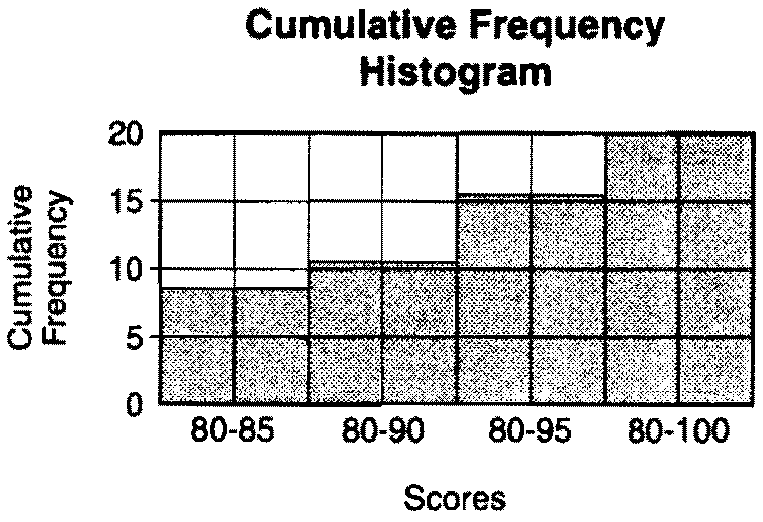

How many students have scores of 96 to 100?
1) | 55 | 3) | 5
2) | 20 | 4) | 4

6 The following cumulative frequency histogram shows the distances swimmers completed in a recent swim test.

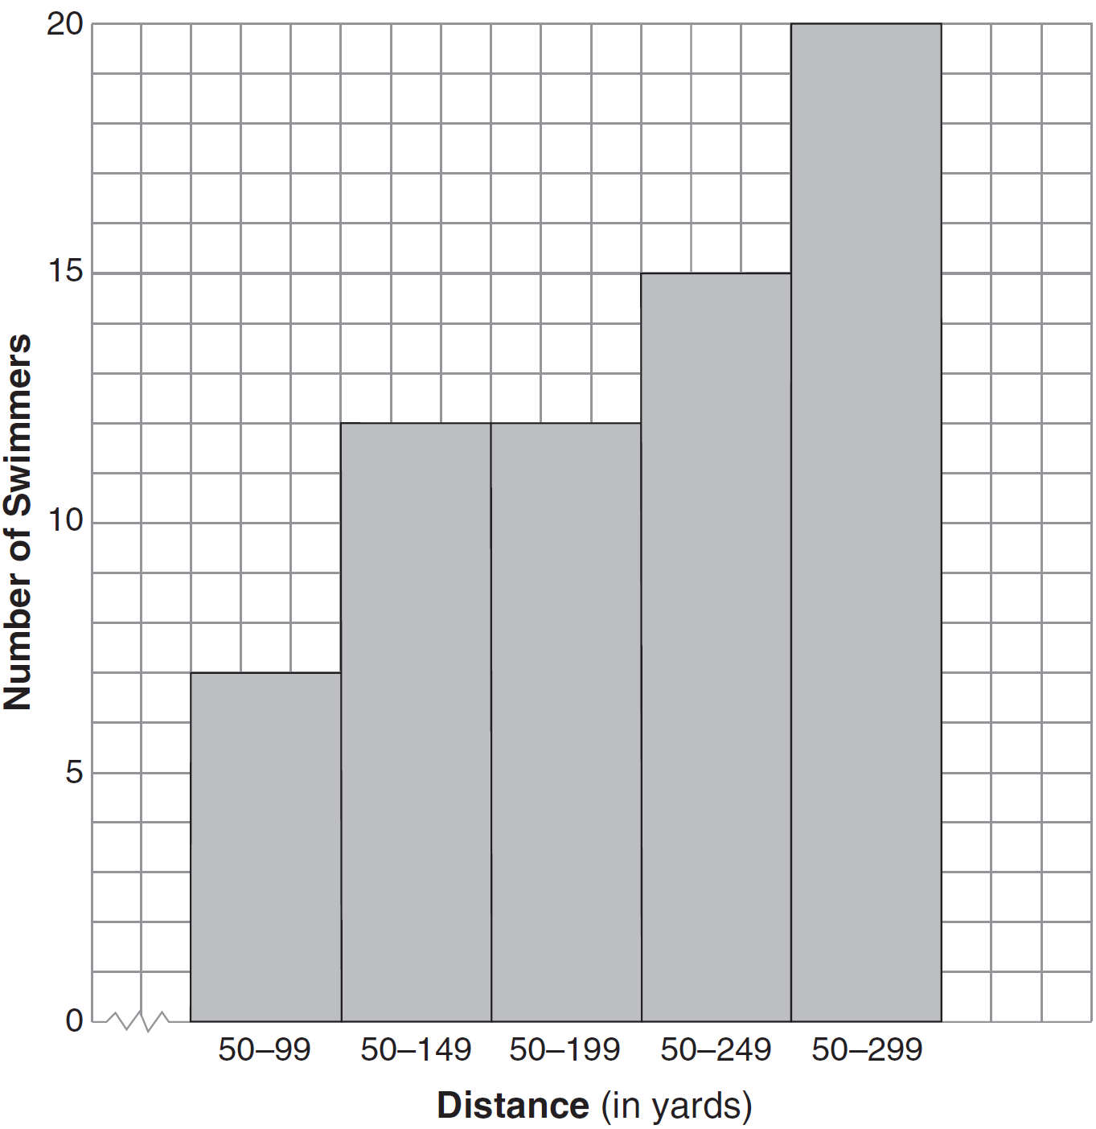

Based on the cumulative frequency histogram, determine the number of swimmers who swam between 200 and 249 yards. Determine the number of swimmers who swam between 150 and 199 yards. Determine the number of swimmers who took the swim test.

7 The diagram below shows a cumulative frequency histogram of the students' test scores in Ms. Wedow's algebra class.

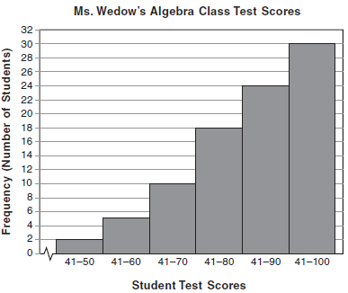

Determine the total number of students in the class. Determine how many students scored higher than 70. State which ten-point interval contains the median. State which two ten-point intervals contain the same frequency.
1 ANS:
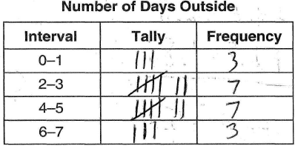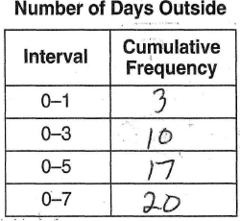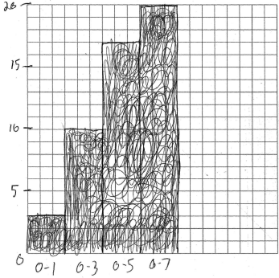
REF: 080838ia

2 ANS:
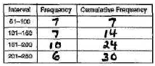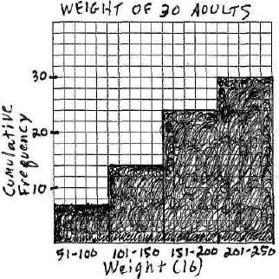
REF: 080134a

3 ANS: 4 REF: 011530ia

4 ANS:
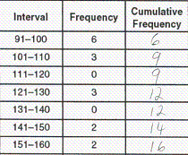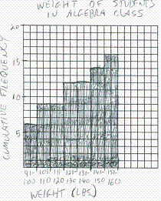
REF: 010739a

5 ANS: 4 REF: spring9818a

6 ANS:
3, 0, 20. .
REF: 081234ia

7 ANS:
30, 20, 71-80, 81-90 and 91-100
REF: 061038ia

