1 Ms. Hopkins recorded her students' final exam scores in the frequency table below.

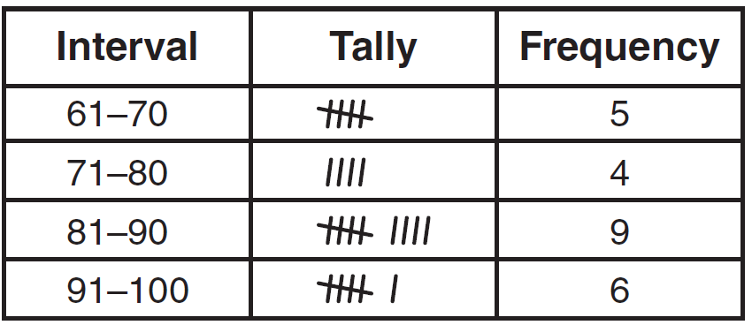

On the grid below, construct a frequency histogram based on the table.

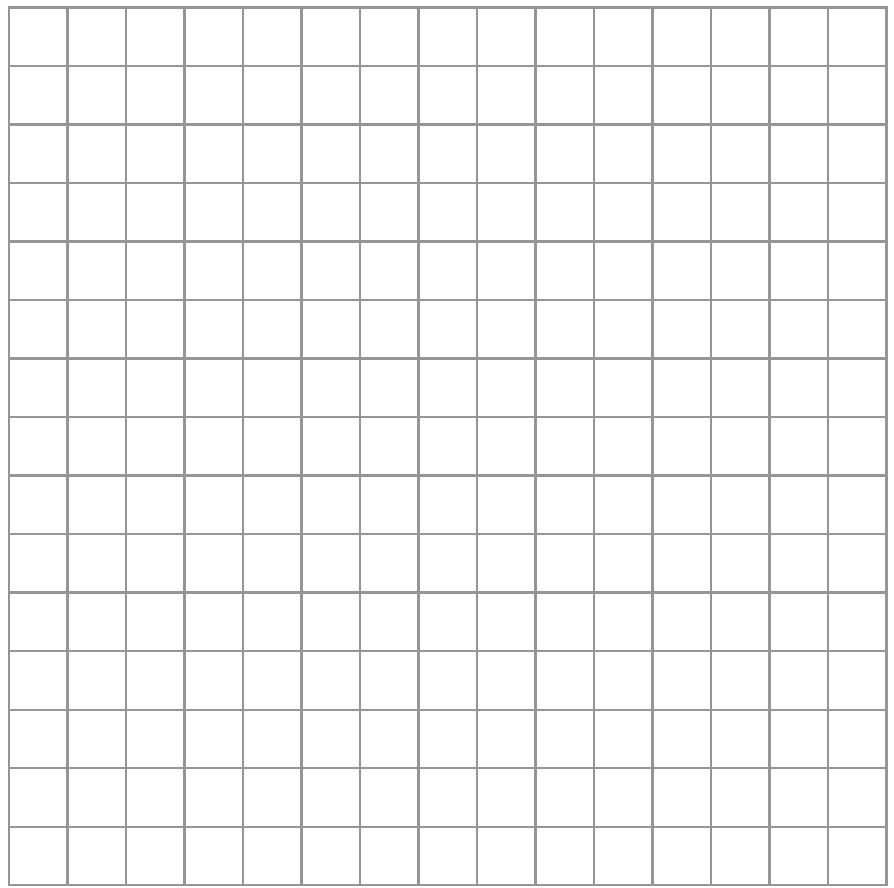

2 In the time trials for the 400-meter run at the state sectionals, the 15 runners recorded the times shown in the table below.

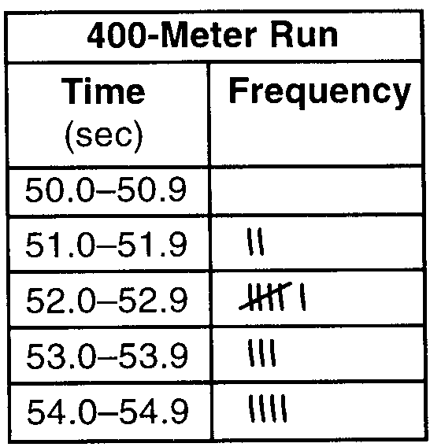

a Using the data from the frequency column, draw a frequency histogram on the grid provided below.

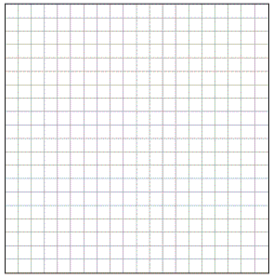

b What percent of runners completed the time trial between 52.0 and 53.9 seconds?

3 The Fahrenheit temperature readings on 30 April mornings in Stormville, New York, are shown below.
41°, 58°, 61°, 54°, 49°, 46°, 52°, 58°, 67°, 43°,
47°, 60°, 52°, 58°, 48°, 44°, 59°, 66°, 62°, 55°,
44°, 49°, 62°, 61°, 59°, 54°, 57°, 58°, 63°, 60°
Using the data, complete the frequency table below.

Interval | Tally | Frequency
40-44
45-49
50-54
55-59
60-64
65-69

On the grid below, construct and label a frequency histogram based on the table.

4 The test scores for 18 students in Ms. Mosher’s class are listed below:
86, 81, 79, 71, 58, 87, 52, 71, 87,
87, 93, 64, 94, 81, 76, 98, 94, 68
Complete the frequency table below.

Interval | Tally | Frequency
51-60
61-70
71-80
81-90
91-100

Draw and label a frequency histogram on the grid below.

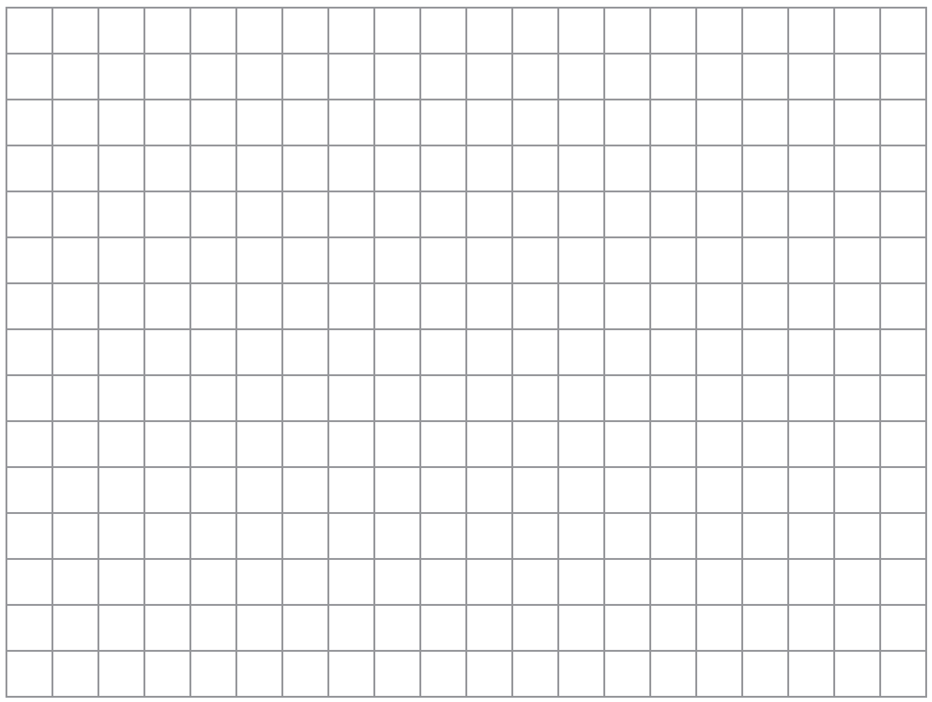

5 The scores on a mathematics test were:
70, 55, 61, 80, 85, 72, 65, 40, 74, 68, 84
Complete the accompanying table, and use the table to construct a frequency histogram for these scores.

Score | Tally | Frequency
40-49
50-59
60-69
70-79
80-89

6 The following set of data represents the scores on a mathematics quiz:
58, 79, 81, 99, 68, 92, 76, 84, 53, 57,
81, 91, 77, 50, 65, 57, 51, 72, 84, 89
Complete the frequency table below and, on the accompanying grid, draw and label a frequency histogram of these scores.

Mathematics Quiz Scores
Interval | Tally | Frequency
50-59
60-69
70-79
80-89
90-99

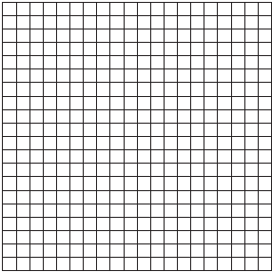

7 The daily high temperatures for the month of February in New York City were:
34°, 37°, 31°, 36°, 30°, 32°, 32°,
34°, 30°, 37°, 31°, 30°, 30°, 31°,
36°, 34°, 36°, 32°, 32°, 30°, 37°,
31°, 36°, 32°, 31°, 36°, 31°, 35°
Complete the table below. Use the table to construct a frequency histogram for these temperatures on the accompanying grid.

Temperature,  in Degrees | Tally | Frequency
30
31
32
33
34
35
36
37

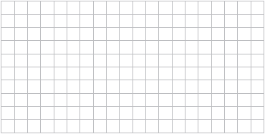

8 Sarah’s mathematics grades for one marking period were:
85, 72, 97, 81, 77, 93, 100, 75, 86, 70, 96, 80
a Complete the tally sheet and frequency table below, and construct and label a frequency histogram for Sarah’s grades using the accompanying grid.

Interval  (grades) | Tally | Frequency
61-70
71-80
81-90
91-100

b Which interval contains the 75th percentile (upper quartile)?

9 The following set of data represents the heights, in inches, of the 20 students in Ms. Fitzgerald's freshman class:
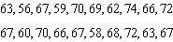
Complete the frequency table below.

Heights of Students
Interval | Tally | Frequency

On the grid below, draw and label a frequency histogram for these data.

10 On a science quiz, 20 students received the following scores:
100, 95, 95, 90, 85, 85, 85, 80, 80, 80,
80, 75, 75, 75, 70, 70, 65, 65, 60, 55
Construct a statistical graph, such as a histogram or a stem-and-leaf plot, to display this data. [Be sure to title the graph and label all axes or parts used.]

11 The accompanying histogram shows the heights of the students in Kyra’s health class.

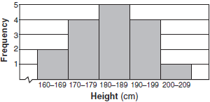

What is the total number of students in the class?
1) | 5 | 3) | 16
2) | 15 | 4) | 209

12 The heights, in feet, of former New York Knicks basketball players are listed below.
6.4 6.9 6.3 6.2 6.3 6.0 6.1 6.3 6.8 6.2
6.5 7.1 6.4 6.3 6.5 6.5 6.4 7.0 6.4 6.3
6.2 6.3 7.0 6.4 6.5 6.5 6.5 6.0 6.2
Using the heights given, complete the frequency table below.

Interval | Frequency
6.0-6.1
6.2-6.3
6.4-6.5
6.6-6.7
6.8-6.9
7.0-7.1

Based on the frequency table created, draw and label a frequency histogram on the grid below.



Determine and state which interval contains the upper quartile. Justify your response.
1 ANS:
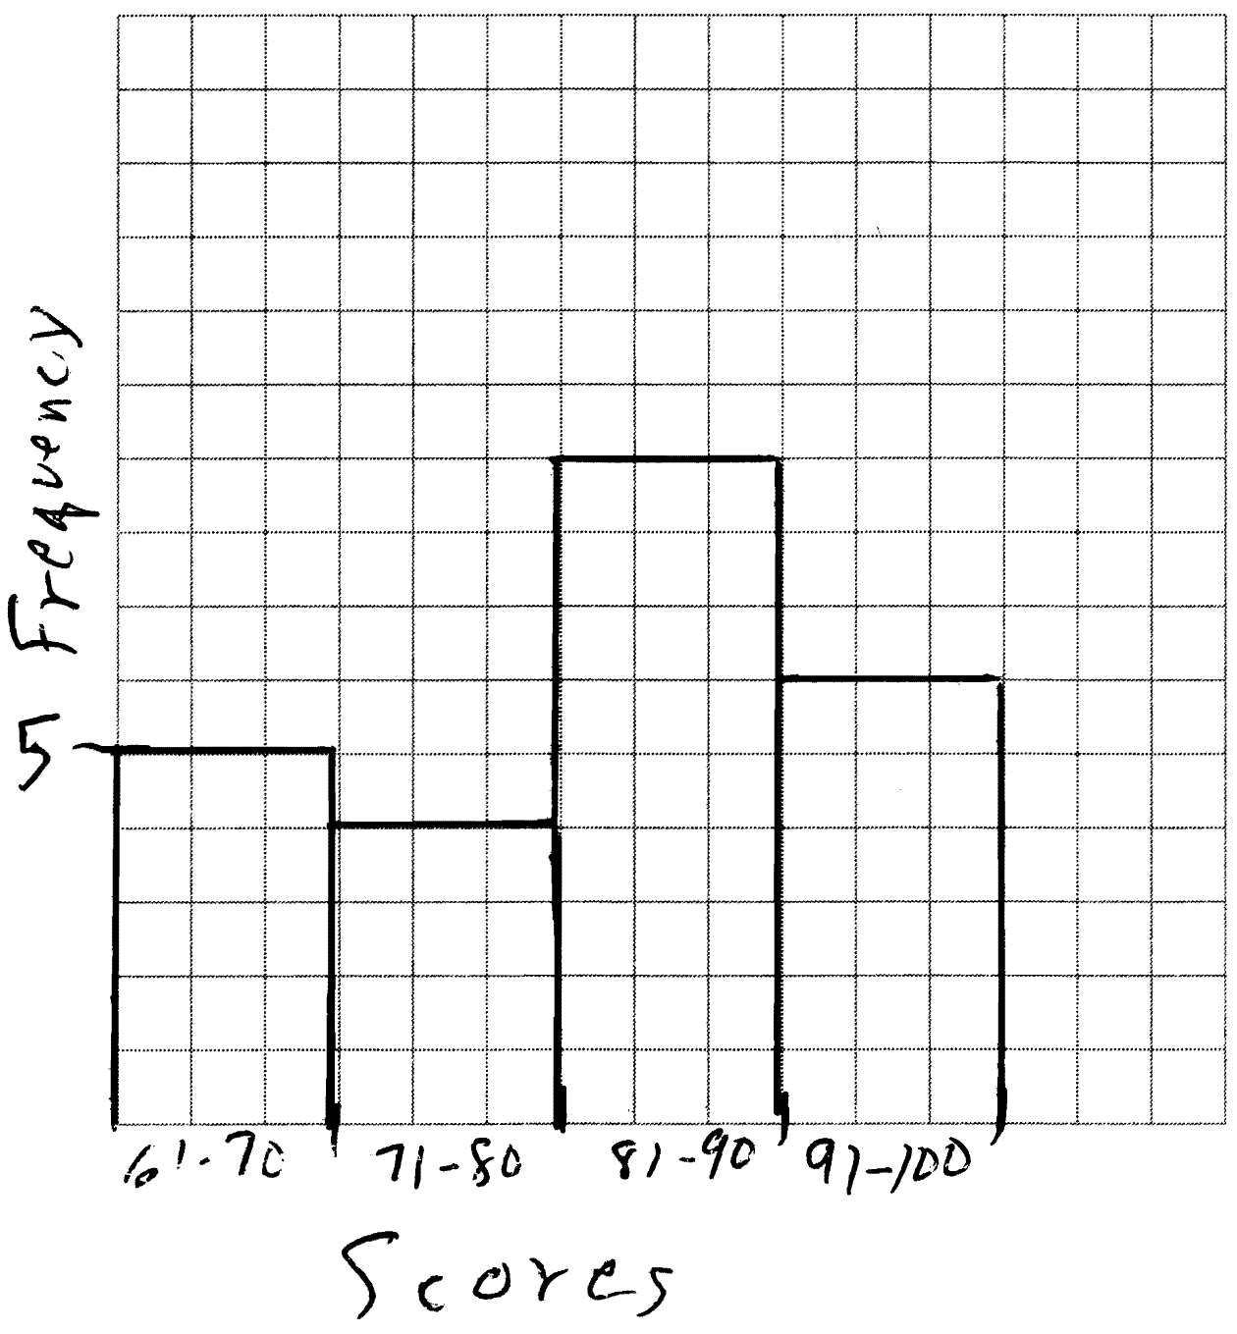

REF: 081132ia

2 ANS:
a) 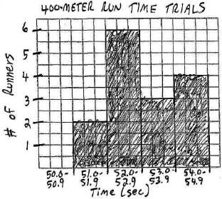 b) 60%. 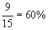

REF: 010032a

3 ANS:
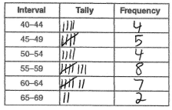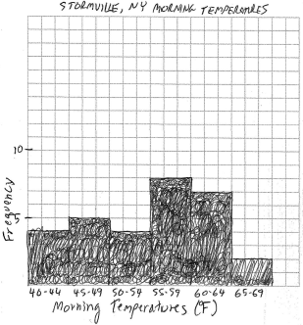

REF: 060938ia

4 ANS:
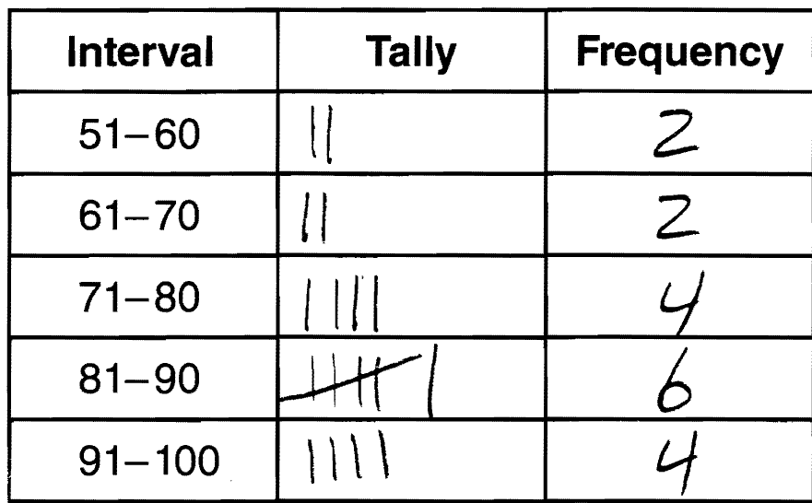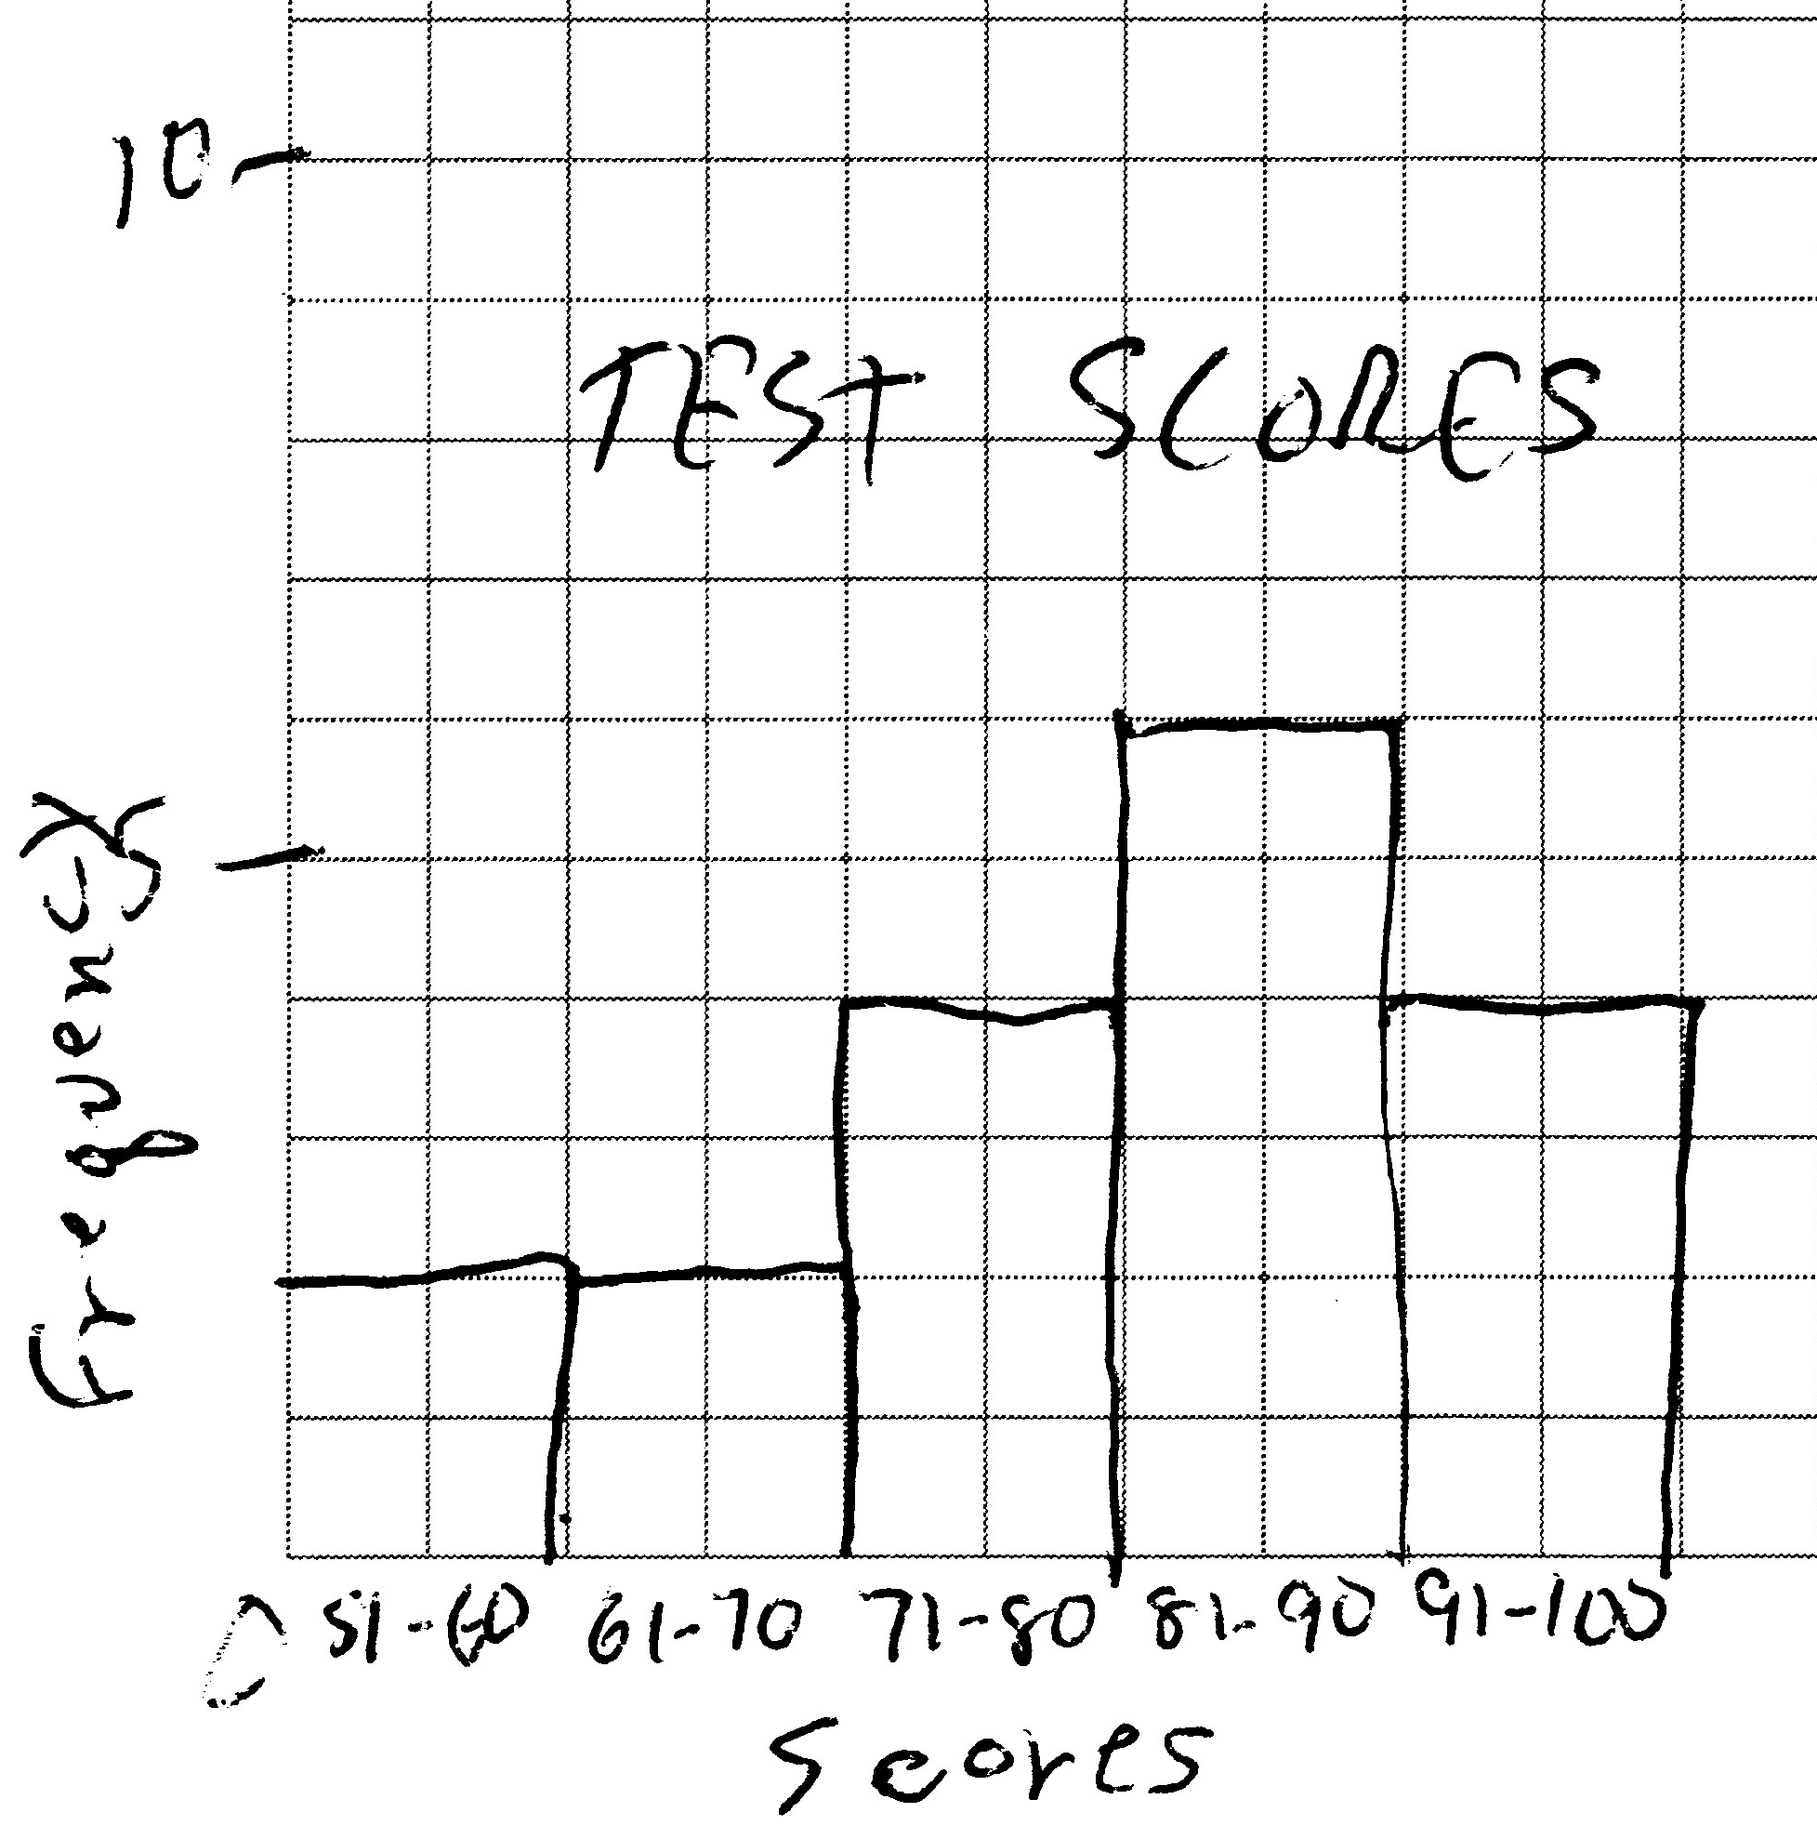

REF: 011135ia

5 ANS:
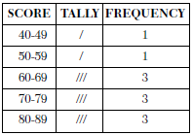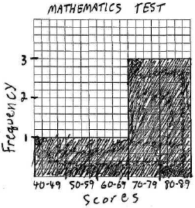

REF: 060033a

6 ANS:
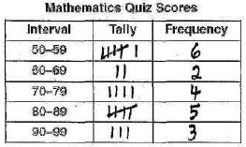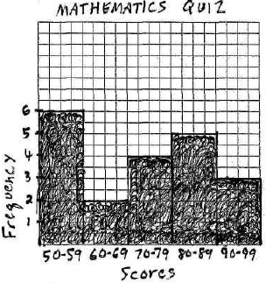

REF: 080437a

7 ANS:
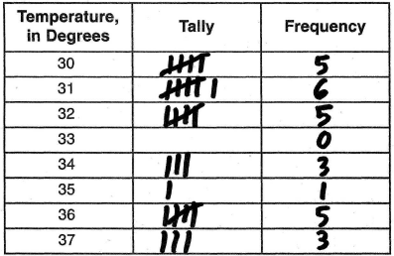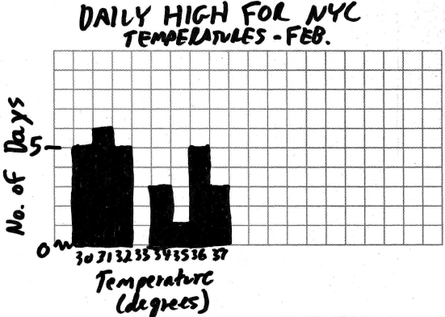

REF: 010939a

8 ANS:
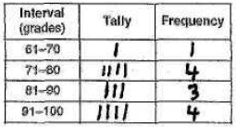 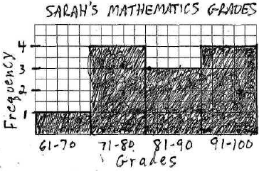 91-100. Since there are 12 grades, the 75th percentile begins with the ninth (12 x 75%) highest grade, which is in the 91-100 interval.

REF: 010334a

9 ANS:
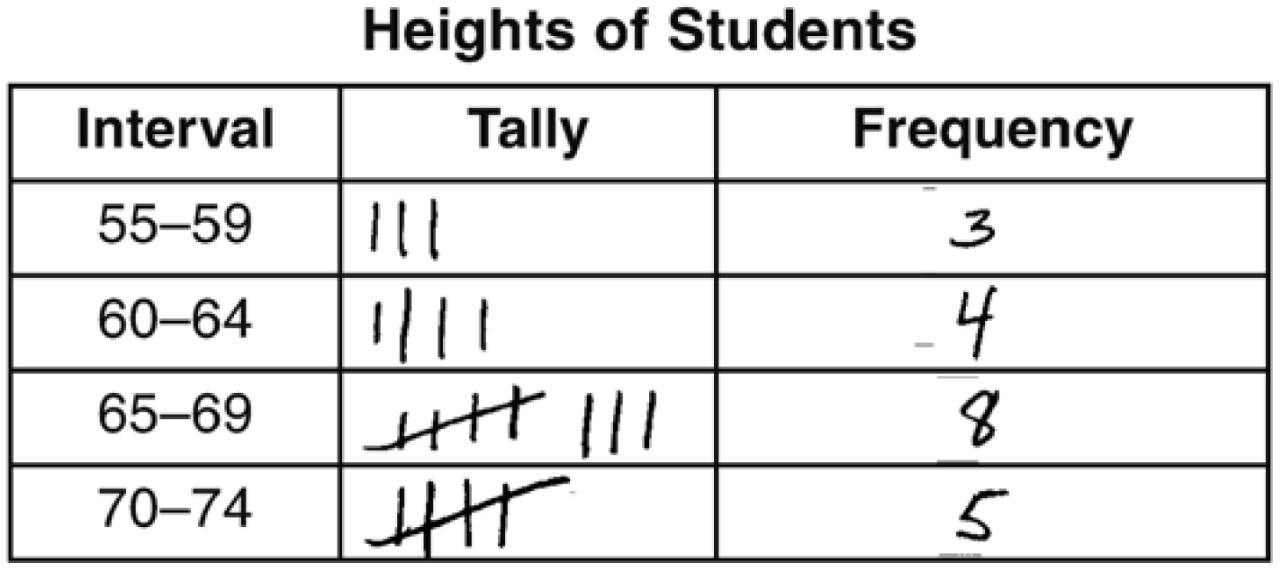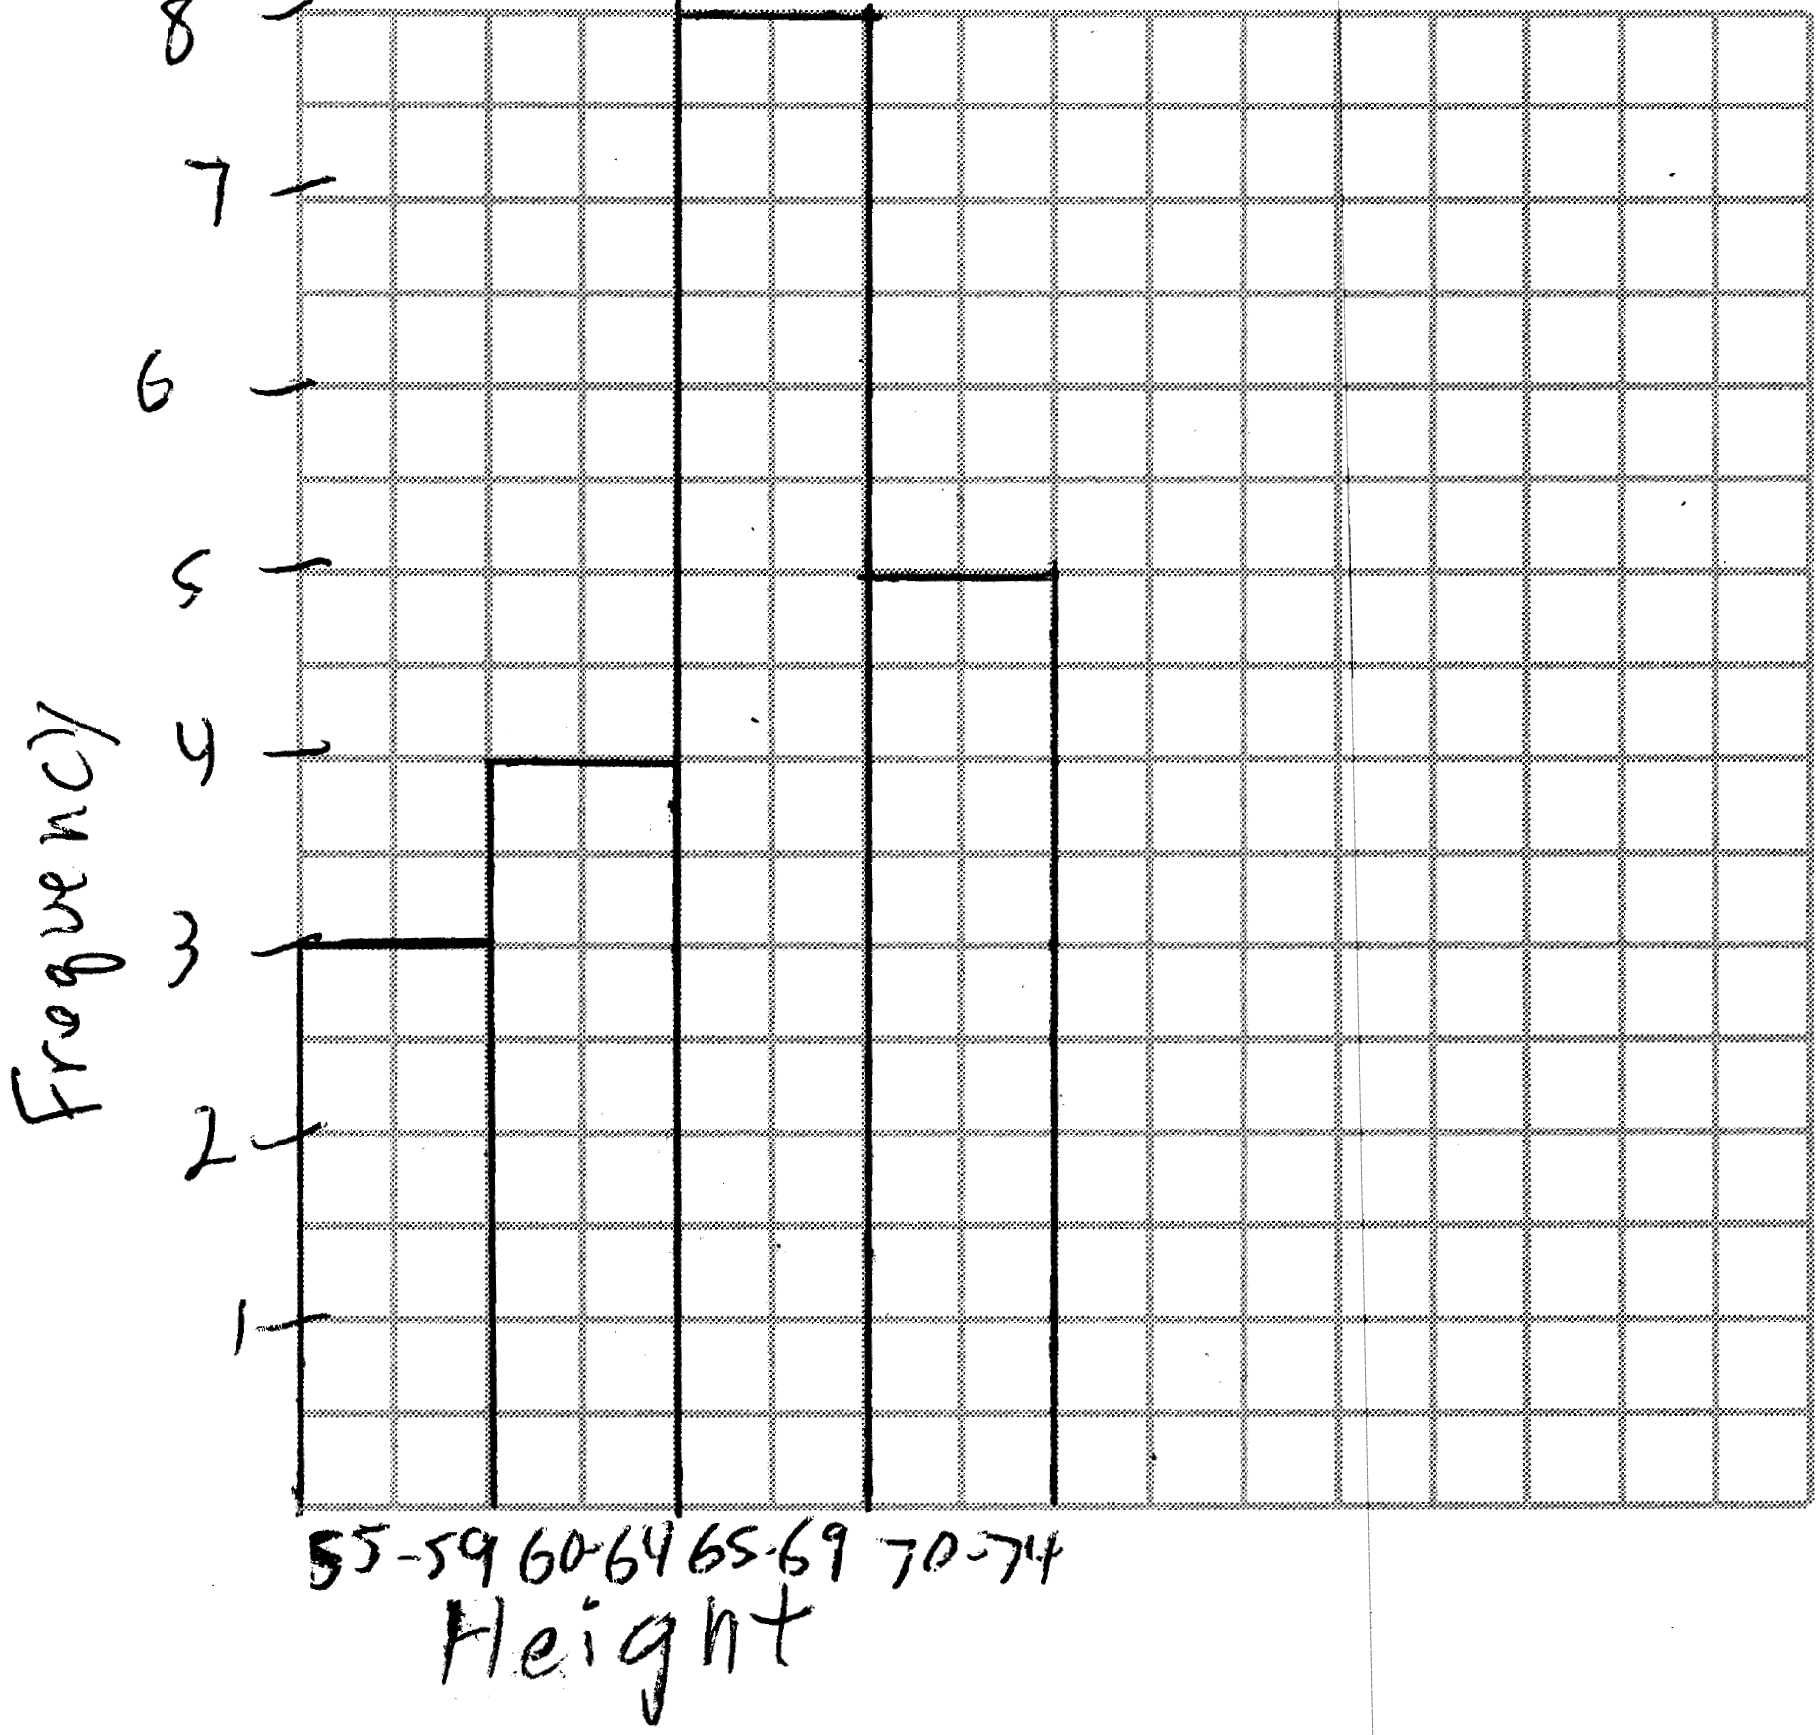

REF: 061536ia

10 ANS:
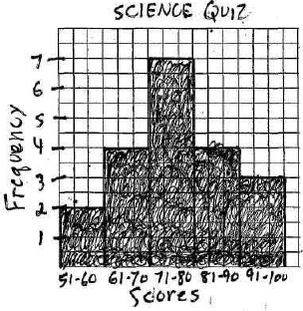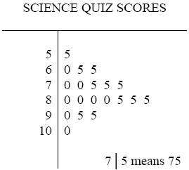

REF: 010132a

11 ANS: 3
2 + 4 + 5 + 4 + 1 = 16

REF: 010504a

12 ANS:
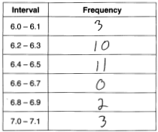 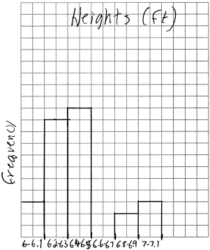 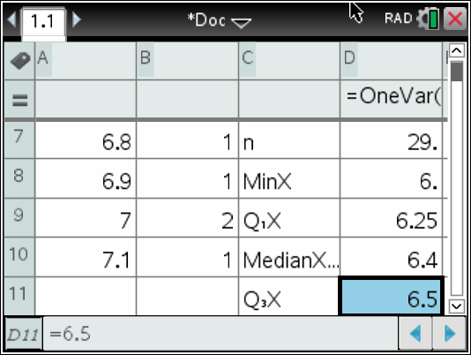 6.4-6.5

REF: 081734ai

