1 The dot plot below shows the number of goals Jessica scored in each lacrosse game last season.

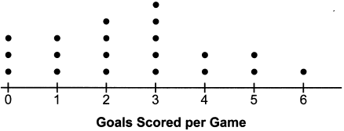

Which statement about the dot plot is correct?
1) | mean > mode | 3) | mode = median
2) | mean = median | 4) | median > mean

2 The dot plot shown below represents the number of pets owned by students in a class.

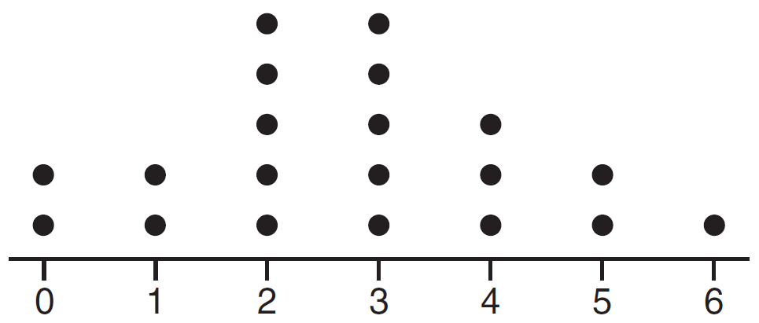

Which statement about the data is not true?
1) | The median is 3. | 3) | The mean is 3.
2) | The interquartile range is 2. | 4) | The data contain no outliers.

3 Different ways to represent data are shown below.

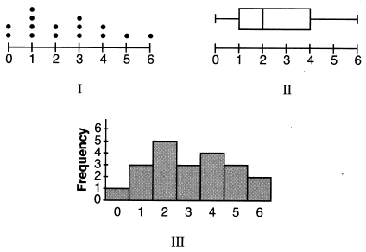

Which data representations have a median of 2?
1) | I and II, only | 3) | II and III, only
2) | I and III, only | 4) | I, II, and III

4 Given the following data set:

Which representations are correct for this data set?

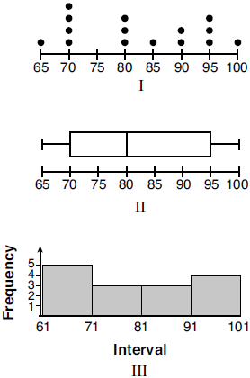
1) | I and II | 3) | II and III, only
2) | I and III, only | 4) | I, II, and III

5 Student scores on a recent test are shown in the table below.

85 | 96 | 92 | 82 | 90
90 | 88 | 95 | 85 | 88
90 | 87 | 96 | 82 | 85
92 | 96 | 85 | 92 | 87

On the number line below, create a dot plot to model the data.

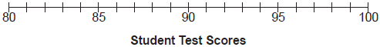

State the median test score for the data set.
1 ANS: 2
mean: 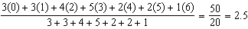, mode: 3, median: 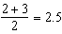

REF: 062416ai

2 ANS: 3
, , . An outlier is outside the interval . 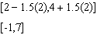

REF: 061620ai

3 ANS: 1 REF: 082210ai

4 ANS: 4 REF: 012022ai

5 ANS:
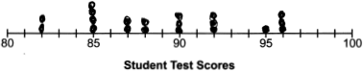 89

REF: 012425ai

