1 The accompanying circle graph shows how the Marino family spends its income each month.

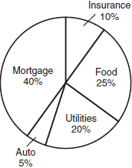

What is the measure, in degrees, of the central angle that represents the percentage of income spent on food?
1) | 25
2) | 50
3) | 90
4) | 360

2 The accompanying circle graph shows how Joan invested her money.

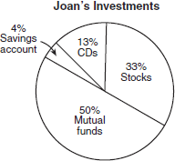

If she invested a total of $12,000, how much money did she invest in CDs?
1) | $1,560
2) | $9,230
3) | $15,600
4) | $92,308

3 The accompanying circle graph shows how Shannon earned $600 during her summer vacation.

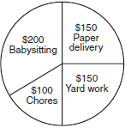

What is the measure of the central angle of the section labeled "Chores"?
1) | 30°
2) | 60°
3) | 90°
4) | 120°

4 In a recent poll in Syracuse, New York, 3,000 people were asked to pick their favorite baseball team. The accompanying circle graph shows the results of that poll.

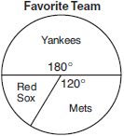

How many of the people polled picked the Red Sox as their favorite team?
1) | 300
2) | 500
3) | 1,200
4) | 1,800

5 In a survey, 450 high school students were asked for their preference of fast food for lunch. The accompanying circle graph represents the results.

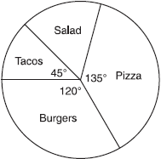

How many students preferred salad?
1) | 60
2) | 75
3) | 150
4) | 300

6 Mr. Smith’s class voted on their favorite ice cream flavors, and the results are shown in the accompanying diagram. If there are 20 students in Mr. Smith’s class, how many students chose coffee ice cream as their favorite flavor?

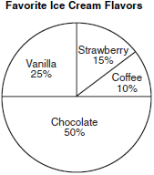

7 In a recent poll, 600 people were asked whether they liked Chinese food. A circle graph was constructed to show the results. The central angles for two of the three sectors are shown in the accompanying diagram. How many people had no opinion?

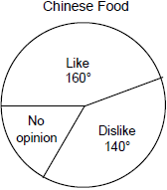

8 The accompanying circle graph shows the favorite colors of the 300 students in the ninth grade. How many students chose red as their favorite color?

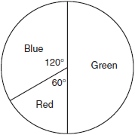

9 Nine hundred students were asked whether they thought their school should have a dress code. A circle graph was constructed to show the results. The central angles for two of the three sectors are shown in the accompanying diagram. What is the number of students who felt that the school should have no dress code?

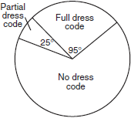

10 In a class of 24 students, 10 have brown hair, 8 have black hair, 4 have blond hair, and 2 have red hair. On the accompanying diagram, construct a circle graph to show the students' hair color.

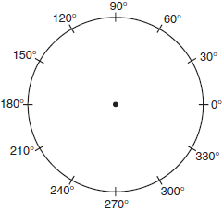
1 ANS: 3
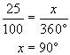

REF: 060422a

2 ANS: 1
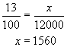

REF: 080702a

3 ANS: 2
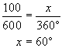

REF: 010611a

4 ANS: 2
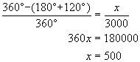

REF: 060715a

5 ANS: 2
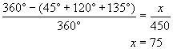

REF: 080827a

6 ANS:
2. 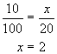

REF: 010325a

7 ANS:
100. 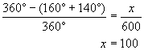

REF: 089924a

8 ANS:
50. 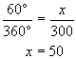

REF: 080435a

9 ANS:
600. 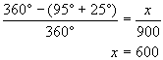

REF: 080534a

10 ANS:
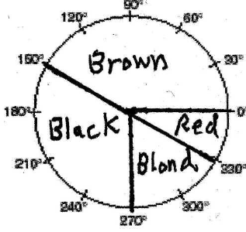

REF: 060538a

