1 In the box-and-whisker plot below, what is the 2nd quartile?

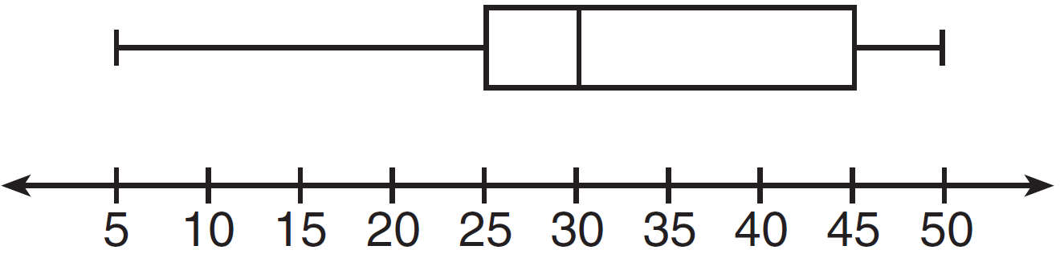
1) | 25
2) | 30
3) | 45
4) | 50

2 The accompanying diagram shows a box-and-whisker plot of student test scores on last year’s Mathematics A midterm examination.

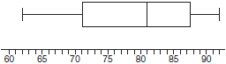

What is the median score?
1) | 62
2) | 71
3) | 81
4) | 92

3 The accompanying box-and-whisker plot represents the scores earned on a science test.

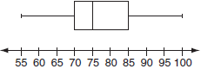

What is the median score?
1) | 70
2) | 75
3) | 77
4) | 85

4 What is the value of the third quartile shown on the box-and-whisker plot below?

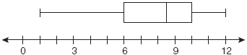
1) | 6
2) | 8.5
3) | 10
4) | 12

5 What is the value of the third quartile in the box plot shown below?

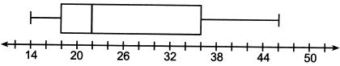
1) | 18
2) | 22
3) | 36
4) | 46

6 The box plot below summarizes the data for the average monthly high temperatures in degrees Fahrenheit for Orlando, Florida.

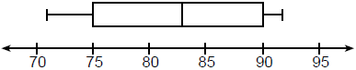

The third quartile is
1) | 92
2) | 90
3) | 83
4) | 71

7 A box plot is shown below.

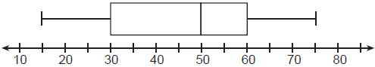

Which number represents the third quartile?
1) | 30
2) | 50
3) | 60
4) | 75

8 The box-and-whisker plot below represents students' scores on a recent English test.

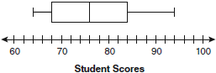

What is the value of the upper quartile?
1) | 68
2) | 76
3) | 84
4) | 94

9 What is the range of the box plot shown below?

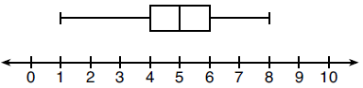
1) | 7
2) | 2
3) | 3
4) | 4

10 What is the range of the data represented in the box-and-whisker plot shown below?

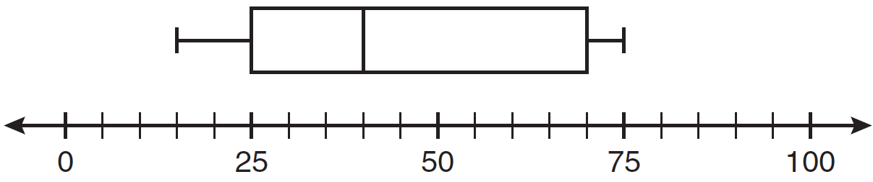
1) | 40
2) | 45
3) | 60
4) | 100

11 The box plot below summarizes the data for the amount of snowfall, in inches, during the winter of 2021 for 12 locations in western New York.

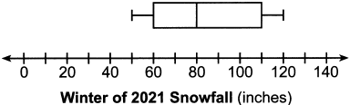

What is the interquartile range?
1) | 30
2) | 50
3) | 80
4) | 110

12 The box-and-whisker plot below represents the math test scores of 20 students.

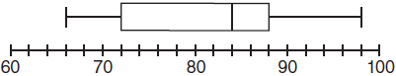

What percentage of the test scores are less than 72?
1) | 25
2) | 50
3) | 75
4) | 100

13 The box-and-whisker plot below represents the ages of 12 people.

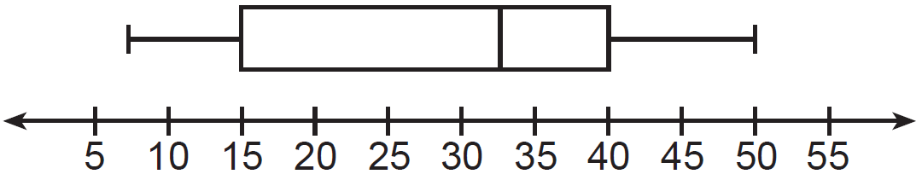

What percentage of these people are age 15 or older?
1) | 25
2) | 35
3) | 75
4) | 85

14 The box-and-whisker plot below represents a set of grades in a college statistics class.

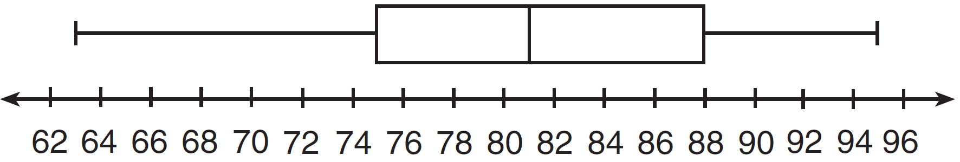

Which interval contains exactly 50% of the grades?
1) | 63-88
2) | 63-95
3) | 75-81
4) | 75-88

15 The box-and-whisker plot below represents the results of tests scores in a math class.

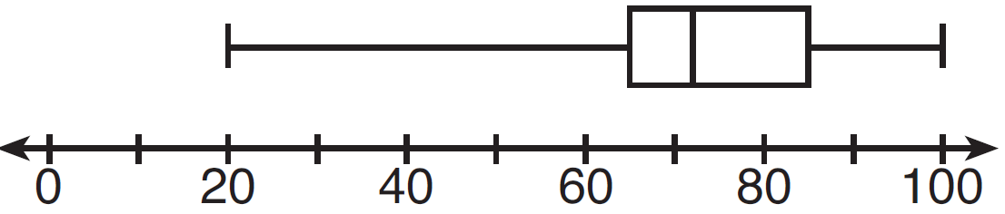

What do the scores 65, 85, and 100 represent?
1) | , median,
2) | , , maximum
3) | median, , maximum
4) | minimum, median, maximum

16 The box-and-whisker plot shown below represents the number of magazine subscriptions sold by members of a club.

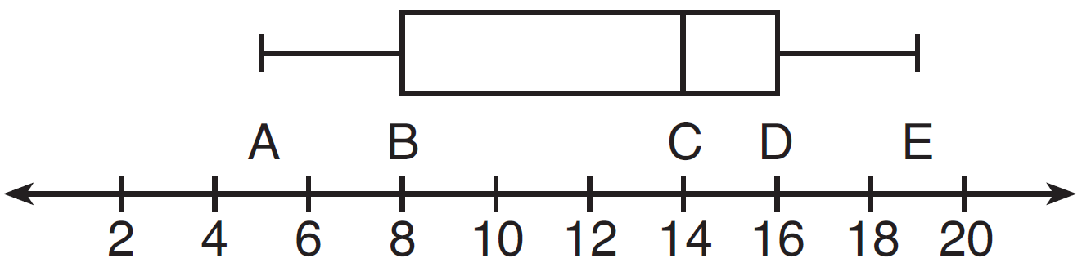

Which statistical measures do points B, D, and E represent, respectively?
1) | minimum, median, maximum
2) | first quartile, median, third quartile
3) | first quartile, third quartile, maximum
4) | median, third quartile, maximum

17 A movie theater recorded the number of tickets sold daily for a popular movie during the month of June. The box-and-whisker plot shown below represents the data for the number of tickets sold, in hundreds.

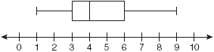

Which conclusion can be made using this plot?
1) | The second quartile is 600.
2) | The mean of the attendance is 400.
3) | The range of the attendance is 300 to 600.
4) | Twenty-five percent of the attendance is between 300 and 400.

18 Based on the box-and-whisker plot below, which statement is false?

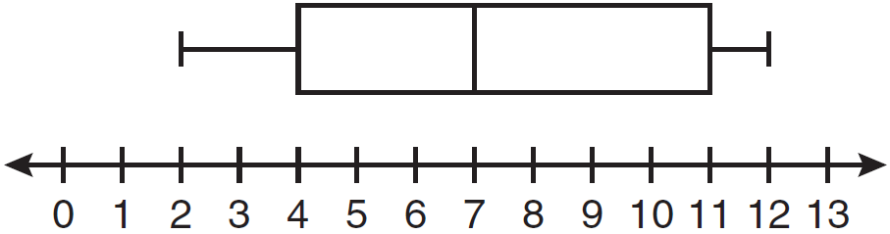
1) | The median is 7.
2) | The range is 12.
3) | The first quartile is 4.
4) | The third quartile is 11.

19 Below are two representations of data.

A:

B: 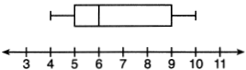

Which statement about A and B is true?
1) | median of A > median of B
2) | range of A < range of B
3) | upper quartile of A < upper quartile of B
4) | lower quartile of A > lower quartile of B

20 Which statistic can not be determined from a box plot representing the scores on a math test in Mrs. DeRidder's algebra class?
1) | the lowest score
2) | the median score
3) | the highest score
4) | the score that occurs most frequently

1 ANS: 2 REF: 011512ia

2 ANS: 3
The median score is the vertical line in the center of the box.

REF: 010301a

3 ANS: 2
The median score is the vertical line in the center of the box.

REF: 060610a

4 ANS: 3
The value of the third quartile is the last vertical line of the box.

REF: 080818ia

5 ANS: 3
The value of the third quartile is the last vertical line of the box.

REF: 012306ai

6 ANS: 2 REF: 061805ai

7 ANS: 3
The value of the third quartile is the last vertical line of the box.

REF: 082307ai

8 ANS: 3
The value of the upper quartile is the last vertical line of the box.

REF: 060915ia

9 ANS: 1

REF: 081915ai

10 ANS: 3

REF: 011113ia

11 ANS: 2

REF: 062413ai

12 ANS: 1 REF: 011001ia

13 ANS: 3 REF: 011220ia

14 ANS: 4 REF: 081312ia

15 ANS: 2 REF: 061314ia

16 ANS: 3 REF: 011408ia

17 ANS: 4 REF: 010929ia

18 ANS: 2 REF: 081106ia

19 ANS: 3 REF: 062119ai

20 ANS: 4 REF: 08160

