1 The accompanying diagram is an example of which type of graph?

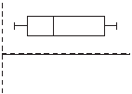
1) | bar graph
2) | stem-and-leaf plot
3) | histogram
4) | box-and-whisker plot

2 The heights, in inches, of eight football players are given below.
76, 70, 72, 70, 69, 71, 78, 74
Which box plot represents these data?
1) | 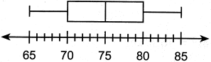
2) | 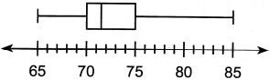
3) | 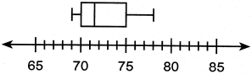
4) | 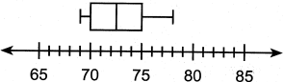

3 The students in Ms. Glenn's math class earned the grades shown below.
Which box-and-whisker plot represents these data?
1) | 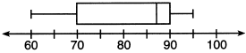
2) | 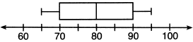
3) | 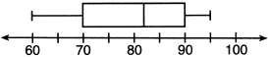
4) | 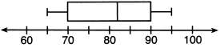

4 The data set 5, 6, 7, 8, 9, 9, 9, 10, 12, 14, 17, 17, 18, 19, 19 represents the number of hours spent on the Internet in a week by students in a mathematics class. Which box-and-whisker plot represents the data?
1) | 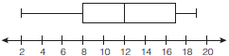
2) | 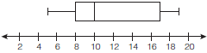
3) | 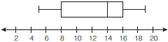
4) | 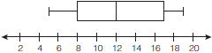

5 Using his data on annual deer population in a forest, Noj found the following information:
25th percentile: 12
50th percentile: 15
75th percentile: 22
Minimum population: 8
Maximum population: 27
Using the number line below, construct a box-and-whisker plot to display these data.

6 The data set 20, 36, 52, 56, 24, 16, 40, 4, 28 represents the number of books purchased by nine book club members in a year. Construct a box plot for these data on the number line below.

7 The test scores from Mrs. Gray’s math class are shown below.
72, 73, 66, 71, 82, 85, 95, 85, 86, 89, 91, 92
Construct a box-and-whisker plot to display these data.

8 Robin collected data on the number of hours she watched television on Sunday through Thursday nights for a period of 3 weeks. The data are shown in the table below.

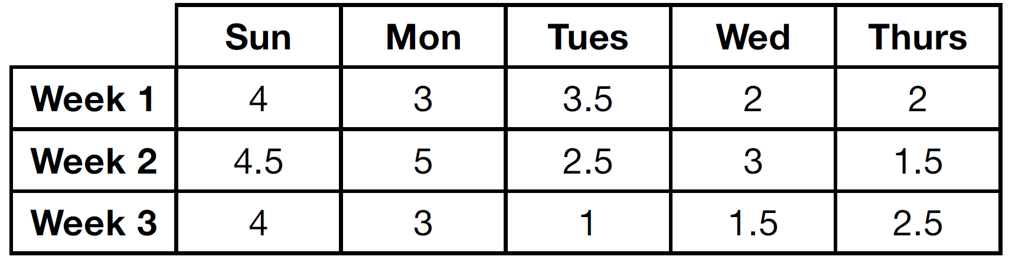

Using an appropriate scale on the number line below, construct a box plot for the 15 values.

9 The number of songs fifteen students have on their MP3 players is:
120, 124, 132, 145, 200, 255, 260, 292,
308, 314, 342, 407, 421, 435, 452
State the values of the minimum, 1st quartile, median, 3rd quartile, and maximum. Using these values, construct a box-and-whisker plot using an appropriate scale on the line below.

10 During the last 15 years of his baseball career, Andrew hit the following number of home runs each season.
State and label the values of the minimum, 1st quartile, median, 3rd quartile, and maximum. Using the line below, construct a box-and-whisker plot for this set of data.

11 Using the line provided, construct a box-and-whisker plot for the 12 scores below.
26, 32, 19, 65, 57, 16, 28, 42, 40, 21, 38, 10

Determine the number of scores that lie above the 75th percentile.
1 ANS: 4 REF: 060220a

2 ANS: 3
69,70,70,71,72,74,76,78 ordered. median: 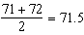

REF: 082409ai

3 ANS: 4 REF: 061616ia

4 ANS: 2
The median score, 10, is the vertical line in the center of the box.

REF: fall0709ia

5 ANS:

REF: 081431ia

6 ANS:
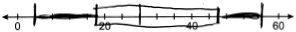

REF: 062328ai

7 ANS:
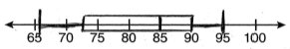

REF: 080939ia

8 ANS:
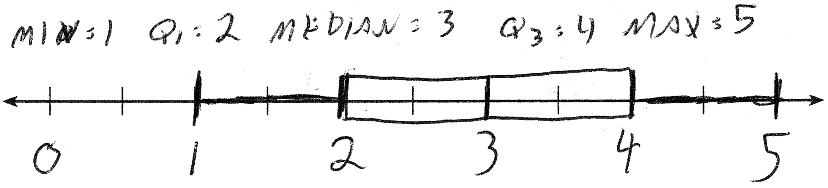

REF: 061432ai

9 ANS:
minimum is 120, 1st quartile is 145, median is 292, 3rd quartile is 407, and maximum is 452
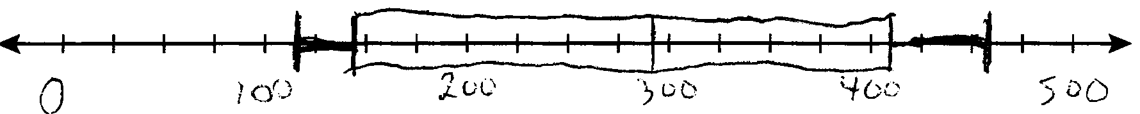

REF: 081034ia

10 ANS:
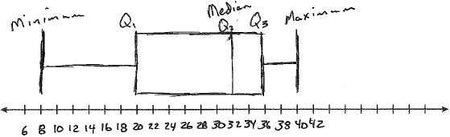
Min: 8, Q1: 20, Med: 32, Q3: 36, Max: 40

REF: 061439ia

11 ANS:
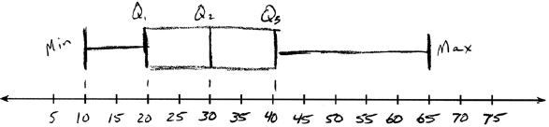. Three scores are above 41.

REF: 011337ia

