1 A company wishes to determine the cooking time for one pound of spaghetti. The company's technicians cooked one pound of spaghetti and recorded the time needed for the spaghetti to be ready to eat. Repeating this process 35 times resulted in an approximately normal distribution, with a mean of 9.82 minutes and a standard deviation of 1.4 minutes. In which interval should the middle 95% of cooking times fall?
1) |  | 3)
2) |  | 4)

2 A public opinion poll was conducted on behalf of Mayor Ortega's reelection campaign shortly before the election. 264 out of 550 likely voters said they would vote for Mayor Ortega; the rest said they would vote for his opponent. Which statement is least appropriate to make, according to the results of the poll?
1) | There is a 48% chance that Mayor Ortega will win the election. | 3) | It is most likely that between 44% and 52% of voters will vote for Mayor Ortega.
2) | The point estimate of voters who will vote for Mayor Ortega is 48%. | 4) | Due to the margin of error, an inference cannot be made regarding whether Mayor Ortega or his opponent is most likely to win the election.

3 The Hot and Tasty Coffee chain conducts a survey of its customers at its location at the Staten Island ferry terminal. After the survey is completed, the statistical consultant states that 70% of customers who took the survey said the most important factor in choosing where to get their coffee is how fast they are served. Based on this result, Hot and Tasty Coffee can infer that
1) | most of its customers in New York State care most about being served quickly | 3) | most of its customers at the Staten Island ferry terminal care most about being served quickly
2) | coffee drinkers care less about taste and more about being served quickly | 4) | most of its customers at transportation terminals and stations care most about being served quickly

4 Two surveys were conducted to estimate the proportion of teens who use social media at least once per day.
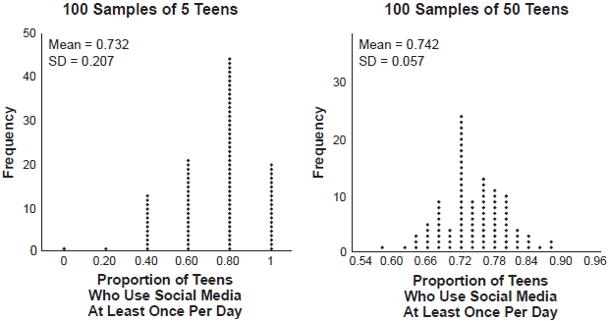

Based on these results, it was determined that approximately 75% of teens use social media at least once per day. What is the best explanation of the difference in the results between the two surveys?
1) | The smaller sample size of five teens resulted in a smaller margin of error and should provide a more accurate estimate. | 3) | The larger sample size of 50 teens resulted in a smaller margin of error and should provide a more accurate estimate.
2) | The smaller sample size of five teens resulted in a bigger margin of error and should provide a more accurate estimate. | 4) | The larger sample size of 50 teens resulted in a bigger margin of error and should provide a more accurate estimate.

5 A survey was given to 1250 randomly selected high school students at the end of their junior year. The survey offered four post-graduation options: two-year college, four-year college, military, or work. Of the 1250 responses, 475 chose a four-year college. State one possible conclusion that can be made about the population of high school juniors, based on this survey.

6 An orange-juice processing plant receives a truckload of oranges. The quality control team randomly chooses three pails of oranges, each containing 50 oranges, from the truckload. Identify the sample and the population in the given scenario. State one conclusion that the quality control team could make about the population if 5% of the sample was found to be unsatisfactory.

7 Elizabeth waited for 6 minutes at the drive thru at her favorite fast-food restaurant the last time she visited. She was upset about having to wait that long and notified the manager. The manager assured her that her experience was very unusual and that it would not happen again. A study of customers commissioned by this restaurant found an approximately normal distribution of results. The mean wait time was 226 seconds and the standard deviation was 38 seconds. Given these data, and using a 95% level of confidence, was Elizabeth’s wait time unusual? Justify your answer.
1 ANS: 2

REF: 012411aii

2 ANS: 1 REF: 081722aii

3 ANS: 3 REF: 082201aii

4 ANS: 3 REF: 012418aii

5 ANS:
About 38% 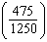 of high school juniors in the population will choose a four-year college.

REF: 012432aii

6 ANS:
sample: pails of oranges; population: truckload of oranges. It is likely that about 5% of all the oranges are unsatisfactory.

REF: 011726aii

7 ANS:
Using a 95% level of confidence, standard deviations sets the usual wait time as 150-302 seconds. 360 seconds is unusual.

REF: 081629aii

