1 In the diagram below, the spinner is divided into eight equal regions.

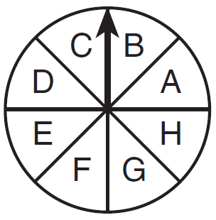

Which expression represents the probability of the spinner landing on B exactly three times in five spins?
1) | 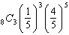
2) | 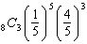
3) | 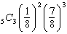
4) | 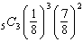

2 A spinner is divided into five equal sectors labeled 1 to 5. What is the probability of spinning exactly 3 even numbers in 4 spins?
1) | 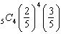
2) | 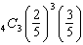
3) | 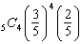
4) | 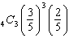

3 The fair spinner shown in the diagram below is spun three times. What is the probability of getting a C exactly twice?

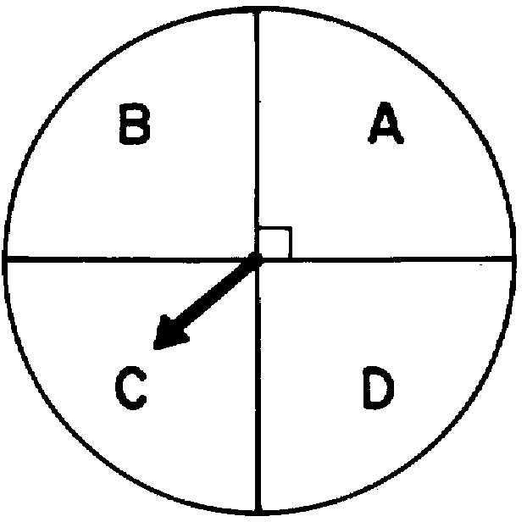
1)
2)
3)
4)

4 If the spinner below is spun five times, what is the probability that it will land in the green area exactly three times?

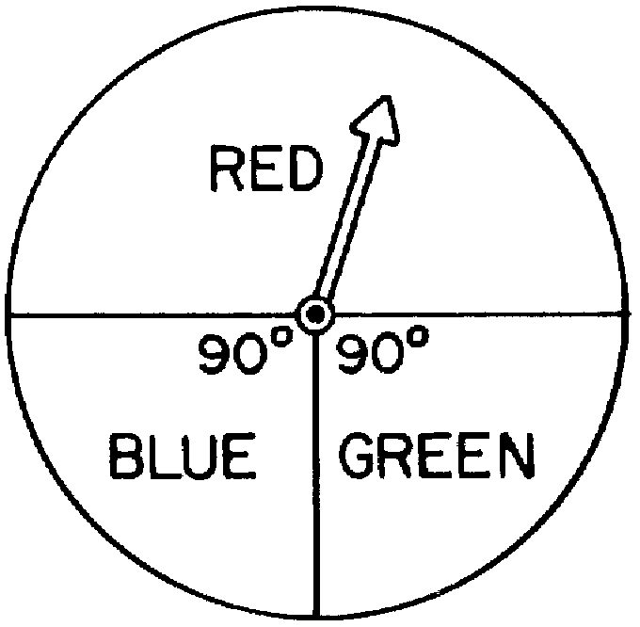
1)
2)
3)
4)

5 A spinner is divided into eight equal sections. Five sections are red and three are green. If the spinner is spun three times, what is the probability that it lands on red exactly twice?
1)
2)
3)
4)

6 In the accompanying diagram, a circle with a spinner is divided into three regions such that 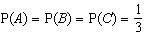.
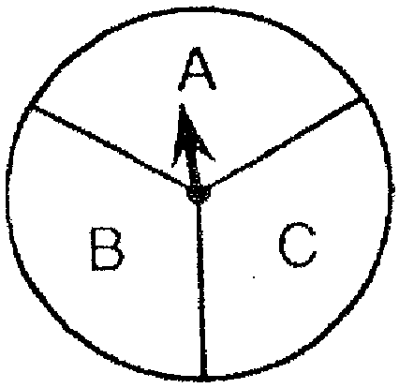

If the spinner is spun five times, what is the probability that it will land in region A at most two times?

7 The circle in the accompanying diagram is divided into six regions of equal area and has a spinner. The regions are labeled 1, 3, 6, 9, 12, and 15. If the spinner is spun five times, what is the probability that it will land in an even-numbered region at most two times?

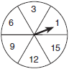

8 A board game has a spinner on a circle that has five equal sectors, numbered 1, 2, 3, 4, and 5, respectively. If a player has four spins, find the probability that the player spins an even number no more than two times on those four spins.

9 A circle that is partitioned into five equal sectors has a spinner. The colors of the sectors are red, orange, yellow, blue, and green. If four spins are made, find the probability that the spinner will land in the green sector
(1) on exactly two spins
(2) on at least three spins

10 A spinner is divided into two regions, green and red. The probability of the pointer landing on the green region is . The pointer is spun 5 times. What is the probability of the pointer landing on the green region exactly 2 times? What is the probability of the pointer landing on the red region at least 4 times?

11 The circle shown in the accompanying diagram is divided into five regions of equal area labeled as shown. On any spin of the spinner, the probability of stopping on any of the regions is the same.

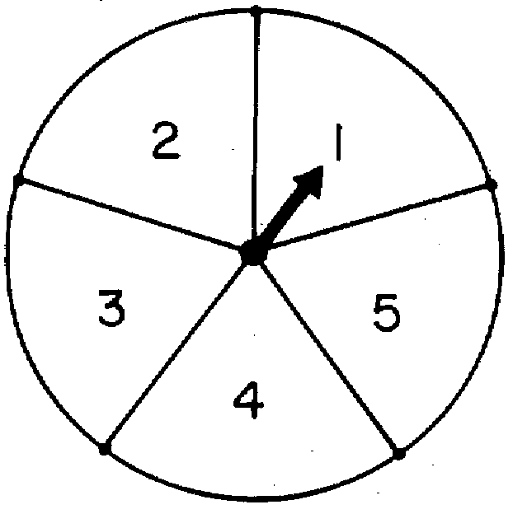

a Find: P(3); P(even); P(odd)
b Find the probability of:
(1) spinning exactly 3 odd numbers on 4 random spins
(2) spinning at least 3 even numbers on 4 random spins

12 The diagram below shows a disc with an arrow that can be spun so that it has an equal chance of landing on one of the 5 regions of the disc.

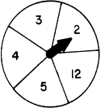

What is the probability that it will land on a prime number? If the spinner is spun 3 times, determine the probability that the spinner will land on a prime number.
(1) exactly twice
(2) at least twice
(2) no more than twice

13 In the accompanying diagram, the circle is divided into five equal sections. Assume an unbiased experiment when a spinner is spun.

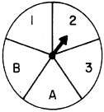

a If the spinner is spun once, find: P(B); P(number)
b If the spinner is spun three times, determine the probability it will land on
(1) no B’s
(2) at least two numbers
(3) no more than one number

14 In the accompanying diagram, a regular hexagon with a spinner is divided into six equal areas labeled with a letter or number.

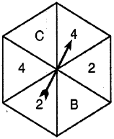

If the spinner is spun four times, find the probability that it will land in a
(1) numbered area at most one time
(2) lettered area at least three times

15 A spinner is divided into six equal sections and labeled as shown in the accompanying diagram.

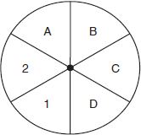

Determine the probability of getting a letter in one spin. Determine the probability of getting no letters in three spins. Determine the probability of getting at least two letters in three spins.

16 Circle O is partitioned into four regions as shown, with a diameter. Assume an unbiased experiment when a spinner is spun.

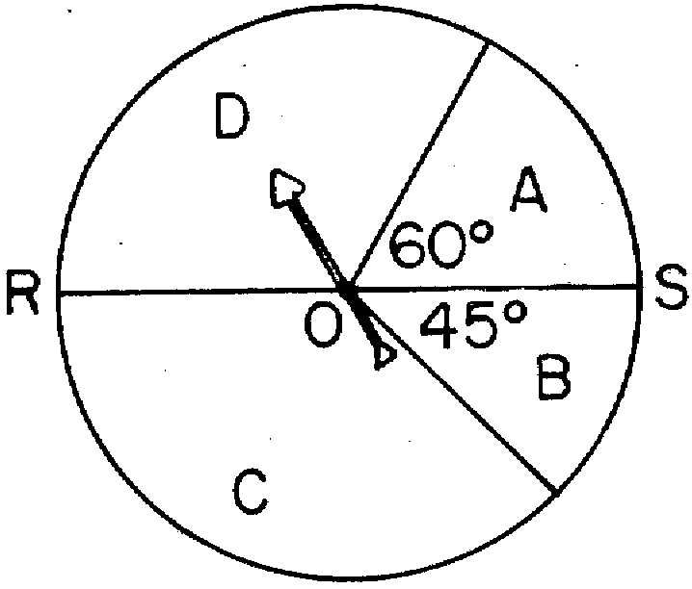

If the spinner is spun once, determine the probability that the spinner will stop in
(1) region A
(2) region C
(3) region D
If the spinner is spun three times, what is the probability that
(1) the spinner will stop in region A exactly twice
(2) the spinner will stop in region D at least twice

17 In the diagram below, regular pentagon ABCDE is inscribed in circle O. Radii , , and divide the pentagon into regions 1, 2, 3. Assume an unbiased experiment when the spinner is spun.

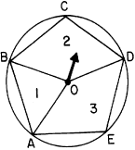

If the spinner is spun once, determine the probability that it will stop
(1) in region 1
(2) in region 2
If the spinner is spun three times, determine the probability that it will stop
(1) in region 1 no more than once
(2) in region 2 at least twice
(3) in region 2 exactly once

18 In the accompanying diagram, circle O is partitioned into six regions by diameters , , , , and .

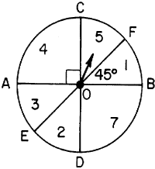

a If the spinner is spun once, determine: P(3); P(EVEN); P(7)
b Determine the probability of obtaining:
(1) exactly two EVEN's on three spins
(2) no more than one 3 on three spins
(3) exactly one 7 on four spins

19 In the accompanying diagram, the circle is divided into four sections as shown, and

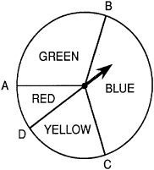

a If the spinner is spun once, find: P(RED); P(GREEN)
b Determine the probability of obtaining:
(1) exactly two GREEN's in three spins
(2) at least three RED's in four spins
(3) at most two YELLOW's in three spins
1 ANS: 4 REF: 011605a2

2 ANS: 2 REF: 069926siii

3 ANS: 4 REF: 069029siii

4 ANS: 3 REF: 088635siii

5 ANS: 4
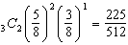

REF: 011221a2

6 ANS:

REF: 019437siii

7 ANS:

REF: 060142siii

8 ANS:
0.821. The probability of spinning an even number is P(0 evens) = 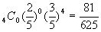 + P(1 evens) = 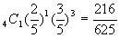 + P(2 evens) = 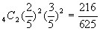

REF: 010428b

9 ANS:
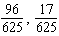

REF: 069739siii

10 ANS:
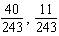

REF: 088942siii

11 ANS:
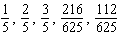

REF: 018538siii

12 ANS:
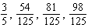

REF: 018741siii

13 ANS:
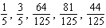

REF: 088942siii

14 ANS:
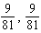

REF: 019739siii

15 ANS:
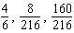

REF: 080342siii

16 ANS:
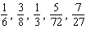

REF: 068540siii

17 ANS:
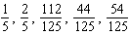

REF: 068742siii

18 ANS:
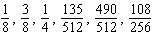

REF: 018939siii

19 ANS:
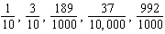

REF: 089042siii

