1 For a member of a certain species of bird, the probability of surviving to adulthood is . In a nest of five eggs, what is the probability, to the nearest hundredth, that at least four eggs will survive to adulthood?
1) | 0.23
2) | 0.29
3) | 0.63
4) | 0.94

2 The members of a men’s club have a choice of wearing black or red vests to their club meetings. A study done over a period of many years determined that the percentage of black vests worn is 60%. If there are 10 men at a club meeting on a given night, what is the probability, to the nearest thousandth, that at least 8 of the vests worn will be black?

3 The probability of rain on the last day of July is 90%. If the probability remains constant for the first seven days of August, what is the probability that it will rain at least six of those seven days in August?

4 East West Airlines has a good reputation for being on time. The probability that one of its flights will be on time is .91. If Mrs. Williams flies East West for her next five flights, what is the probability that at least three of them will be on time? Round your answer to the nearest thousandth.

5 Because Sam’s backyard gets very little sunlight, the probability that a geranium planted there will flower is 0.28. Sam planted five geraniums. Determine the probability, to the nearest thousandth, that at least four geraniums will flower.

6 Dave is the manager of a construction supply warehouse and notes that 60% of the items purchased are heating items, 25% are electrical items, and 15% are plumbing items. Find the probability that at least three out of the next five items purchased are heating items.

7 On any given day, the probability that the entire Watson family eats dinner together is . Find the probability that, during any 7-day period, the Watsons eat dinner together at least six times.

8 The probability that the Stormville Sluggers will win a baseball game is . Determine the probability, to the nearest thousandth, that the Stormville Sluggers will win at least 6 of their next 8 games.

9 Tim Parker, a star baseball player, hits one home run for every ten times he is at bat. If Parker goes to bat five times during tonight’s game, what is the probability that he will hit at least four home runs?

10 On mornings when school is in session in January, Sara notices that her school bus is late one-third of the time. What is the probability that during a 5-day school week in January her bus will be late at least three times?

11 The probability that a planted watermelon seed will sprout is . If Peyton plants seven seeds from a slice of watermelon, find, to the nearest ten thousandth, the probability that at least five will sprout.

12 The probability that a professional baseball player will get a hit is . Calculate the exact probability that he will get at least 3 hits in 5 attempts.

13 Dave does not tell the truth of the time. Find the probability that he will tell the truth at most twice out of the next five times.

14 If the probability of winning a game is , find the probability of winning at least 3 games out of 4.

15 Team A and team B are playing in a league. They will play each other five times. If the probability that team A wins a game is , what is the probability that team A will win at least three of the five games?

16 The probability of a biased coin coming up tails is . When the coin is flipped four times, what is the probability of obtaining at least two tails?

17 The probability of a biased coin coming up heads is . When the coin is flipped three times, what is the probability of at least two heads? When the coin is flipped four times, what is the probability of at most one head?

18 The probability of rain on any given day is . What is the probability of at most one day of rain during the next three days?

19 In a baseball game, the probability that Peter gets on base safely is . If he comes to bat four times, what is the probability that he will get on base safely at least three times?

20 During the school year, Michele receives four report cards. The probability that she will get an A in mathematics on any one report card is . What is the probability that she will get an A in mathematics on at least three of the four report cards?

21 A study shows that 35% of the fish caught in a local lake had high levels of mercury. Suppose that 10 fish were caught from this lake. Find, to the nearest tenth of a percent, the probability that at least 8 of the 10 fish caught did not contain high levels of mercury.

22 As shown in the accompanying diagram, a circular target with a radius of 9 inches has a bull’s-eye that has a radius of 3 inches. If five arrows randomly hit the target, what is the probability that at least four hit the bull’s-eye?

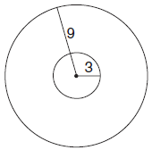

23 According to a federal agency, when a lie detector test is given to a truthful person, the probability that the test will show that the person is not telling the truth is 20%. If a company interviews five truthful candidates for a job and asks about thefts from prior employers, what is the probability a lie detector test will show that at most one candidate is not telling the truth?

24 Whenever Sara rents a movie, the probability that it is a horror movie is 0.57. Of the next five movies she rents, determine the probability, to the nearest hundredth, that no more than two of these rentals are horror movies.

25 Mrs. Gruber gave her history class a multiple choice quiz containing five questions. A student must answer at least four questions correctly to pass. Greg decided to guess on every question. If each of the four possible answers to each question is equally likely to be chosen, what is the probability that Greg passed the quiz?

26 A mathematics quiz has five multiple-choice questions. There are four possible responses for each question. Jennifer selects her responses at random on every question. What is the probability she will select the correct response for at most one question? What is the probability she will select the correct response to at least three questions?

27 In the accompanying diagram, the triangular pad is divided into nine keys. The probability of pressing any key at random is the same.

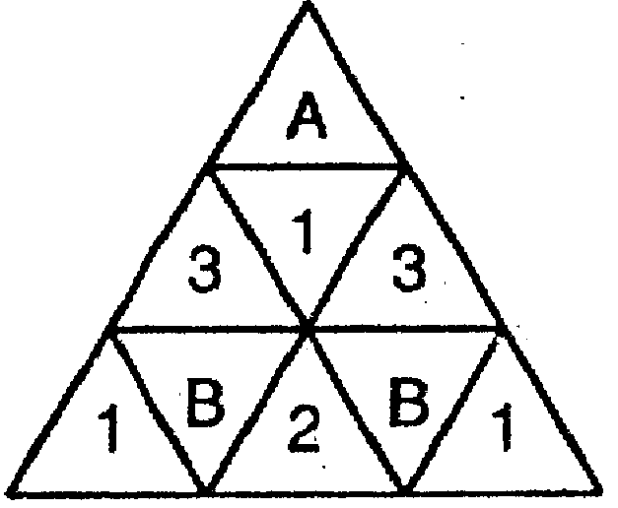

Find the probability of pressing
(1) a letter key
(2) exactly two number keys on three random tries
(3) at least two letter keys on three random tries

28 The sides of a square dartboard have length 10. Circle A, with an area of 9, and circle B, with an area of 16, lie inside the square and do not overlap. [Assume that a dart has an equal probability of landing anywhere on the board.]

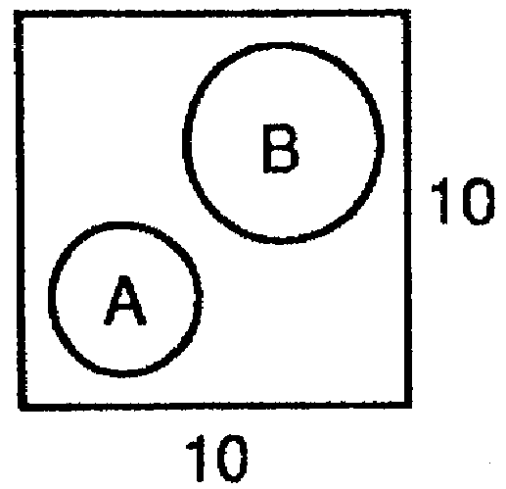

Find the probability that a dart hits the board
(1) inside circle A
(2) inside circle B
(3) outside both circles
If a dart hits the board three times, find the probability that it lands outside both circles at most once.
1 ANS: 2
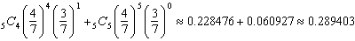
REF: 081619a2

2 ANS:
0.167.
REF: 061036a2

3 ANS:
0.8503056. P(6 days) = + P(7 days) =
REF: 060830b

4 ANS:
0.994. P(3 times) = + P(4 times) = + P(5 times) =
REF: 080830b

5 ANS:
REF: 011437a2

6 ANS:
0.68256. P(3 items) = + P(4 items) = + P(5 items) =
REF: 080928b

7 ANS:
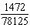. P(6 dinners) = 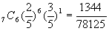 + P(7 dinners) = 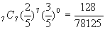
REF: 060331b

8 ANS:
0.468. 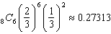. 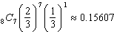. .
REF: 011138a2

9 ANS:
0.00046. P(4 homers) = 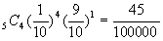 + P(5 homers) = 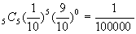
REF: 080430b

10 ANS:
. P(3 times late) = 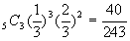 + P(4 times late) = 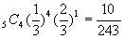 + P(5 times late) = 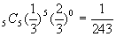
REF: 080630b

11 ANS:
0.7564. P(5 sprouts) = 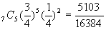 + P(6 sprouts) = 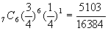 + P(7 sprouts) = 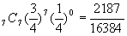
REF: 060529b

12 ANS:
. 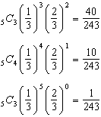
REF: 061138a2

13 ANS:
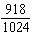. The probability Dave will tell the truth is P(0) = 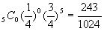 + P(1) = 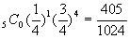 + P(2) = 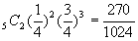
REF: 060930b

14 ANS:
REF: 068118siii

15 ANS:
. P(3 wins) = + P(4 wins) = + P(5 wins) =
REF: 010229b

16 ANS:
REF: 069941siii

17 ANS:
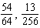
REF: 089642siii

18 ANS:
REF: 068819siii

19 ANS:
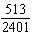
REF: 010142siii

20 ANS:
REF: 060241siii

21 ANS:
26.2%.
REF: 081038a2

22 ANS:
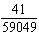. The areas of the circles are 81π and 9π. Therefore the probability of hitting the bull’s-eye is 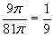. P(4 hits) = 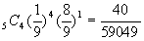 + P(5 hits) = 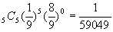
REF: 080128b

23 ANS:
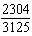
REF: 011030b

24 ANS:
REF: 061438a2

25 ANS:
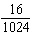
REF: 010441siii

26 ANS:
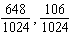
REF: 019941siii

27 ANS:
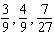
REF: 089540siii

28 ANS:
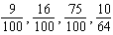
REF: 069438siii

