1 A fair coin is tossed 5 times. What is the probability that it lands tails up exactly 3 times?
1)  2) 3)  4) 

2 If the probability that the Islanders will beat the Rangers in a game is , which expression represents the probability that the Islanders will win exactly four out of seven games in a series against the Rangers?
1)  2) 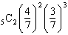 3) 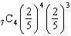 4) 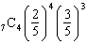

3 Gordon tosses a fair die six times. What is the probability that he will toss exactly two 5’s?
1) 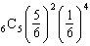 2) 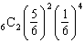 3) 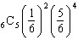 4) 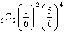

4 If a fair die is tossed five times, what is the probability of getting exactly three 6’s?
1) 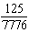 2) 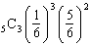 3) 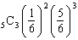 4) 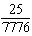

5 The probability that Kyla will score above a 90 on a mathematics test is . What is the probability that she will score above a 90 on three of the four tests this quarter?
1)  2) 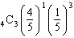 3)  4) 

6 Each day the probability of rain on a tropical island is . Which expression represents the probability that it will rain on the island exactly n days in the next three days?
1) 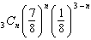 2) 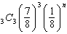 3) 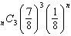 4)

7 A multiple-choice test has 4 possible choices for each question. A person guesses on 10 questions. What is the probability the person gets exactly 8 questions correct?
1) 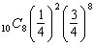 2) 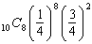 3) 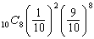 4) 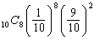

8 Pete and Sean decide to raise money for a charity by having a carnival in their backyard. In one of the games that they set up, the probability that a person will win is 0.4. If Robyn plays that game nine times, what is the probability that she wins exactly four times?
1) 2) 3) 4)

9 The Hiking Club plans to go camping in a State park where the probability of rain on any given day is 0.7. Which expression can be used to find the probability that it will rain on exactly three of the seven days they are there?
1) 2) 3) 4)

10 During a single day at radio station WMZH, the probability that a particular song is played is .38. Which expression represents the probability that this song will be played on exactly 5 days out of 7 days?
1) 2) 3) 4)

11 Sean tells prospective clients that the probability of rain at the dive location is .2 each day. Which expression can be used to calculate the probability that it will rain on exactly 5 days of the 7 days at the dive location?
1) 2) 3) 4)

12 The probability of Gordon’s team winning any given game in a 5-game series is 0.3. What is the probability that Gordon’s team will win exactly 2 games in the series?
1) 2) 3) 4)

13 A study finds that 80% of the local high school students text while doing homework. Ten students are selected at random from the local high school. Which expression would be part of the process used to determine the probability that, at most, 7 of the 10 students text while doing homework?
1) 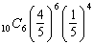 2) 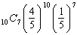 3) 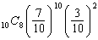 4) 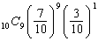
1 ANS: 3 REF: fall9918b

2 ANS: 4 REF: 010903b

3 ANS: 4 REF: 069723siii

4 ANS: 2 REF: 089822siii

5 ANS: 1 REF: 010302b

6 ANS: 1 REF: 069629siii

7 ANS: 2 REF: 061604a2

8 ANS: 3 REF: 061001b

9 ANS: 1 REF: 060402b

10 ANS: 2 REF: 060702b

11 ANS: 1 REF: 010805b

12 ANS: 3 REF: 019730siii

13 ANS: 1 REF: 061223a2

