1 In a group of 40 people, 20 have brown hair, 22 have blue eyes, and 15 have both brown hair and blue eyes. How many people have neither brown hair nor blue eyes?
1) 0 2) 13 3) 27 4) 32

2 In a survey of people who recently bought a laptop, 45% said they were looking for a large screen, 31% said they were looking for a fast processor, and 58% said they wanted a large screen or a fast processor. If a survey respondent is selected at random, what is the probability that the respondent wanted both a large screen and a fast processor?
1) 76% 2) 14% 3) 77% 4) 18%

3 The probability of having math homework is and the probability of having English homework is . The probability of having math homework or having English homework is . What is the probability of having math homework and having English homework?
1) 2) 3) 4)

4 A suburban high school has a population of 1376 students. The number of students who participate in sports is 649. The number of students who participate in music is 433. If the probability that a student participates in either sports or music is 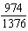, what is the probability that a student participates in both sports and music?

5 At Andrew Jackson High School, students are only allowed to enroll in AP U.S. History if they have already taken AP World History or AP European History. Out of 825 incoming seniors, 165 took AP World History, 66 took AP European History, and 33 took both. Given this information, determine the probability a randomly selected incoming senior is allowed to enroll in AP U.S. History.

6 Given events A and B, such that , , and , determine whether A and B are independent or dependent.

7 A student is chosen at random from the student body at a given high school. The probability that the student selects Math as the favorite subject is . The probability that the student chosen is a junior is . If the probability that the student selected is a junior or that the student chooses Math as the favorite subject is , what is the exact probability that the student selected is a junior whose favorite subject is Math? Are the events "the student is a junior" and "the student's favorite subject is Math" independent of each other? Explain your answer.

8 In contract negotiations between a local government agency and its workers, it is estimated that there is a 50% chance that an agreement will be reached on the salaries of the workers. It is estimated that there is a 70% chance that there will be an agreement on the insurance benefits. There is a 20% chance that no agreement will be reached on either issue. Find the probability that an agreement will be reached on both issues. Based on this answer, determine whether the agreement on salaries and the agreement on insurance are independent events. Justify your answer.
1 ANS: 2

REF: 062204aii

2 ANS: 4

REF: 082307aii

3 ANS: 3
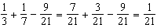

REF: 082410aii

4 ANS:

REF: 061629aii

5 ANS:
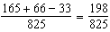

REF: 081925aii

6 ANS:
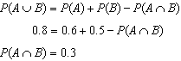 A and B are independent since 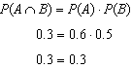

REF: 081632aii

7 ANS:
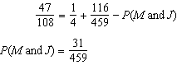; No, because 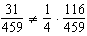
REF: 011834aii

8 ANS:
This scenario can be modeled with a Venn Diagram: 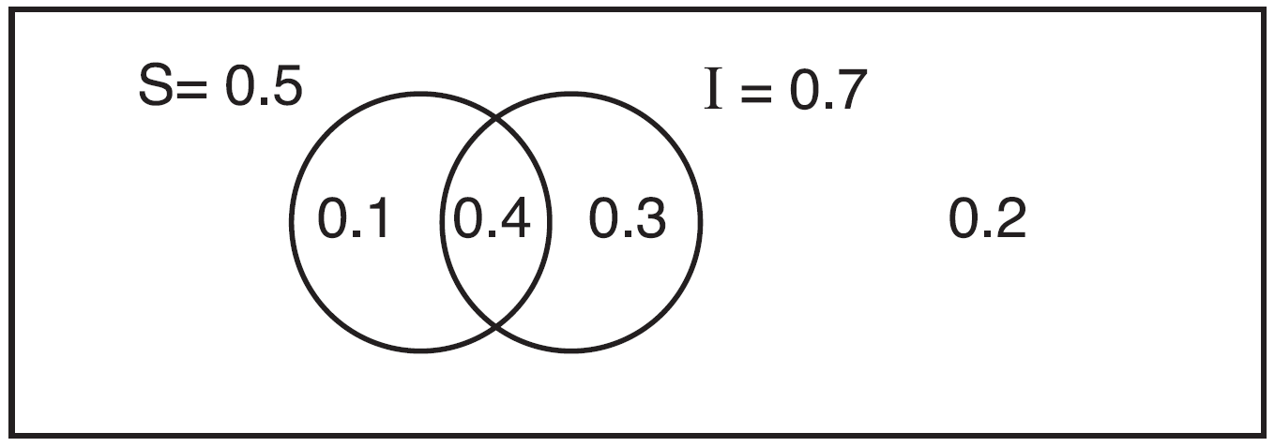 Since . Then, 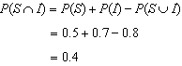 If S and I are independent, then the Product Rule must be satisfied. However, . Therefore, salary and insurance have not been treated independently.
REF: spr1513aii

