1 Given 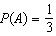 and 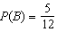, where A and B are independent events, determine .

2 A dartboard is shown in the diagram below. The two lines intersect at the center of the circle, and the central angle in sector 2 measures .

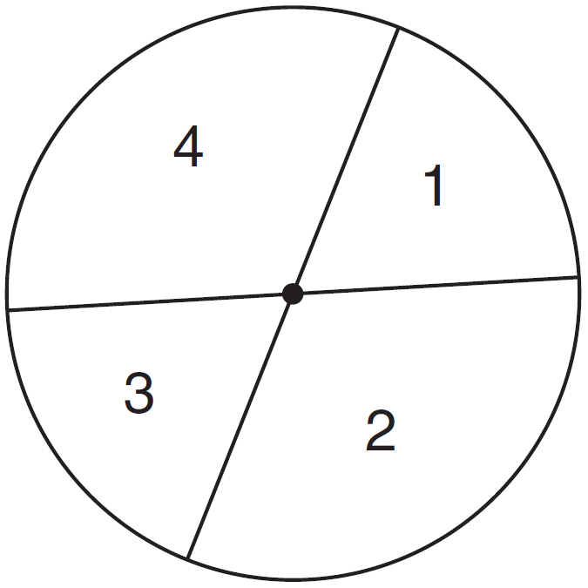

If darts thrown at this board are equally likely to land anywhere on the board, what is the probability that a dart that hits the board will land in either sector 1 or sector 3?
1) 2) 3) 4)

3 Suppose events A and B are independent and is 0.2. Which statement could be true?
1) 2) 3) 4)

4 On a given school day, the probability that Nick oversleeps is 48% and the probability he has a pop quiz is 25%. Assuming these two events are independent, what is the probability that Nick oversleeps and has a pop quiz on the same day?
1) 73% 2) 36% 3) 23% 4) 12%

5 Selena and Tracey play on a softball team. Selena has 8 hits out of 20 times at bat, and Tracey has 6 hits out of 16 times at bat. Based on their past performance, what is the probability that both girls will get a hit next time at bat?
1) 1 2) 3) 4)

6 The probability that the Cubs win their first game is . The probability that the Cubs win their second game is . What is the probability that the Cubs win both games?
1) 2) 3) 4)

7 The probability that Jinelle’s bus is on time is , and the probability that Mr. Corney is driving the bus is . What is the probability that on any given day Jinelle’s bus is on time and Mr. Corney is the driver?
1) 2) 3) 4)

8 The probability it will rain tomorrow is . The probability that our team will win tomorrow’s basketball game is . Which expression represents the probability that it will rain and that our team will not win the game?
1) 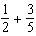 2) 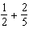 3) 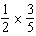 4) 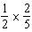

9 Three fair coins are tossed. What is the probability that two heads and one tail appear?
1) 2) 3) 4)

10 The probability that it will snow on Sunday is . The probability that it will snow on both Sunday and Monday is . What is the probability that it will snow on Monday, if it snowed on Sunday?
1) 2) 2 3) 4)

11 The probability that a student owns a dog is . The probability that the same student owns a dog and a cat is . Determine the probability that the student owns a cat.

12 A student council has seven officers, of which five are girls and two are boys. If two officers are chosen at random to attend a meeting with the principal, what is the probability that the first officer chosen is a girl and the second is a boy?
1) 2) 3) 4)

13 Bob and Laquisha have volunteered to serve on the Junior Prom Committee. The names of twenty volunteers, including Bob and Laquisha, are put into a bowl. If two names are randomly drawn from the bowl without replacement, what is the probability that Bob’s name will be drawn first and Laquisha’s name will be drawn second?
1) 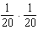 2) 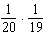 3) 4)

14 Mr. Yee has 10 boys and 15 girls in his mathematics class. If he chooses two students at random to work on the blackboard, what is the probability that both students chosen are girls?

15 There are four students, all of different heights, who are to be randomly arranged in a line. What is the probability that the tallest student will be first in line and the shortest student will be last in line?

16 There are six apples, five oranges, and one pear in John's basket. His friend takes three pieces of fruit at random without replacement. Determine the probability that all three fruits taken are apples.

17 Vince buys a box of candy that consists of six chocolate pieces, four fruit-flavored pieces, and two mint pieces. He selects three pieces of candy at random, without replacement. Calculate the probability that the first piece selected will be fruit flavored and the other two will be mint. Calculate the probability that all three pieces selected will be the same type of candy.

18 A bottle contains 12 red marbles and 8 blue marbles. A marble is chosen at random and not replaced. Then, a second marble is chosen at random. Determine the probability that the two marbles are not the same color. Determine the probability that at least one of the marbles is red.

19 A jar contains five red marbles and three green marbles. A marble is drawn at random and not replaced. A second marble is then drawn from the jar. Find the probability that the first marble is red and the second marble is green. Find the probability that both marbles are red. Find the probability that both marbles are the same color.

20 Throughout history, many people have contributed to the development of mathematics. These mathematicians include Pythagoras, Euclid, Hypatia, Euler, Einstein, Agnesi, Fibonacci, and Pascal. What is the probability that a mathematician’s name selected at random from those listed will start with either the letter E or the letter A?
1) 2) 3) 4)

21 The faces of a cube are numbered from 1 to 6. If the cube is tossed once, what is the probability that a prime number or a number divisible by 2 is obtained?
1) 2) 3) 4)

22 At a school fair, the spinner represented in the accompanying diagram is spun twice.

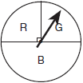

What is the probability that it will land in section G the first time and then in section B the second time?
1) 2) 3) 4)

23 Keisha is playing a game using a wheel divided into eight equal sectors, as shown in the diagram below. Each time the spinner lands on orange, she will win a prize.

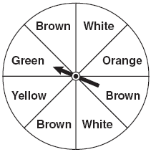

If Keisha spins this wheel twice, what is the probability she will win a prize on both spins?
1) 2) 3) 4)

24 Brianna is using the two spinners shown below to play her new board game. She spins the arrow on each spinner once. Brianna uses the first spinner to determine how many spaces to move. She uses the second spinner to determine whether her move from the first spinner will be forward or backward.

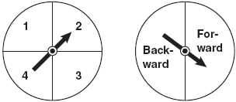

Find the probability that Brianna will move fewer than four spaces and backward.
1 ANS:
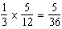

REF: 012327aii

2 ANS: 2
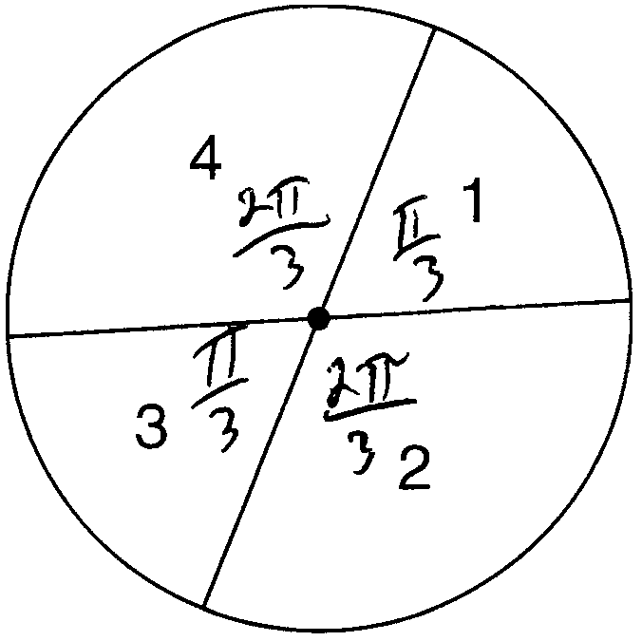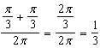

REF: 011108a2

3 ANS: 2
(1) , (2) , (3) 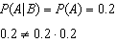, (4)

REF: 011912aii

4 ANS: 4

REF: 061811aii

5 ANS: 4
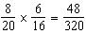

REF: 080430a

6 ANS: 2
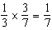

REF: 060529a

7 ANS: 2
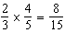

REF: 060821a

8 ANS: 4 REF: 081229ia

9 ANS: 2 REF: 011212ia

10 ANS: 3
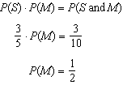

REF: 081024ia

11 ANS:
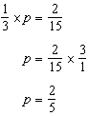

REF: 011533ia

12 ANS: 1
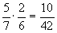

REF: 010525a

13 ANS: 2 REF: 060305a

14 ANS:
. 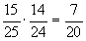

REF: 060130a

15 ANS:
. 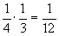

REF: 080127a

16 ANS:
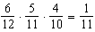

REF: 081435ia

17 ANS:
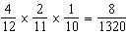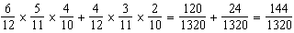

REF: 081137ia

18 ANS:
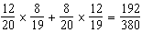. 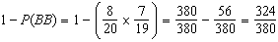

REF: 081339ia

19 ANS:
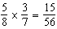. 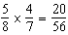. 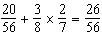

REF: 061338ia

20 ANS: 3 REF: fall0702ia

21 ANS: 2
The events are not mutually exclusive: P(prime) = , P(even) = , P(prime AND even) =
P(prime OR even) = 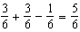

REF: 080830ia

22 ANS: 3
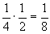

REF: 010106a

23 ANS: 1
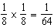

REF: 010928ia

24 ANS:
. 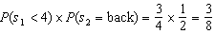

REF: 080832ia

