1 Monique has three sons who play football, two sons who play baseball, and one son who plays both sports. If all of her sons play baseball or football, how many sons does she have?
1) | 5
2) | 6
3) | 3
4) | 4

2 The accompanying diagram shows the results of a survey asking which sports the members of the Key Club watch on television.

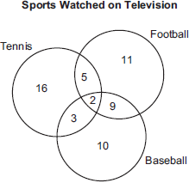

Which statement or statements are true?
I The most watched sport is tennis.
II The least watched sport is baseball.
III More Key Club members watch tennis than football.
1) | I, only
2) | II, only
3) | I and II, only
4) | II and III, only

3 In a class of 50 students, 18 take music, 26 take art, and 2 take both art and music. How many students in the class are not enrolled in either music or art?
1) | 6
2) | 8
3) | 16
4) | 24

4 In a class of 450 students, 300 are taking a mathematics course and 260 are taking a science course. If 140 of these students are taking both courses, how many students are not taking either of these courses?
1) | 30
2) | 40
3) | 110
4) | 140

5 Seventy-eight students participate in one or more of three sports: baseball, tennis, and golf. Four students participate in all three sports; five play both baseball and golf, only; two play both tennis and golf, only; and three play both baseball and tennis, only. If seven students play only tennis and one plays only golf, what is the total number of students who play only baseball?
1) | 12
2) | 44
3) | 56
4) | 60

6 In Ms. Wright’s English class, 16 students are in band, 7 students play sports, 3 students participate in both activities, and 9 students are not in band and do not play sports. How many students are in Ms. Wright’s English class?
1) | 10
2) | 26
3) | 29
4) | 35

7 A school newspaper took a survey of 100 students. The results of the survey showed that 43 students are fans of the Buffalo Bills, 27 students are fans of the New York Jets, and 48 students do not like either team. How many of the students surveyed are fans of both the Buffalo Bills and the New York Jets?
1) | 16
2) | 18
3) | 52
4) | 70

8 At an all-county music competition, 150 students participated. If 90 students sang in the chorus and 90 played in the band, how many students both sang in the chorus and played in the band?
1) | 0
2) | 30
3) | 60
4) | 240

9 The accompanying Venn diagram shows the number of students who take various courses. All students in circle A take mathematics. All in circle B take science. All in circle C take technology. What percentage of the students take mathematics or technology?

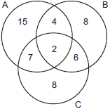

10 In a school of 320 students, 85 students are in the band, 200 students are on sports teams, and 60 students participate in both activities. How many students are not involved in either band or sports? Show how you arrived at your answer.

11 A school district offers hockey and basketball. The result of a survey of 300 students showed:
120 students play hockey, only
90 students play basketball, only
30 students do not participate in either sport
Of those surveyed, how many students play both hockey and basketball?

12 In a telephone survey of 100 households, 32 households purchased Brand A cereal and 45 purchased Brand B cereal. If 10 households purchased both items, how many of the households surveyed did not purchase either Brand A or Brand B cereal?

13 A car dealer has 22 vehicles on his lot. If 8 of the vehicles are vans and 6 of the vehicles are red, and 10 vehicles are neither vans nor red, how many red vans does he have on his lot?

14 The senior class at South High School consists of 250 students. Of these students, 130 have brown hair, 160 have brown eyes, and 90 have both brown hair and brown eyes. How many members of the senior class have neither brown hair nor brown eyes?

15 In a survey of 400 teenage shoppers at a large mall, 240 said they shopped at Abernathy's, 210 said they shopped at Bongo Republic, and 90 said they shopped at both stores. How many of the teenage shoppers surveyed did not shop at either store?

16 There are 30 students on a school bus. Of these students, 24 either play in the school band or sing in the chorus. Six of the students play in the school band but do not sing in the chorus. Fourteen of the students sing in the chorus and also play in the school band. How many students on the school bus sing in the chorus but do not play in the band?

17 In Clark Middle School, there are 60 students in seventh grade. If 25 of these students take art only, 18 take music only, and 9 do not take either art or music, how many take both art and music?

18 Jose surveyed 20 of his friends to find out what equipment they use to play recorded movies. He found that 12 of his friends have only DVD players, 5 have both DVD players and VCRs, and 2 have neither type of player. The rest of his friends have only VCRs. What is the total number of his friends that have VCRs?

1 ANS: 4

REF: 081320ia

2 ANS: 2
Key Club members watching: Tennis – 26; Football – 27; Baseball – 24. I The most watched sport IS NOT tennis. II The least watched sport IS baseball. III More Key Club members DO NOT watch tennis than football. Only statement II is true.

REF: 060203a

3 ANS: 2
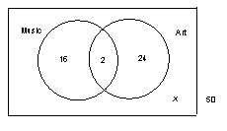. Start with 2 in the intersection of the two circles to represent the students taking both art and music. From this, you calculate that 16 (18–2) take music, only, and that 24 (26–2) take art, only. .

REF: 069919a

4 ANS: 1
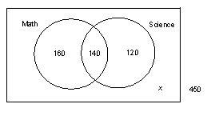. Start with 140 in the intersection of the two circles to represent the students taking both math and science. From this, you calculate that 160 (300–140) take math, only, and that 120 (260–140) take science, only. 

REF: 080117a

5 ANS: 3
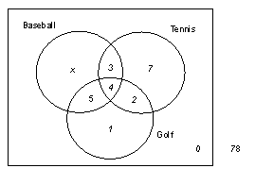. 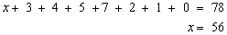

REF: 080419a

6 ANS: 3
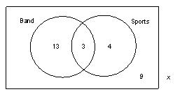. Start with 3 in the intersection of the two circles to represent the students participating in both band and sports. From this, you calculate that 13 (16–3) participate in band, only, and that 4 (7–3) participate in sports, only. 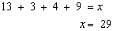

REF: 010519a

7 ANS: 2
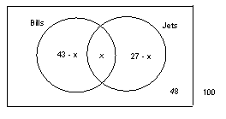. 

REF: 010815a

8 ANS: 2 REF: 060803a

9 ANS:
84%. 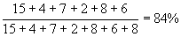

REF: 060026a

10 ANS:
95. 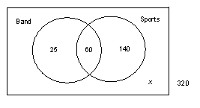. Start with 60 in the intersection of the two circles to represent the students that participate in both band and sports. From this, you calculate that 25 (85–60) participate in band, only, and that 140 (200–60) participate in sports, only. 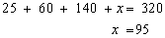

REF: spring9829a

11 ANS:
60. 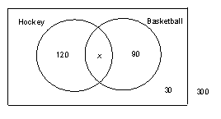. 

REF: 060121a

12 ANS:
33. 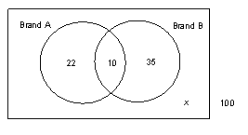. Start with 10 in the intersection of the two circles to represent the households that purchase both brands. From this, you calculate that 22 (32–10) households purchase Brand A, only, and that 35 (45–10) households purchase Brand B, only. 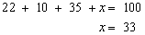

REF: 080226a

13 ANS:
2. 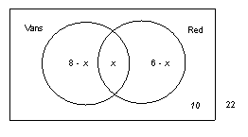. 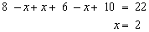

REF: 010434a

14 ANS:
50. 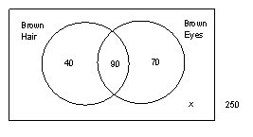. Start with 90 in the intersection of the two circles to represent the students that have both brown hair and brown eyes. From this, you calculate that 40 (130–90) students have brown hair, only, and that 70 (160–90) students have brown eyes, only. 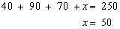

REF: 060436a

15 ANS:
40. 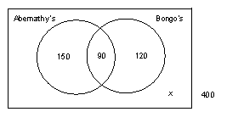. Start with 90 in the intersection of the two circles to represent the shoppers that shop at both Abernathy’s and Bongo’s. From this, you calculate that 150 (240–90) shop Abernathy’s, only, and that 120 (210–90) shop Bongo’s, only. 

REF: 060533a

16 ANS:
4. 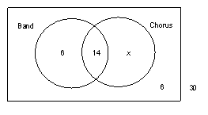. Find the number of students on the bus who neither play in the band nor sing in the chorus, which is 6 (30–24). 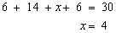

REF: 080532a

17 ANS:
8. 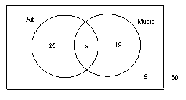. 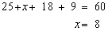

REF: 080631a

18 ANS:
6. 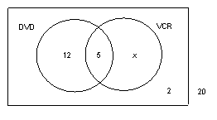. 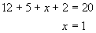. The total number of Jose’s friends that have VCRs is 6 (5+1).

REF: 060732a

