1 If the universal set is {pennies, nickels, dimes, quarters}, what is the complement of the set {nickels}?
1) | { }
2) | {pennies, quarters}
3) | {pennies, dimes, quarters}
4) | {pennies, nickels, dimes, quarters}

2 Given: 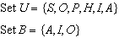
If set B is a subset of set U, what is the complement of set B?
1)
2)
3)
4)

3 Given: 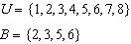
Set B is a subset of set U. What is the complement of set B?
1)
2)
3)
4)

4 Given:
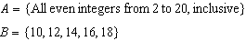
What is the complement of set B within the universe of set A?
1)
2)
3)
4)

5 Given:
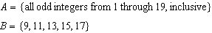
What is the complement of set B within set A?
1)
2)
3)
4)

6 Given:
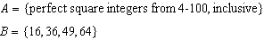
The complement of set B in the universal set A is
1)
2)
3)
4)

7 Given: 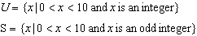
The complement of set S within the universal set U is
1)
2)
3)
4)

8 Consider the set of integers greater than and less than 6. A subset of this set is the positive factors of 5. What is the complement of this subset?
1)
2)
3)
4)

9 Twelve players make up a high school basketball team. The team jerseys are numbered 1 through 12. The players wearing the jerseys numbered 3, 6, 7, 8, and 11 are the only players who start a game. Using set notation, list the complement of this subset.

1 ANS: 3 REF: 081103ia

2 ANS: 4 REF: 061001ia

3 ANS: 3 REF: 081009ia

4 ANS: 4

REF: 080912ia

5 ANS: 4

REF: 081306ia

6 ANS: 2

REF: 011326ia

7 ANS: 4 REF: 011426ia

8 ANS: 2
The set of integers greater than -2 and less than 6 is . The subset of this set that is the positive factors of 5 is . The complement of this subset is .

REF: 060818ia

9 ANS:
{1,2,4,5,9,10,12}

REF: 080833ia

