1 Given: 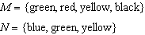
Which set represents ?
1)
2)
3)
4)

2 Given: 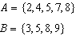
What is ?
1)
2)
3)
4)

3 Given: 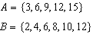
What is the union of sets A and B?
1)
2)
3)
4)

4 If and , the intersection of sets A and B is
1)
2)
3)
4)

5 If and , then the intersection of these two sets is
1)
2)
3)
4)

6 Given:
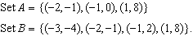
What is the intersection of sets A and B?
1)
2)
3)
4)

7 Given: 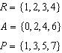
What is ?
1)
2)
3)
4)

8 Given: 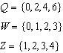
What is the intersection of sets Q, W, and Z?
1)
2)
3)
4)

9 Given: 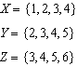
What is the intersection of sets X, Y, and Z?
1)
2)
3)
4)

10 Given: 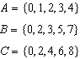
What is the intersection of sets A, B, and C?
1)
2)
3)
4)

11 Given the following:
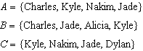
What is the intersection of sets A, B, and C?
1)
2)
3)
4)

12 If , , and , then is
1)
2)
3)
4)

13 Which set represents the intersection of sets A, B, and C shown in the diagram below?

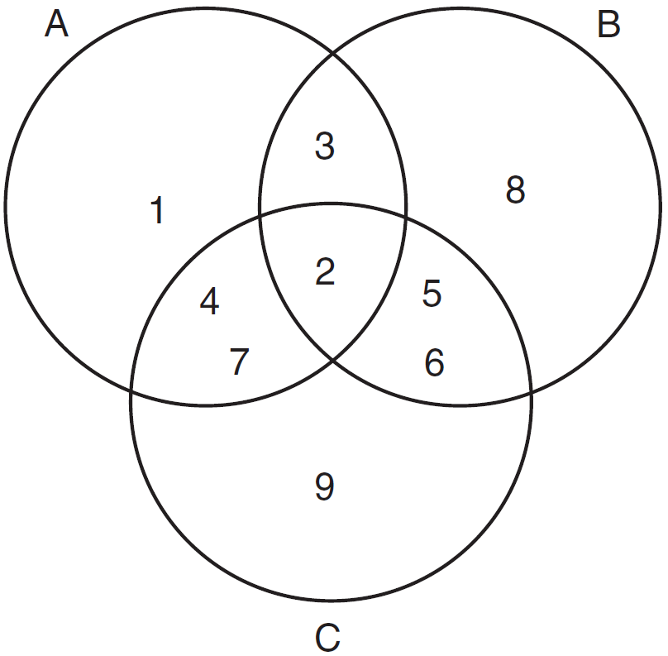
1)
2)
3)
4)

14 Given: 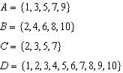
What statement is false?
1)
2)
3)
4)

15 Maureen tracks the range of outdoor temperatures over three days. She records the following information.

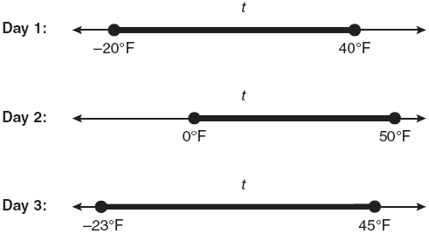

Express the intersection of the three sets as an inequality in terms of temperature, t.

1 ANS: 4 REF: 061426ia

2 ANS: 4 REF: 011225ia

3 ANS: 4 REF: 061123ia

4 ANS: 2 REF: 011501ia

5 ANS: 3 REF: 061501ia

6 ANS: 3 REF: fall0710ia

7 ANS: 3 REF: 061324ia

8 ANS: 1 REF: 011004ia

9 ANS: 1 REF: 011101ia

10 ANS: 2 REF: 061604ia

11 ANS: 4 REF: 081408ia

12 ANS: 3 REF: 061208ia

13 ANS: 2 REF: 081003ia

14 ANS: 3

REF: 081221ia

15 ANS:

REF: 060833ia

