1 The expression simplifies to
1) | 22.9
2) | 48
3) | 864
4) | 3,456

2 Express the product of in simplest radical form.

3 Perform the indicated operations and express the answer in simplest radical form.
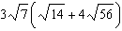

4 If is divided by , the result is
1) | 1
2)
3)
4)

5 Simplify: 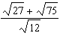

6 Simplify: 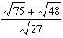

7 Express 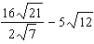 in simplest radical form.

8 The length of a rectangle is and the width is . Express the perimeter of the rectangle in simplest radical form. Express the area of the rectangle in simplest radical form.
1 ANS: 2

REF: 060218a

2 ANS:
.

REF: 080834ia

3 ANS:

REF: 061436ia

4 ANS: 1 REF: 068922siii

5 ANS:
4

REF: 089603al

6 ANS:
3

REF: 089710al

7 ANS:
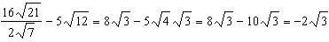

REF: 081136ia

8 ANS:
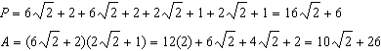

REF: 061639ia

