1 Expressed in simplest radical form, the product of is
1)
2)
3)
4)

2 Which value is equivalent to the product of and ?
1)
2)
3)
4)

3 Simplify:

4 Simplify:

5 Simplify:

6 The expression 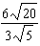 is equivalent to
1)
2)
3) | 8
4) | 4

7 Rationalize: 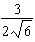

8 Simplify:

9 Simplify: 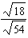

10 Simplify: 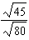

11 Express 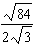 in simplest radical form.
1 ANS: 2

REF: 060627a

2 ANS: 1

REF: 061528ia

3 ANS:

REF: 119313al

4 ANS:
REF: 039505al

5 ANS:
REF: 039114al

6 ANS: 4
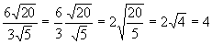
REF: 010622a

7 ANS:
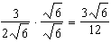
REF: fall2303ai

8 ANS:
REF: 119313al

9 ANS:
REF: 039505al

10 ANS:
REF: 099414al

11 ANS:
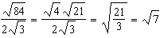
REF: 011431ia

