1 Simplify:

2 Simplify: 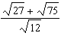

3 Simplify: 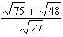

4 Simplify:

5 Simplify: 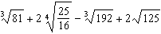

6 Simplify:

7 Simplify:

8 Simplify:

9 Simplify:

10 Simplify:

11 Simplify:

12 Simplify:

13 Simplify: 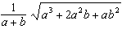

14 Simplify: 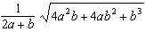

15 Simplify: 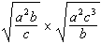

16 Simplify: 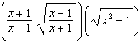

17 Simplify:

18 Simplify: 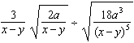

19 Simplify:

20 Simplify:

21 Simplify:

22 Simplify:

23 Simplify:

24 Simplify: 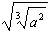

25 Simplify:

26 Simplify:

27 Simplify: 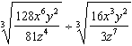

28 Simplify: 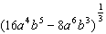
1 ANS:
1

REF: 089710al

2 ANS:
4

REF: 089603al

3 ANS:
3

REF: 089710al

4 ANS:

REF: 090511al

5 ANS:

REF: 010610al

6 ANS:

REF: 090404al

7 ANS:

REF: 099602al

8 ANS:

REF: 019811al

9 ANS:

REF: 069812al

10 ANS:

REF: 019713al

11 ANS:

REF: 089710al

12 ANS:

REF: 069812al

13 ANS:

REF: 089603al

14 ANS:

REF: 039807al

15 ANS:

REF: 099911al

16 ANS:

REF: 019911al

17 ANS:

REF: 069709al

18 ANS:
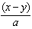

REF: 069709al

19 ANS:

REF: 019615al

20 ANS:

REF: 019811al

21 ANS:

REF: 019713al

22 ANS:

REF: 039807al

23 ANS:

REF: 069812al

24 ANS:

REF: 089603al

25 ANS:

REF: 019713al

26 ANS:

REF: 089603al

27 ANS:

REF: 019811al

28 ANS:

REF: 069812al

