1 Find the value of the following expression when , , , : 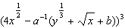

2 Find the numeric value of the following expression when , , , : 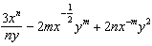

3 Simplify:

4 Simplify:

5 Simplify:

6 Simplify: 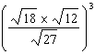

7 Simplify:

8 Simplify:

9 Simplify: 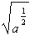

10 Simplify: 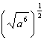

11 Simplify:

12 Simplify:

13 Simplify:

14 Simplify:

15 Simplify:

16 Simplify:

17 Find the sum of and .

18 Simplify:

19 Simplify:

20 Simplify:

21 Simplify:

22 Simplify:

23 Simplify:

24 Simplify: 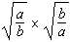

25 Simplify: 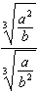
1 ANS:
125

REF: 039305al

2 ANS:
14

REF: 019414al

3 ANS:
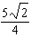

REF: 039114al

4 ANS:
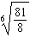

REF: 099511al

5 ANS:

REF: 019013al

6 ANS:

REF: 039309al

7 ANS:

REF: 019111al

8 ANS:

REF: 119313al

9 ANS:

REF: 099414al

10 ANS:

REF: 119411al

11 ANS:

REF: 089312al

12 ANS:
REF: 019415al

13 ANS:
REF: 039309al

14 ANS:
REF: 099511al

15 ANS:
REF: 119313al

16 ANS:
REF: 089312al

17 ANS:
REF: 119209al

18 ANS:
REF: 019111al

19 ANS:
REF: 089413al

20 ANS:
REF: 119313al

21 ANS:
REF: 069108al

22 ANS:
REF: 119411al

23 ANS:
REF: 039413al

24 ANS:
1
REF: 089312al

25 ANS:
REF: 019415al

