1 The value of 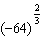 is
1) 16 2) 3) 4) 512

2 The value of 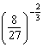 is
1) 2) 3) 4)

3 Find the value of .

4 Find the value of 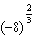.

5 Evaluate: 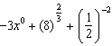

6 If 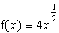, find .

7 If 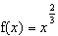, find .

8 If 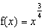, find .

9 If 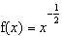, find .

10 If 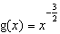, find .

11 If 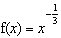, what is ?
1) 2) 3) 4) 4

12 What is the value of the expression when ?
1) 1 2) 2 3) 4)

13 If 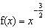, find 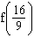.

14 If 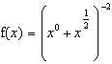, find .

15 Find the value of the expression 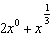 when .

16 Express in simplest form the value of 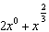 if .

17 Find the value of 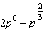 if .

18 If 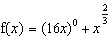, find .

19 If 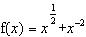, what is the value of ?

20 If , the value of 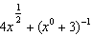 is
1) 2) 3) 4)

21 If , evaluate 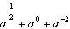.

22 If 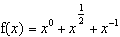, find .

23 What is the value of 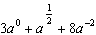 when ?

24 Find the value of 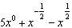 when .

25 If 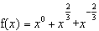, find .

26 If 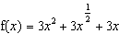, then is equal to
1) 2) 3) 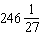 4) 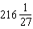

27 If , evaluate 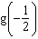.

28 If 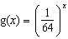, find 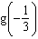.

29 If , find 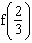 in simplest form.

30 If , find the value of .
1 ANS: 1 REF: 019520siii

2 ANS: 4 REF: 018922siii

3 ANS:
81

REF: 010203siii

4 ANS:
4

REF: 088511siii

5 ANS:
5

REF: 069911siii

6 ANS:
8

REF: 068101siii

7 ANS:
9

REF: 068002siii

8 ANS:
8

REF: 089004siii

9 ANS:

REF: 069007siii

10 ANS:

REF: 068611siii

11 ANS: 1 REF: 080116siii

12 ANS: 1 REF: 060132siii

13 ANS:

REF: 010310siii

14 ANS:
REF: 069416siii

15 ANS:
7
REF: 080306siii

16 ANS:
11
REF: 018609siii

17 ANS:
REF: 088614siii

18 ANS:
17
REF: 019807siii

19 ANS:
REF: 089705siii

20 ANS: 4 REF: 019418siii

21 ANS:
REF: 089810siii

22 ANS:
REF: 089901siii

23 ANS:
5.5
REF: 010407siii

24 ANS:
REF: 010013siii

25 ANS:
REF: 069711siii

26 ANS: 2 REF: 089431siii

27 ANS:
REF: 060010siii

28 ANS:
4
REF: 060204siii

29 ANS:
REF: 080206siii

30 ANS:
3.59
REF: 068614siii

