1 Simplify: 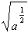

2 Simplify: 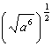

3 Simplify: 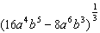

4 Find the numeric value of the following expression when , , , : 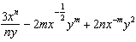

5 Find the value of the following expression when , , , : 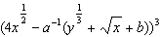
1 ANS:

REF: 099414al

2 ANS:

REF: 119411al

3 ANS:

REF: 069812al

4 ANS:
14

REF: 019414al

5 ANS:
125

REF: 039305al

