1 The expression 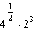 is equal to
1)
2)
3) | 16
4) | 4

2 The expression 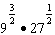 is equivalent to
1)
2)
3)
4) | 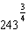

3 Which number is the largest?
1) | 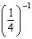
2) | 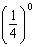
3) | 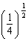
4) | 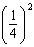

4 Determine the exact value of 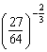 as a fraction in simplest form.

5 The expression is equivalent to
1) | 1
2)
3) | 3
4)

6 The value of 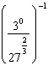 is
1)
2) | 9
3)
4)

7 If 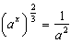, what is the value of x?
1) | 1
2) | 2
3)
4)

8 If 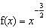, then 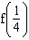 is equal to
1) | 8
2)
3)
4)

9 What is the value of 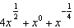 when ?
1)
2)
3)
4)

10 Find the value of 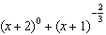 when .

11 Evaluate the expression 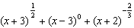 when .

12 If x is a positive integer, is equivalent to
1)
2)
3)
4)

13 The volume of a soap bubble is represented by the equation , where A represents the surface area of the bubble. Which expression is also equivalent to V?
1) | 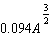
2) | 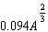
3)
4) | 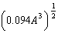

14 The expression is equivalent to
1)
2)
3) | 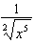
4) | 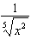

15 The expression 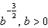, is equivalent to
1) | 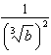
2) | 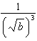
3) | 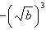
4) | 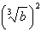

16 If , the expression 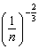 is equal to
1)
2)
3)
4)

17 Simplify the expression 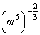 and write your answer using a positive exponent.

18 When simplified, the expression 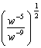 is equivalent to
1)
2)
3)
4)

19 The expression 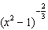 is equivalent to
1)
2) | 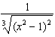
3)
4) | 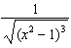

20 Which expression is equivalent to 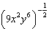?
1) | 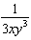
2)
3)
4)

21 Which expression is equivalent to b in the equation 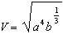?
1)
2)
3)
4)

22 The expression is equivalent to
1) | 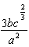
2) | 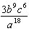
3) | 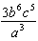
4) | 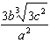

23 The expression is equivalent to
1) | 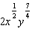
2)
3) | 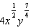
4)

24 The expression is equivalent to
1)
2) | 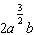
3)
4) | 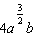

25 The expression is equivalent to
1) | 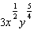
2) | 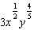
3) | 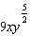
4) | 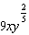

26 Which expression is equivalent to 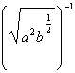?
1) | 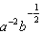
2) | 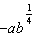
3)
4)

27 The expression 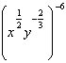 is equivalent to
1)
2)
3) | 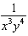
4)

1 ANS: 3

REF: 080601b

2 ANS: 2
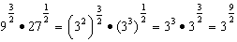

REF: 011707a2

3 ANS: 1 REF: 061002b

4 ANS:
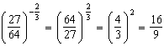

REF: 011729a2

5 ANS: 3
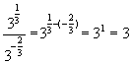

REF: 080218b

6 ANS: 2
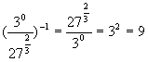

REF: 010217b

7 ANS: 3
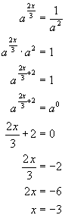

REF: 060516b

8 ANS: 1
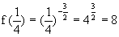

REF: 060602b

9 ANS: 4
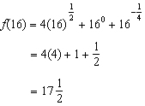

REF: 081503a2

10 ANS:
1.25. 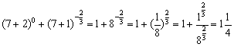

REF: 080322b

11 ANS:
4.25. 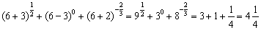

REF: 080921b

12 ANS: 3 REF: 060208b

13 ANS: 1
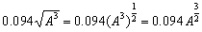

REF: 060708b

14 ANS: 4
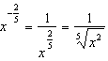

REF: 011118a2

15 ANS: 2
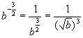

REF: 010413b

16 ANS: 3
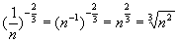

REF: 080807b

17 ANS:

REF: 010824b

18 ANS: 2
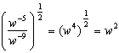

REF: 081011a2

19 ANS: 2 REF: 061011a2

20 ANS: 1 REF: 011306a2

21 ANS: 1 REF: 011015b

22 ANS: 1
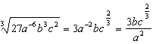

REF: 011606a2

23 ANS: 1
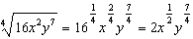

REF: 061107a2

24 ANS: 2
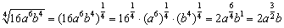

REF: 060419b

25 ANS: 1
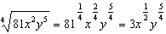

REF: 081504a2

26 ANS: 4
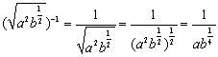

REF: 060912b

27 ANS: 1
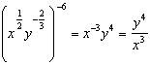

REF: 081611a2

