1 For all positive values of x, which expression is equivalent to ?
1) 2) 3) 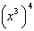 4)

2 The expression 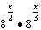 is equivalent to
1) 2) 3) 4)

3 Which expression is an equivalent form of ?
1) 2) 3) 4)

4 Which expression is equivalent to ?
1) 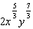 2) 3) 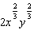 4)

5 The expression is equivalent to
1) 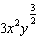 2) 3) 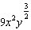 4)

6 Given , the expression can be rewritten as
1) 2) 3) 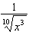 4)

7 Given , the expression 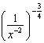 is equivalent to
1) 2) 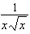 3) 4) 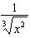

8 The expression 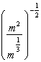 is equivalent to
1) 2) 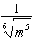 3) 4) 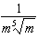

9 When and d is a positive integer, the expression 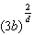 is equivalent to
1) 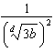 2) 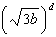 3) 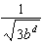 4) 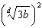

10 Which equation is equivalent to 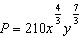
1) 2) 3) 4)

11 What does 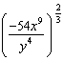 equal?
1) 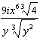 2) 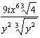 3) 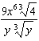 4) 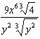

12 For , which expressions are equivalent to one divided by the sixth root of x?
I. II. III.
1) I and II, only 2) I and III, only 3) II and III, only 4) I, II, and III

13 Given x and y are positive, which expressions are equivalent to ?

I. 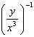 II. III. 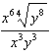
1) I and II, only 2) I and III, only 3) II and III, only 4) I, II, and III

14 For , which equation is false?
1) 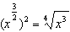 2) 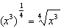 3) 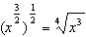 4) 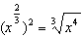

15 If and , where , an expression for could be
1) 2) 3) 4)

16 Kenzie believes that for , the expression 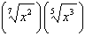 is equivalent to . Is she correct? Justify your response algebraically.

17 Write 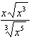 as a single term in simplest form, with a rational exponent.

18 Justify why 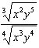 is equivalent to 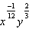 using properties of rational exponents, where and .

19 When 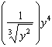 is written in the form , what is the value of n? Justify your answer.

20 Given that 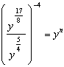, where , determine the value of n.

21 For n and , is the expression 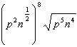 equivalent to ? Justify your answer.

22 Express the fraction 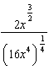 in simplest radical form.

23 Given the equal terms and , determine and state y, in terms of x.

24 Use the properties of rational exponents to determine the value of y for the equation:
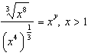

25 Given , solve the equation for x algebraically.

26 For and , . Determine the value of a.
1 ANS: 1 REF: 062201aii

2 ANS: 1
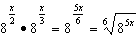

REF: 082419aii

3 ANS: 2
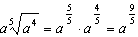

REF: 062306aii

4 ANS: 2
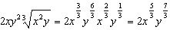

REF: 062413aii

5 ANS: 1
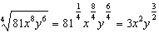

REF: 012001aii

6 ANS: 3
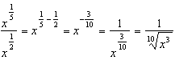

REF: 012312aii

7 ANS: 2
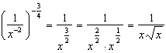

REF: 082412aii

8 ANS: 2
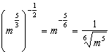

REF: 011707aii

9 ANS: 4 REF: 061601aii

10 ANS: 3
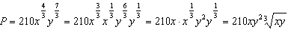

REF: 012413aii

11 ANS: 4
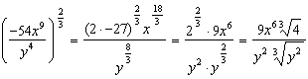

REF: 081723aii

12 ANS: 4 REF: 061716aii

13 ANS: 4
I. 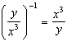; II. 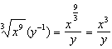; III. 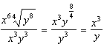

REF: 062320aii

14 ANS: 1
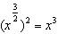

REF: 061908aii

15 ANS: 4
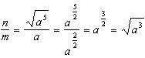

REF: 011811aii

16 ANS:
No. 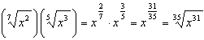

REF: 061929aii

17 ANS:
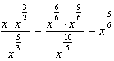

REF: 082331aii

18 ANS:
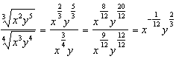

REF: 011925aii

19 ANS:
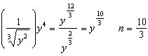

REF: 012428aii

20 ANS:
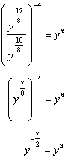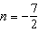

REF: 082228aii

21 ANS:
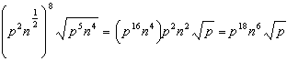

REF: 012025aii

22 ANS:
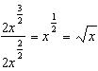

REF: 081826aii

23 ANS:
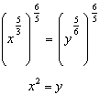

REF: 011730aii

24 ANS:
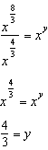

REF: spr1505aii

25 ANS:
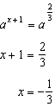

REF: 012326aii

26 ANS:
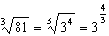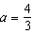

REF: 062230aii

