1 The expression 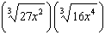 is equivalent to
1)
2)
3)
4)

2 The product of and expressed in simplest radical form is
1)
2)
3)
4)

3 When simplified, the expression 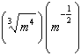 is equivalent to
1)
2)
3)
4)

4 What is the product of and ?
1)
2)
3)
4)

5 The expression 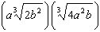 is equivalent to
1)
2)
3)
4)

6 The expression is equivalent to
1)
2)
3)
4)

7 Given , the expression is equivalent to
1)
2)
3) | 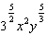
4) | 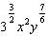

8 For , which expression is equivalent to 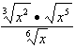?
1)
2)
3)
4)

9 Simplify: 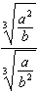

10 Simplify: 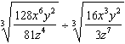

11 Write as a single term with a rational exponent.

12 Simplify:

13 Simplify:

14 Simplify:

15 Simplify:

16 For positive values of x, which expression is equivalent to 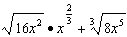
1)
2)
3)
4)

17 The sum of and , expressed in simplest radical form, is
1)
2)
3)
4)

18 Simplify: 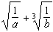
1 ANS: 4
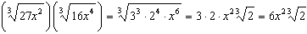

REF: 011421a2

2 ANS: 4

REF: 081627a2

3 ANS: 4
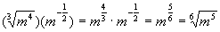

REF: 010617b

4 ANS: 1

REF: 011516a2

5 ANS: 1
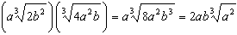

REF: 082213aii

6 ANS: 1

REF: 061504a2

7 ANS: 4
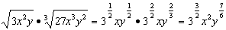

REF: 081914aii

8 ANS: 3
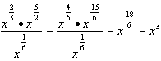

REF: 081812aii

9 ANS:

REF: 019415al

10 ANS:

REF: 019811al

11 ANS:
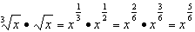

REF: 061731aii

12 ANS:

REF: 019713al

13 ANS:

REF: 089603al

14 ANS:

REF: 119411al

15 ANS:

REF: 039413al

16 ANS: 2
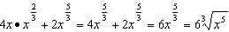

REF: 061820aii

17 ANS: 3
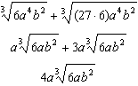

REF: 011319a2

18 ANS:
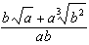

REF: 089710al

