1 The expression 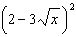 is equivalent to
1)
2)
3)
4)

2 Simplify:

3 Simplify:

4 Simplify: 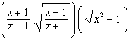

5 Simplify: 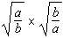

6 Simplify: 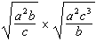

7 Express 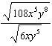 in simplest radical form.

8 Simplify: 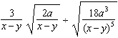

9 Simplify:

10 Simplify:

11 Simplify:

12 Express in simplest radical form.

13 Find the sum of and .

14 Simplify:

15 The expression is equivalent to
1)
2)
3)
4)

16 Simplify:

17 The expression 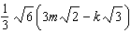 is equivalent to
1)
2)
3)
4)

18 Express 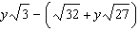 in simplest radical form.

19 The legs of a right triangle are represented by and . The length of the hypotenuse of the right triangle is represented by
1)
2)
3)
4)

1 ANS: 3 REF: 061407a2

2 ANS:

REF: 039309al

3 ANS:

REF: 090404al

4 ANS:

REF: 019911al

5 ANS:
1

REF: 089312al

6 ANS:

REF: 099911al

7 ANS:
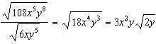

REF: 011133a2

8 ANS:
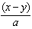

REF: 069709al

9 ANS:

REF: 099511al

10 ANS:

REF: 089312al

11 ANS:

REF: 119313al

12 ANS:

REF: 061032a2

13 ANS:

REF: 119209al

14 ANS:

REF: 019111al

15 ANS: 4

REF: fall0918a2

16 ANS:

REF: 069709al

17 ANS: 1
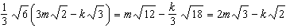

REF: 011710a2

18 ANS:

REF: 081436ia

19 ANS: 1

REF: 011626a2

