1 The product of and is
1)
2)
3) | 14
4) | 4

2 Simplify:

3 Simplify:

4 Simplify: 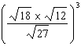

5 Classical mathematics uses the term "Golden Ratio" for the ratio 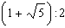. The Golden Ratio was used by many famous artists to determine the dimensions of their paintings. If the ratio of the length to the width of a painting is , find the length, in feet, of a painting that has a width of 14 feet. Express your answer in simplest radical form.
1 ANS: 4

REF: 081001a2

2 ANS:
1

REF: 089710al

3 ANS:
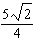

REF: 039114al

4 ANS:

REF: 039309al

5 ANS:
. 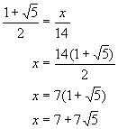

REF: 080724b

