1 On a certain day in Toronto, Canada, the temperature was 15° Celsius (C). Using the formula 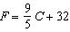, Peter converts this temperature to degrees Fahrenheit (F). Which temperature represents 15°C in degrees Fahrenheit?
1) |  | 3) | 59
2) | 35 | 4) | 85

2 The formula 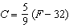 can be used to find the Celsius temperature (C) for a given Fahrenheit temperature (F). What Celsius temperature is equal to a Fahrenheit temperature of 77°?
1) | 8° | 3) | 45°
2) | 25° | 4) | 171°

3 If the temperature in Buffalo is 23° Fahrenheit, what is the temperature in degrees Celsius? [Use the formula .]
1) |  | 3)
2) | 5 | 4) | 45

4 The formula for converting temperatures in degrees Celsius to degrees Fahrenheit is . If the temperature is 20°C, what is the temperature in degrees Fahrenheit?
1) | 68 | 3) | 33.8
2) | 43.1 | 4) | 4

5 The formula for changing Celsius (C) temperature to Fahrenheit (F) temperature is 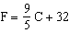. Calculate, to the nearest degree, the Fahrenheit temperature when the Celsius temperature is .

6 The formula is used to convert Fahrenheit temperature, F, to Celsius temperature, C. What temperature, in degrees Fahrenheit, is equivalent to a temperature of 10° Celsius?

7 Connor wants to compare Celsius and Fahrenheit temperatures by drawing a conversion graph. He knows that and that . On the accompanying grid, construct the conversion graph and, using the graph, determine the Celsius equivalent of .

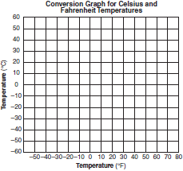

8 Which expression can be used to change 75 kilometers per hour to meters per minute?
1) | 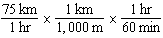 | 3) | 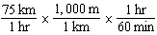
2) | 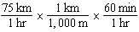 | 4) | 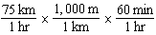

9 If the speed of sound is 344 meters per second, what is the approximate speed of sound, in meters per hour?

60 seconds = 1 minute
60 minutes = 1 hour

1) | 20,640 | 3) | 123,840
2) | 41,280 | 4) | 1,238,400

10 Elizabeth is baking chocolate chip cookies. A single batch uses teaspoon of vanilla. If Elizabeth is mixing the ingredients for five batches at the same time, how many tablespoons of vanilla will she use?

3 teaspoons = 1 tablespoon

1) |  | 3)
2) |  | 4)

11 Peter walked 8,900 feet from home to school.

1 mile = 5,280 feet

How far, to the nearest tenth of a mile, did he walk?
1) | 0.5 | 3) | 1.6
2) | 0.6 | 4) | 1.7

12 A soda container holds gallons of soda. How many ounces of soda does this container hold?

1 quart = 32 ounces
1 gallon = 4 quarts

1) | 44 | 3) | 640
2) | 176 | 4) | 704

13 A parking lot is 100 yards long. What is the length of of the parking lot, in feet?

1 yard = 3 feet

1) | 300 | 3) | 75
2) | 225 | 4) | 25

14 Last year, Nick rode his bicycle a total of 8000 miles. To the nearest yard, Nick rode an average of how many yards per day?

1 mile = 1760 yards
1 year = 365 days

1) | 22 | 3) | 1659
2) | 236 | 4) | 38,575

15 A total of 1680 ounces of pet food have to be packed in 5-pound bags. How many 5-pound bags of pet food can be packed?

1 pound = 16 ounces

1) | 21 | 3) | 105
2) | 28 | 4) | 336

16 Andy is 6 feet tall. If 1 inch equals 2.54 centimeters, how tall is Andy, to the nearest centimeter?
1) | 15 | 3) | 183
2) | 30 | 4) | 213

17 Liem is 6 feet 2 inches, Eli is 5 feet 9 inches, Faith is 6 feet, and Simon is 5 feet 4 inches. In yards, what is the total of their heights?
1) |  | 3) | 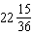
2) |  | 4)

18 Angela wants to purchase carpeting for her living room. The dimensions of her living room are 12 feet by 12 feet. If carpeting is sold by the square yard, determine how many square yards of carpeting she must purchase.

3 feet = 1 yard
9 square feet = 1 square yard

19 Mrs. Chen owns two pieces of property. The areas of the properties are 77,120 square feet and 33,500 square feet.

43,560 square feet = 1 acre

Find the total number of acres Mrs. Chen owns, to the nearest hundredth of an acre.

20 A jogger ran at a rate of 5.4 miles per hour. Find the jogger's exact rate, in feet per minute.

1 mile = 5,280 feet

21 If a United States dollar is worth $1.41 in Canadian money, how much is $100 in Canadian money worth in United States money, to the nearest cent?

22 Roberta needs ribbon for a craft project. The ribbon sells for $3.75 per yard. Find the cost, in dollars, for 48 inches of the ribbon.

1 ANS: 3
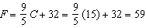

REF: 010901ia

2 ANS: 2
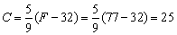

REF: 089908a

3 ANS: 1
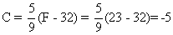

REF: 060407a

4 ANS: 1
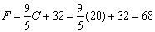

REF: 080804a

5 ANS:
18. 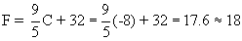

REF: 060021a

6 ANS:
50. 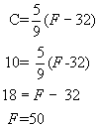

REF: 010734a

7 ANS:
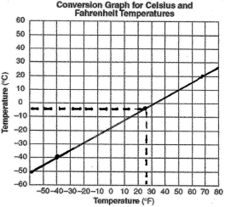;

REF: 060128a

8 ANS: 3 REF: 011317ia

9 ANS: 4
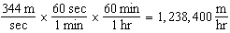

REF: 060911ia

10 ANS: 1
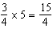 teaspoons 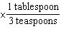=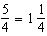 tablespoon

REF: 061228ia

11 ANS: 4
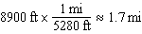

REF: 081210ia

12 ANS: 4
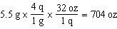

REF: 061305ia

13 ANS: 2
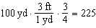

REF: 081415ia

14 ANS: 4
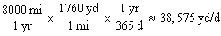

REF: 011522ia

15 ANS: 1
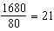

REF: 061521ia

16 ANS: 3
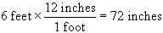. 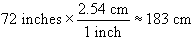

REF: 060709a

17 ANS: 1
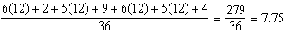

REF: 061629ia

18 ANS:
16. 12 feet equals 4 yards. .

REF: 011031ia

19 ANS:
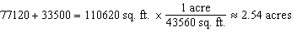

REF: 081133ia

20 ANS:
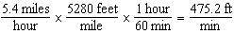

REF: 081331ia

21 ANS:
70.92. 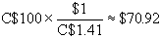

REF: 060731a

22 ANS:
5. 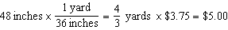

REF: 011131ia

